| **Department** | **Printed Name** | **Signature** | **Date** |
| --- | --- | --- | --- |
| Author/LSD | Prakruthi Rao Chavali | See electronic signature | See stamp |
| PQ | Jacob Elmquist | See electronic signature | See stamp |
| RA | Tiffany Lin | See electronic signature | See stamp |
| PRMO | Saravanan K | See electronic signature | See stamp |
| Service | Simon Fontana | See electronic signature | See stamp |
| Software | Lalu Krishnan | See electronic signature | See stamp |
| Marketing | Jason Knox | See electronic signature | See stamp |
| PDO | Derek Neiman | See electronic signature | See stamp |

**ABSTRACT:**

This document describes the changes to the PrisMax SW3.4/ SW3.5 software to include Customer improvements and Software bug fixes.

**Table of Contents**

1 Introduction 5

1.1 Purpose and Scope 5

1.2 Summary 5

1.3 Terms and Definitions 6

1.4 References 6

1.5 Entities Impacted 6

1.6 Individuals Involved 7

2 Change Analysis (CA) 8

2.1 Design Inputs (CA1) 8

2.1.1 Reason for Change 8

2.1.2 Description of Changes 8

2.1.3 Use Case Analysis 25

2.1.4 Human Factors Analysis 39

2.1.5 Risk Analysis 39

2.1.6 Risk Mitigation Analysis 41

2.1.6 Product Requirement Analysis 44

2.1.7 System Requirement Analysis 46

2.2 Sub-System Requirements Analysis (CA2) 56

2.2.1 Hardware Requirement Analysis 56

2.2.2 Software Requirement Analysis 56

2.2.3 Labeling Requirement Analysis 110

3 Change Description (CD) 112

3.1.1 Allow previous treatment event data to be selected and viewed on the GUI (PFAL-2249) 112

3.1.2 Ensure that displayed PFR total are all rounded to the same precision (PFAL-2266**)** 122

3.1.3 Allow all users to update system time, and remove multiple time offsets (PFAL-2216) 125

3.1.4 Support updating product codes for filter sets in the field (PFAL-2218) 130

3.1.5 Support reloading of filter set when “CRRT/TPE Wrong Set” alarm is raised (PFAL-2227) 143

3.1.6 Text/Image updates for Therapy Recovery and Manual Blood Return (PFAL-2287) 152

3.1.7 TPE priming updates to ensure air bubbles are removed from return line (PFAL-2281) 166

3.1.8 HPX labeling updates (PFAL-2275) 167

3.1.9 Bag mixing image update before priming (PFAL-2274) 170

3.1.10 Miscellaneous GUI labeling updates (PFAL-2273) 172

3.1.11 German translations for “hours” vs. “time of day” (PFAL-2263) 178

3.1.12 Update software to prevent T2300 TherMax bag inflation failures during priming (PFAL-2299) 182

3.1.13 Improve reliability of the software in handling simultaneous bag changes (PFAL-2219) 184

3.1.14 HP-X Auto leveling Priming update (PFAL-2288) 188

3.1.15 Improve HP-X Priming sequence when no PBP bag is used (PFAL-2288) 190

3.1.16 Update Data Sampling Rate to Match EMR Transmission Rate (PFAL-2267) 191

3.1.17 Sustained High Return Pressure Causes a BIOT (PFAL-2341) 192

3.1.18 English XML Updates (PFAL-2297) 193

3.1.19 PrisMax Delivered Dose is displayed incorrectly (PFAL-2510) 194

4 Change Verification (CV) 196

4.1 Verification Testing 196

4.1.1 System Requirement Verification 196

4.2 Regression Testing 196

4.2.1 Regression Testing 196

4.3 Verification Results 196

Figure 1 - Updated Wrong Set Detected Alarm 11

Figure 2 - Set Load Failure Alarm 12

Figure 3 – System Halt Alarm text in Treatment 13

Figure 4 System Halt Alarm text not in Treatment 13

Figure 5 B2222 Alarm System Reset Occurred 14

Figure 6 - Select Log File Button on History Screen 115

Figure 7 - Previous Log Selection 116

Figure 8 - Filter by Date Screen 117

Figure 9 - Load in Progress Dialog 118

Figure 10 - Loaded Events 119

Figure 11 - PFR History Screen 124

Figure 12 - Update Date/Time Menu 127

Figure 13 - Barcode Import Screen 132

Figure 14 - USB Ready for Import 133

Figure 15 - Import in Progress 134

Figure 16 - Import Success Screen 135

Figure 17 - Import Failure Screen 136

Figure 18 - Set Loading Failure Alarm 145

Figure 19 - Wrong Set Detected Alarm 146

Figure 20 - System Failure (In Treatment) 154

Figure 21 - System Failure Alarm (Not in Treatment) 155

Figure 22 - System Reset Alarm (B2222) 156

Figure 23 - Manual Return Part 1 157

Figure 24 - Manual Return Part 2 158

Figure 25 - Manual Return Part 3 159

Figure 26 - Manual Return Part 4 160

Figure 27 - Manual Return Part 5 161

Figure 28 - Manual Return Part 6 162

Figure 29 - Manual Return Part 7 163

Figure 30 - Manual Return Part 8 164

Figure 31 - Dialog Displayed for Adsorba Cartridges 170

Figure 32 - Updated Bag Mixing Graphic 172

Figure 33 - Updated Prime Complete Steps 174

Figure 34 - Review Prescription Fix 175

Figure 35 - Static Discharge Detect Alarm previously High Voltage Detected 176

Figure 36 - TherMax Discharge Detected previously TherMax at Mains Voltage 177

Figure 37 - Battery Communication Problem previous High Battery Temp 178

Figure 38 - Example German Translation 180

Figure 39 - German on Dose Screen 181

Figure 40 - Change Bag Start 186

Figure 41 - Bag Change Complete 3 187

Figure 42 - Bag Change Complete 188

**Table 1 Related Hazard Definitions** 42

**Table 2 Related Risk Control Measures** 43

**Table 3 Risk Control Measures to be deleted** 45

**Table 4 New Risk Control Measures** 45

**Table 5 FMEA8000 updates** 45

**Table 6 Related Therapy Requirement Specifications** 46

**Table 7** **Interface Control Document Specifications** 47

**Table 8** **Related Customer Requirement Specifications** 47

**Table 9 - Modified PRD Requirements** 48

**Table 10 - New PRD Requirements** 51

**Table 11 Related Product Requirement Specifications** 51

**Table 12 - Modified SRS Requirements** 58

**Table 13 - New SRS Requirements** 72

**Table 14 - Related SRS Requirements** 77

**Table 15 Modified Design Specifications** 87

**Table 16 Added Software Design Specifications 96**

**Table 17 Related Software Design Specifications** 102

**Table 18 Modified Labeling Requirement Specifications** 112

**Table 19 Related Labeling Requirement Specifications** 113

# **1 Introduction**

## 1.1 Purpose and Scope

The purpose of this CADV report is to describe the Customer improvements and other anomaly resolutions incorporated in the PrisMax SW 3.4/SW 3.5 release.

This CADV report contains the reason for each modification, a summary description of the change, the impact to program risks and requirements, and any impact to labeling. The detailed description of each change including design modifications, detailed implementation documentation, and verification definition is contained in the referenced PrisMax Formal Anomaly List (PFAL) records.

*Note: This CADV document only identifies and describes the changes being applied. Where necessary, additional background material will be provided.*

## 1.2 Summary

The issues resolved in this release were selected based on using the following criteria:

* Benefit – either addressed a significant cause of customer complaints or improved usability.
* Ease/risk of implementation – issues where the resolution could be clearly identified and impacting a well-defined and contained area of the code base.

The modifications documented in this CADV are listed below:

*indicates Issue IDs included in SW 3.5

|  |  |  |
| --- | --- | --- |
| **Issue ID** | **Modification ID** | **Change Summary** |
| PFAL-2202 | PFAL-2216 | Allow all users to update system time and ensure the same offset is used throughout the system |
| PFAL-2204 | PFAL-2218 | Support updating filter set codes in the field |
| PFAL-2221 | PFAL-2227 | Support reloading of filter set when wrong set detect alarm is raised in setup |
| PFAL-1984 | PFAL-2249 | Ability to display events from selected previous treatment session |
| PFAL-2238 | PFAL-2263 | German translations for “hours” vs. “time of day” |
| PFAL-2262 | PFAL-2266 | Ensure all displayed PFR totals are all rounded to the same units |
| PFAL-2184 | PFAL-2273 | Miscellaneous GUI labeling updates |
| PFAL-2184 | PFAL-2274 | Bag mixing image update before priming |
| PFAL-2184 | PFAL-2275 | HPX labeling updates |
| PFAL-2248 | PFAL-2281 | TPE priming updates to ensure air bubbles are removed from return line |
| PFAL-2184 | PFAL-2287 | Text updates for Therapy Recovery and Manual Blood Return |
| PFAL-2205 | PFAL-2219 | Improve reliability of handling simultaneous bag changes |
| PFAL-2292 | PFAL-2288 | HPX Auto-Leveling Priming Update |
| PFAL-2282 | PFAL-2288 | Improve HP Priming sequence when PBP is not used |
| PFAL-2293 | PFAL-2299 | Update the software to prevent TherMax bag inflation failures during priming |
| PFAL-1722 | PFAL-2267 | Update Data Sampling Rate to match EMR Transmission Rate |
| PFAL-2307 | PFAL-2341 | Sustained High Return pressure causes a BIOT |
| PFAL-2296 | PFAL-2297 | English XML Issues |
| *PFAL-2509 | PFAL-2510 | PrisMax Delivered Dose is displayed incorrectly |

## 1.3 Terms and Definitions

| **Term** | **Definition** |
| --- | --- |
| CADV | Change Analysis, Description, and Verification |
| CP | Control Processor |
| PFR | Patient Fluid Removal |
| GUI | Graphical User Interface |
| RTC | Real Time Clock |
| ECMO | Extracorporeal Membrane Oxygenation |

## 1.4 References

| No | **ID** | **Title** |
| --- | --- | --- |
| R1 | RACT8000 | Risk Assessment and Control Table for PrisMax System, TherMax BWU, AE, AEE and 5L Bag |
| R2 | CRS8001 | Customer Requirements Specification |
| R3 | TRS8001 | Therapy Requirements Specification, PrisMax System V3 |
| R4 | PRD8002 | Product Requirements Document, PrisMax Monitor V3 |
| R5 | SRS8001 | Software Requirements Specification, PrisMax V3 |
| R6 | SDS8001 | Software Design Specification, PrisMax V3 |
| R7 | SAD8001 | Software Architecture Document, PrisMax V3 |
| R8 | HFP8002 | Human Factors Plan |
| R9 | HSHA-AE-THERAPIES | Acute Extracorporeal Therapies Hazardous Situation and Harm Analysis |
| R10 | LRD8001 | Labeling Requirements Document, PrisMax V3 |

## 1.5 Entities Impacted

This section contains a list of documents impacted by the change.

| **Document** | **Yes** | **No** | **Comments** |
| --- | --- | --- | --- |
| RACT | X |  | Priming and System Halt RCMs  New RCMs for PFAL-2510 |
| TRS |  | X |  |
| CRS |  | X |  |
| LRD | X |  | Alarm title updates |
| PRD | X |  | New Features and Updates for Clarity |
| HRD |  | X |  |
| SRS | X |  | New Features and Updates for Clarity |
| PDD |  | X |  |
| SDS | X |  |  |
| Operator’s Manual | X |  | Alarm text/button updates and Clock Settings |
| Service Manual | X |  | Barcode Updates, Clock Settings, and Event History |
| Code | X |  |  |
| Licensing |  | X |  |
| Labeling | X |  | Alarms updates, Advisory updates, Manual Return Dialog, Bag mixing image update |
| Error Code List | X |  | Alarm T2379 “Set loading failure” added as a part of PFAL-2227 |
| Test Protocols | X |  | To be determined as a part of CV |
| Other: | X |  | Communication Programmers Guide AW8081 to include accurate refresh rate for EMR parameters (included as a part of SW 3.5) |

## 1.6 Individuals Involved

The names of the primary individuals involved in the creation of this document are as follows:

|  |  |
| --- | --- |
| **Name** | **Section (CA, CD, or CV)** |
| Derek Neiman | CA |
| Prakruthi Rao | CA |
| Lalu Krishnan | CD |
| Shilpa Dwarakinatha | CV |

# **2 Change Analysis (CA)**

## 2.1 Design Inputs (CA1)

## 2.1.1 Reason for Change

The resolutions of the anomalies described by this CADV are implemented to either eliminate instances where the requirements were not being met, to improve the functionality and/or performance of the system, or to improve the maintainability of the system. Additionally, some of the changes are made to add new functionality that does not have a patient safety impact such as service and troubleshooting enhancements.

For each individual change, refer to section 2.1.2 for a description of the specific issue being addressed as well as a description of the change itself*.*

## 2.1.2 Description of Changes

#### Allow previous treatment event data to be selected and viewed on the GUI (PFAL-2249)

The system updates and displays a list of events that can be viewed by an operator while a treatment is ongoing. These events can give some insight into what alarms or other events were generated previously in the treatment. However, this list of events is cleared when a new setup begins or after a power cycle, meaning that the only way to view previous treatment data is to do a USB export of the logs, and then use relevant applications or tools to view the data.

This change will allow an operator or service technician to view previous treatment information directly from the user interface. The user will be able to view a list of all log files saved on the system and will be able to select one file at a time for review.

This feature will be implemented by:

* Creating a new button on the “History” menu that when selected, will display a list of the log files available on the system
* Once a file has been selected, the system will query that specific file and populate the list of events on the GUI
* Ensuring this feature can only be accessed when the system is idle and does not conflict with a treatment session

#### Ensure that displayed PFR total are all rounded to the same precision (PFAL-2266)

The PFR values displayed on the UI are rounded to different precisions on different screens. This can cause confusion to the operator since the calculations can vary slightly depending on the precision used.

This change will ensure that all places where PFR values are displayed, will be rounded to the nearest milliliter. Note that the PFR values that are sent through EMR are already rounded to the nearest whole number, even though they display a trailing “.0” per the message formatting design.

This modification will be addressed by:

* Ensuring all displayed values come from the same source i.e., One calculation used by any software modules in the CP system
* Ensuring that all displayed PFR values are rounded to the same precision

#### Allow all users to update system time, and remove multiple time offsets (PFAL-2216)

Previously, the system used two different offsets to the time obtained from the real-time clock (RTC) hardware to determine the actual time. The first offset, only settable in Service Mode, was applied to the RTC output to determine the system time. The second offset, only settable in therapy mode, was then applied to the system time to determine the displayed time. This system is unnecessarily complicated and causes confusion when attempting to correlate log files with observed events. Furthermore, typical operators such as nurses don’t have access to either of the settings, preventing them from updating systems for common events such as daylight savings time changes.

This change will remove the multiple offsets and only have one that is used throughout the system. Additionally, any user will now be able to update the time in therapy mode.

This modification will be addressed by:

* Using one common time offset used by the entire system
* Allowing all users (including an operator) to adjust the time in Therapy mode
* Automatically rebooting the system when the time is updated to ensure the offset is saved by the Real Time Clock

#### Support updating product codes for filter sets in the field (PFAL-2218)

The barcode on the front of each filter set contains the product code, which is used to determine the filter set type. The set of defined product codes for each filter set type is hardcoded into the software. The product codes change more frequently than originally anticipated and requires a SW update with each barcode change.

This change will allow a service technician to import an updated barcode list as needed, without the need for a software update. The barcode lists will be maintained In TcU.

This feature will be implemented by:

* Adding a new table to the database to store the list of applicable product codes
* Creating a new option to import a new list of product codes
* Updating the system to use the new table instead of hardcoded information to determine the filter type from the product code obtained from scanning the front filter barcode

#### Support reloading of filter set when “CRRT/TPE Wrong Set” alarm is raised (PFAL-2227)

The system performs an automatic recognition check after a filter set is loaded in setup, to determine if the set has loaded properly or if an incorrect set has been attached. One of the main causes for this test to fail is when the set tubing doesn’t fully load on the pump rotor. This issue can be addressed by simply unloading and reloading the set. However, the current implementation does not allow this without forcing the operator to end the treatment session/discard the set and start a new treatment session. Furthermore, the instructions can cause confusion leading the operator to unnecessarily discard the set.

The proposed change will allow the operator to address the issue without discarding the set by creating new actions to load/unload the set directly from the alarm.

This change will:

* Introduce a new alarm “Set Loading Failure” T2379 to inform the user that it is likely that the filter set has not been loaded properly. This alarm will allow unloading and reloading of the set, after which the set recognition test will again run, automatically. If the set recognition test fails again, the alarm T0608 or T1783 will be raised.
* Update existing alarms T0608 and T1783 to have the following actions:
* Unload Set (new action) - will cause the set to be unloaded, or if already completely pushed out (unloaded), cause further rotation of the fluid pumps for 0.25 seconds
* Load Set (new action) - will cause the set to be loaded, or if already completely pulled in (loaded), cause further rotation of the fluid pumps for 5 seconds
* Retry (new action, replaces Continue) - will clear the alarm and cause the system to retry the set recognition test (TPE vs. CRRT set type test)
* Discard Set (currently present) - causes session to transition to end mode (effectively clearing the alarm)

This modification will be addressed by:

* Adding/Updating the allowed actions on the applicable alarms
* Modifying alarm handling logic to process the alarm actions as needed
* Update the text/instructions on the alarm
* Update the graphic on the alar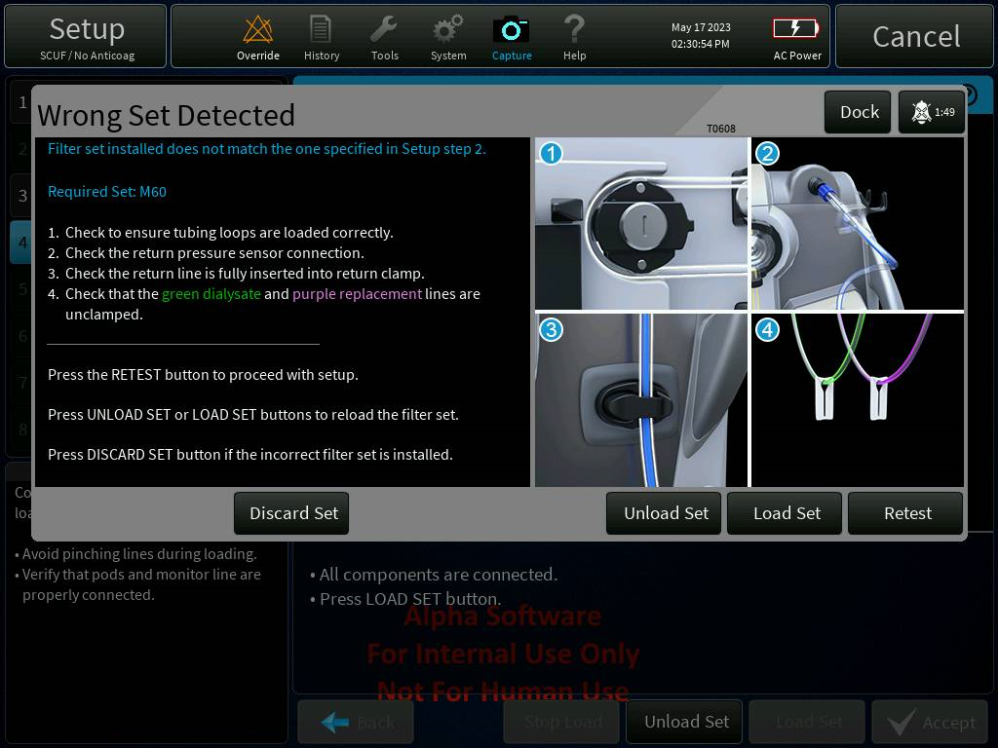m

Figure 1 - Updated Wrong Set Detected Alarm

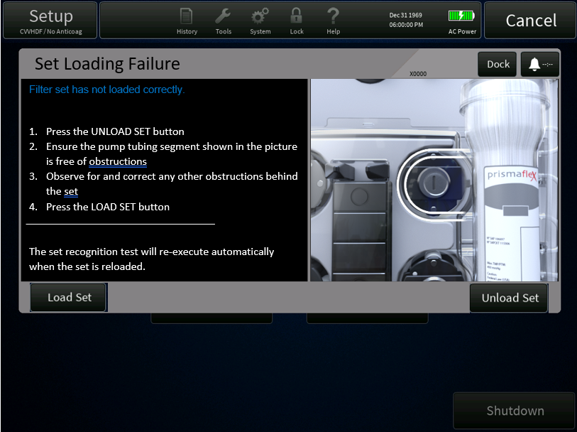

Figure 2 - Set Load Failure Alarm

#### Text/Image updates for Therapy Recovery and Manual Blood Return (PFAL-2287)

The current information displayed to the user when a system halt is encountered does not provide clear information about the therapy recovery feature. Additionally, the current manual blood return instructions to use the hand crank are vague and cause confusion to the operator.

The proposed change will consist of two parts:

1. The first one is to update the text and graphics on all alarms that halt the system and remove any instructions about performing a manual blood return.
   1. The title of the alarm will be changed to “System Failure” instead of “Call Service.”
   2. The instructions for therapy recovery will be updated to have the operator reboot the machine and attempt a therapy recovery if they are in the Treatment state. After the reboot they will be given instructions, in the B2222 alarm window, for manual blood return, if desired. *Refer to Figure 3*
   3. If a system halt occurs outside of the Treatment state, a variation of the alarm text will be displayed since the Therapy Recovery process cannot be initiated when not in Treatment. *Refer to Figure 4*

Below are the proposals for the updated alarm text:

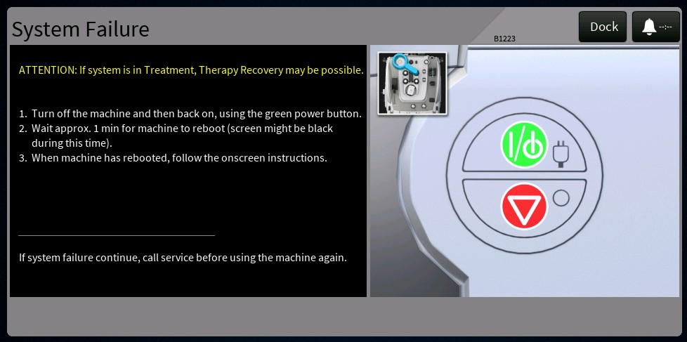

Figure 3 – System Halt Alarm text in Treatment

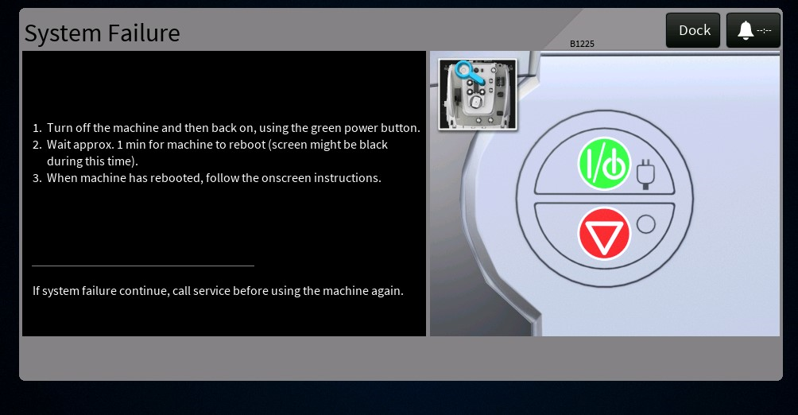

Figure 4 System Halt Alarm text not in Treatment

2) The second part of the change is to create a new dialog with detailed instructions on how to perform a manual blood return with the crank. The dialog will only be accessible from the B2222 alarm that is raised following an unexpected reset/ System Failure. The alarm title was updated as well to indicate a system reset occurred.

Refer to Figure 5 for the proposal for the B2222 alarm text and button updates:

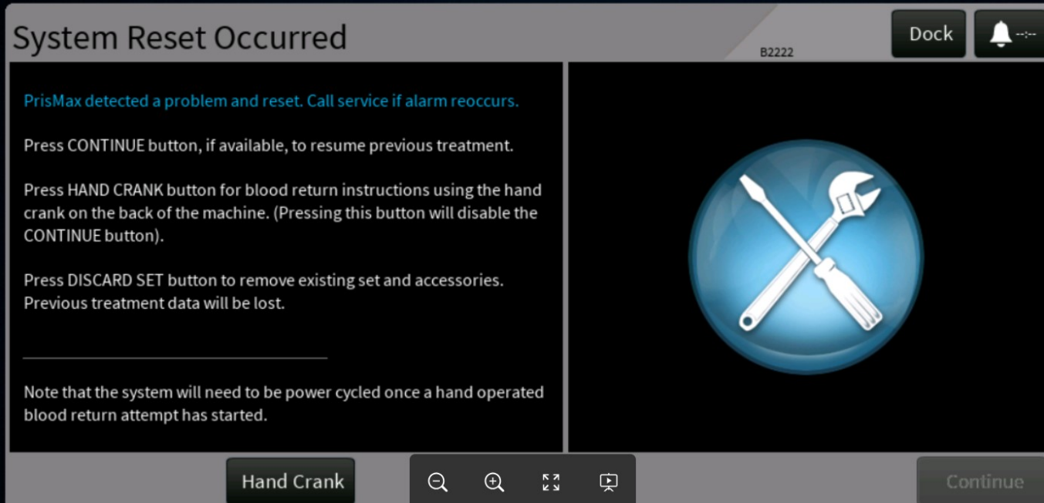

Figure 5 B2222 Alarm System Reset Occurred

Below is the proposal for the dialog containing the manual blood return instructions. Note that this will be a scrolling dialog, so all of it will not be viewable at once.

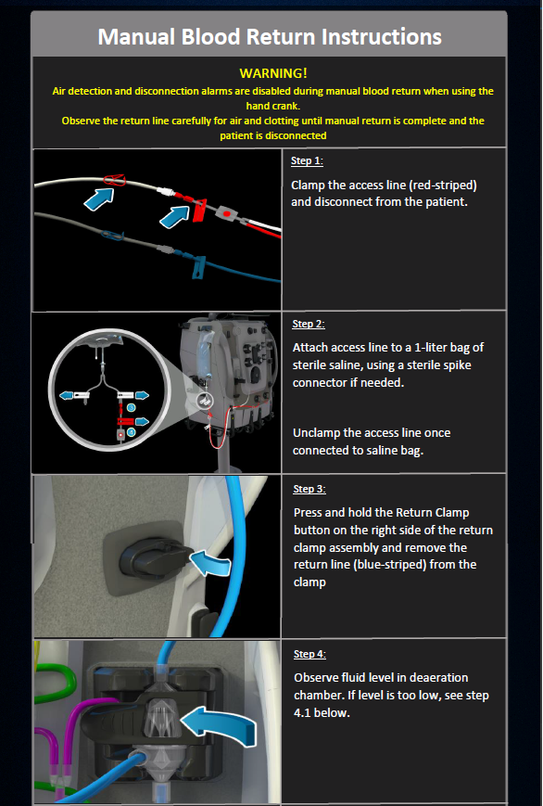

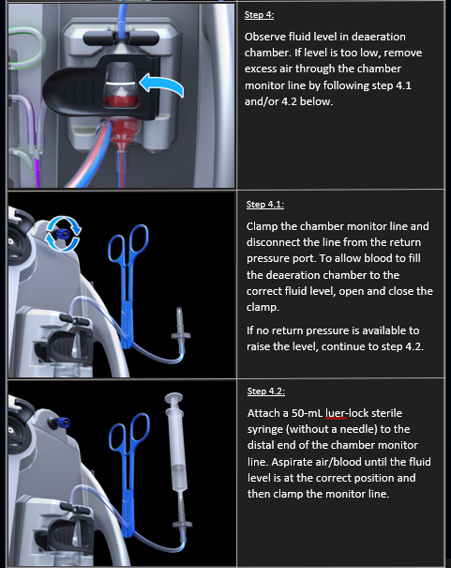

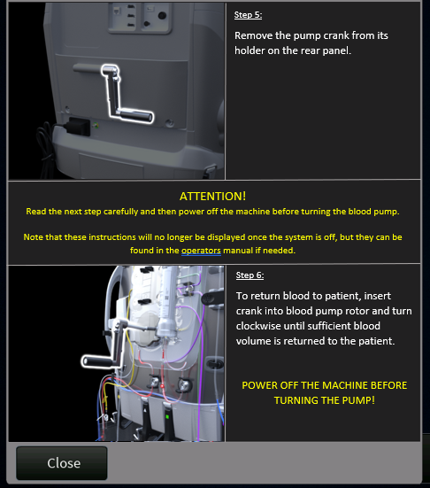

These modifications will be implemented by:

* Modifying the string content for all the “Call Service” alarms
* Introducing a variation of the Call Service alarm, for when system is not in treatment
* Modifying the string content for the B2222 alarm
  + Defining a new button action in the DOORS module and integrating this button on the B2222 alarm
* Creating a new dialog to provide clear instructions for performing a manual blood return with the pump crank
  + Create new strings and images for this dialog
* Updating the B2222 alarm handler to respond to the new button action press
  + Dock the B2222 alarm, raise the new dialog, disable the option to resume a treatment, if applicable

#### TPE priming updates to ensure air bubbles are removed from return line (PFAL-2281)

There have been numerous occurrences of air detection during priming when using TPE sets. During TPE priming, it has been observed that small “pockets” of micro-bubbles tend to “hang” in the return line. In other words, they don’t get flushed out of the return line or rise to the deaeration chamber. This is due to the force of buoyancy of the bubbles being equal to the force of the circulating liquid.

The priming sequence will be updated for TPE, to stop the effluent pump and allow additional time with only the blood pump running for any bubbles to be flushed out of the return line.

The proposed change will update the priming sequence to account for this phenomenon by increasing the duration of time that fluid is flowing through the return line. The blood pump volume processed will not change but allowing the blood pump to run longer (at a slightly reduced speed), while also stopping the effluent pump, will cause additional fluid to flow through the return line and the increased flow will push the bubbles out of the return line.

An additional change will be made to always use the open loop leveling sequence during priming instead of using the LLS signals. This choice was made due to issues discovered with the foam sensor when saline is present at the foam sensor.

This modification will be addressed by:

* Updating the priming algorithm in the model
* Updating the interaction of the higher-level software to enable air detection during priming once the model indicates it is the correct time to do so
  + Previously the higher-level software could enable air detection prematurely if the automatic level adjustment was interrupted before completing
* Update higher level SW to use the open loop commands from the priming model to adjust the liquid level at the end of priming
* Updating the Priming model input to add a signal indicating that a liquid level adjustment is ongoing

#### HPX labeling updates (PFAL-2275)

When performing an HP therapy using Adsorba cartridges, the system presents an advisory to the operator about using glucose solution for the first priming step and then using saline to rinse the set in the second priming step. This advisory is mistakenly shown when performing HPX treatments as well, even though these steps may not be applicable.

Additionally, the name of the HPX cartridge is populated by the user when defining an HPX therapy. However, this name is not displayed to the operator once in the treatment state.

The proposed change will remove the glucose advisory for HPX treatments that use a custom cartridge; and add the name of the HPX cartridge to the “Review Prescription” dialog.

These changes will be implemented by:

* Modifying the current markup text to remove the glucose advisory when Adsorba cartridges are selected
* Modifying the external markup to include the HPX cartridge name on the Review Prescription dialog and updating the code to display this information

Below is a proposal for the change to the Review Prescription dialog:

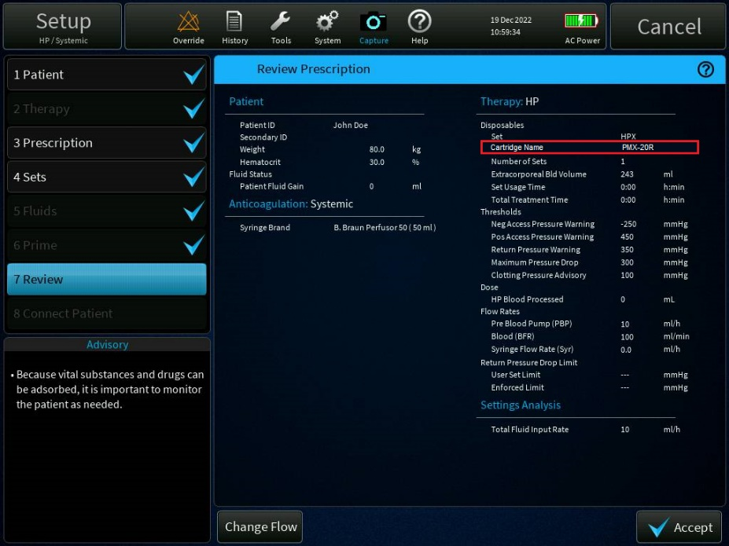

#### Bag mixing image update before priming (PFAL-2274)

The two compartment fluid bags that used a frangible pin for mixing are no longer produced. The current two compartment bags use a slightly different method for mixing. The proposed change will update the images that are shown when the operator is instructed to mix the bags. The proposed change is shown below:

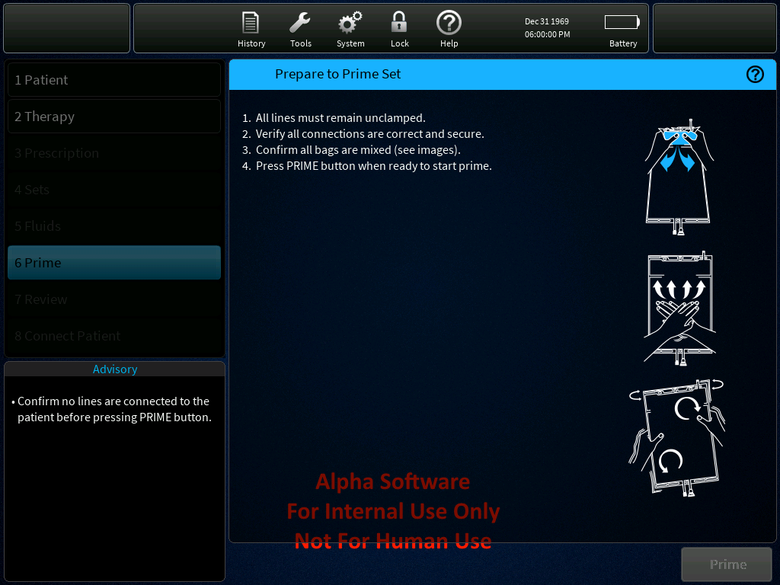

This change will be addressed by:

* Updating the image on the “Prepare to Prime Set” screen with the updated bag mixing instructions

#### Miscellaneous GUI labeling updates (PFAL-2273)

There are several imperfections with the GUI text and/or graphic images that are being addressed by this change. These include things such as removing inadvertent parentheses from text, switching the order of instructions on a screen, and updating alarm text and images of alarms that have been reported to cause confusion.

The proposed changes will address the following issues:

* Remove extra parentheses on the Prescription Dialog when CVVH with Post/Post replacement is used
* Update the text, title, override name, and image for the T1055 – Battery High Temperature alarm
  + This alarm is caused by a communication issue and not directly by high temperature, so the alarm will be updated to reflect that
  + Will also add more detailed instructions on possible ways to address the issue, such as removing AC power temporarily for 10 seconds
* Update the text, title, and image for the T1275 – Patient High Voltage alarm and the T2297 – TherMax High Voltage alarm
  + The text on these alarms indicate that the patient may be in contact with mains power have been reported to be unsettling to the operator and is not the likely cause of the issue
  + The alarms will be updated to indicate the cause was most likely from a temporary static discharge
  + Update the “Override” button on the T2297 alarm to say “Alarm Off”
* Change the order of steps on the “Prime Complete” screen to make adjusting the deaeration chamber be the first step, followed by performing a manual prime if needed

All these changes will be accomplished by updating existing strings and/or swapping an existing image with an updated version

#### German translations for “hours” vs. “time of day” (PFAL-2263)

The abbreviation for “hours” is interchangeable when describing the time of day vs. a duration in the English language. However, these have different meanings when translated to the German language, which can cause the operator confusion on whether the system is displaying a time of day or a duration.

This change will address a translation issue in German to make clear if a displayed time is referring to a time of day vs. duration.

This modification will be addressed by:

* Creating a new string that will be used to indicate “time of day” information
  + This would be translated to “Uhr” in German
* The existing string will be used to indicate a duration
  + This will be translated to “Std” in German

The identified updates are listed below:

* The System Configuration/Operations screen (700:2) will be updated to use new string SID_H_DUR instead of SID_H when used to show the Doses Begin Time and Chart Begin Time fields
* In addition, any screens that display "SID_H" will be impacted in German as the content will change from "Uhr." to "Std." This is the appropriate translation for the usage on these screens.
  + Main screen - axis label for the TMP and deltaP graph in lower right-hand corner
  + Other settings change screen - reminder intervals.
  + History screens (Temperature/Pressure/Flow Rates/Syringe) - indication of duration in graph title

#### Update SW to prevent T2300 TherMax bag inflation failures during priming (PFAL-2299)

The TherMax bag inflation sequence fails in the field when larger sets are used, and no PBP bag is attached to the system. This requires the operator to restart the priming sequence 1-2 times before it passes the test. Since there are no clear instructions to replenish the priming solution bag, when the reprime is initiated, this can lead to the solution being emptied without warning, causing air to be introduced into the set.

The TherMax disposable inflation sequence, done at the start of priming, consists of clamping the return line and running the blood pump until the return pressure reaches 250 mmHg. The test then determines if the pressure rises to the required level within a certain amount of time. The time is ascertained by when the system has pumped 200ml of fluid from the priming bag (typically enough time to complete the pressure rise test).

The inflation sequence fails because instead of computing the volume of priming fluid pumped during the sequence, the overall priming fluid volume pumped is considered. This means that less time is now available for the return pressure to rise.

The priming volume pumped depends on the blood pump flow AND on the PBP flow. When a PBP bag is hung, fluid is pumped from PBP bag into the access line, reducing the amount of priming fluid pumped, and allowing time for the return pressure to rise. When there is no PBP bag, the PBP pump is run backwards to pump fluid from the priming bag down the PBP line; which increases the amount of priming volume used before the inflation sequence starts, thus reducing the amount of time given for the return pressure to rise. When using larger sets, the fluid priming sequence pumps more fluid, further reducing the amount of time available for inflation sequence to run.

This change will update the model software to reduce failures of the TherMax bag inflation sequence, by:

* Computing the threshold by using the volume of priming fluid pumped during the sequence rather than the overall priming fluid pumped
* Update SID_ALARM_T2300_BODY to add a Note to check priming solution volume before restarting prime

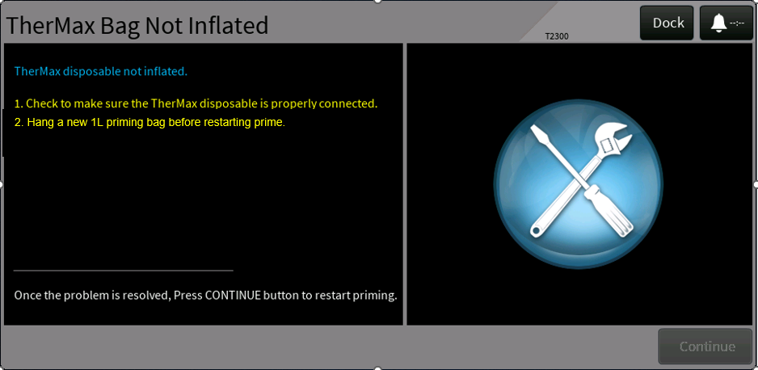

#### Improve reliability of the software in handling simultaneous bag changes (PFAL-2219)

Even though the operator’s manual indicates that operator should change bags one at a time, following the on-screen instructions, there is data to show that operators attempt to change multiple bags simultaneously. This currently causes system exceptions resulting in “Call Service” alarms, which forces the set to be replaced without the possibility of automatic return of patient blood.

When performing bag changes and either doing multiple changes simultaneously, or the operator is performing the changes very fast; the software can get into a state where it processes two different bag changes from the same notification. Shortly after, the 2nd notification is sent indicating a bag is changing, but since the SW has already “marked” that bag as being changed, it results in an invalid array index being accessed, which causes a system exception. This change will update the software to facilitate multiple bag changes more reliably, by doing the following:

* Ensure that when one bag change completes, the GUI is being properly communicated what bag is changing
* Make sure that the system recognizes/completes a bag change even though the state of "no bag" is not recognized

#### HP-X Auto leveling Priming update (PFAL-2288)

In certain cases, in HP/HPX priming, the auto leveling sequence will not initiate as expected. This is due to a state variable being re-initialized each time the system moves to the Initial state. The variable will be correctly coordinated the next time the return clamp changes positions, which means this issue will only occur in the priming state AND if the clamp does not close for any reason during the setup phase.

This change will move the initialization of the member variable so that it is only reset on construction. After construction, the variable will match the actual clamp position as it will be updated on each clamp change event. The modification will be addressed by:

* Updating the ARPS model controller’s clamp tracking variables to be initialized in the constructor instead of in the Initialize method

#### Improve HP-X Priming sequence when no PBP bag is used (PFAL-2288)

If multiple priming solutions are defined, solution 1 is typically Glucose (for Adsorba sets). When the PBP bag is NOT being used during priming, the PBP line is not filled using solution1, as it would be undesirable to leave the PBP line filled with glucose at the end of priming as this would end up being infused into the patient.

When priming with solution 2 (typically saline/heparin) starts, the PBP line is filled all the way down to the PBP bag connector, to allow for the operator to choose to hang a PBP bag when in treatment. Waiting to fill the PBP line until the 2nd solution could result in small amounts of air getting into the set and eventually into the cartridge.

This change will move the PBP line priming to the very beginning of the 1st priming cycle, same as when only one solution is used, to avoid air bubbles entering the HP cartridges during the 1st priming cycle.

The modification will be addressed by:

* Updating the priming algorithm to always prime the PBP line from the 1st solution when the filter set type is HPX
* Note that the priming model is already passed in the set information, and it will be "Adsorba (15 or 16)" for HP and "HPX filter (17)" for HPX

#### Update Data Sampling Rate to Match EMR Transmission Rate (PFAL-2267)

The EMR transmission rate can be configured on the PrisMax system to output the EMR data periodically at a rate between 5 and 60 seconds. However, some of the data that is sent through the EMR message is only refreshed every 20, 30, or 60 seconds. So even though a message can be sent as quickly as once every 5 seconds, the data in that message will remain “stale” for up to 1 minute.

This change will ensure the data is updated at least as quickly as the configured EMR rate. Even though the data is refreshed more often, the frequency that the data will be logged will remain the same as before. In other words, this will only impact the EMR sampling and not the log sampling. The modification will be addressed by:

* Adding a new method to update the applicable data at least once every 5 seconds.
* Remove data updates from the other periodic methods and instead only have those methods set the dictionary item that indicates the data should be written to the log

#### Sustained High Return Pressure Causes a BIOT (PFAL-2341)

The PrisMax system incorporates an internal test to detect whether the return line is attached to the barrier correctly. This is done to ensure that the system can safely monitor for return line disconnects. During this test, the ARPS pressure is raised above the return pressure briefly, the solenoid between the ARPS and Return pressure port is opened, and a very brief pressure spike is expected if the return line is properly attached. This is sometimes referred to as the “puff” test.

As part of this test, the return pressure may briefly spike above the return pressure limit, causing “false” return pressure high alarms. To account for this spike, the internal SW will not schedule a puff test unless the return pressure is below 300 mmHg.

Under normal conditions this “holdoff” threshold is fine since the return pressure will almost certainly dip below 300 mmHg briefly, even when running at the high end of the operating range (350 mmHg). However, an issue presented itself when using the PrisMax system within an ECMO circuit. Due to the higher “baseline” pressure at the access and return lines while connected to an ECMO circuit and the “filtering” effect the ECMO circuit has on the return pressure, it is possible the return pressure does not dip below 300 mmHg when running at the higher end of the operating range.

Since it could be a safety concern to run a treatment for an extended period without doing pod repositions/puff tests, the internal software has a check to halt the system if a reposition (or in this case a puff test) was scheduled to run for more than 30 minutes but never completes. Because of the soft limit to hold off execution of the puff test until the return pressure is below 300 mmHg, it is likely that this test will be scheduled but not executed within 30 minutes when running with some ECMO configurations. This then leads to an eventual system halt.

This change will remove the soft limit so that the test should always be executed shortly after it is scheduled. To prevent false positive return pressure alarms when the puff test occurs at higher return pressures, the definitions of the high return pressure alarms will be modified to account for this. The modification for this change will be addressed by:

* Removing the constraint to prevent the puff test from running until the return pressure is below 300 mmHg
* Modify the two different high return pressure alarm thresholds as follows:
  + If the return pressure operating point is above 300 mmHg then the alarm would raise when the return pressure was:
    - Above 375 mmHg for 2.0 seconds OR
    - Above 350 mmHg for 10.0 seconds
  + If the return pressure operating point is 300 mmHg or less, then the alarm thresholds would remain the same as they currently are
  + The recoverable alarm (T1164) will be cleared at the same thresholds as before
  + The non-recoverable alarm (T0526) will be cleared if the pressure has dropped below 350 mmHg for 2.0 seconds.
  + Both alarms will raise as they currently do if the unfiltered return pressure rises above 500 mmHg for 0.2 seconds

*Note: The configurable limits for HPX are unchanged by this change*

#### English XML Updates (PFAL-2297)

Potential improvements to the English (Master) XML file were identified as part of an internal analysis. A select group of those issues were resolved purely by making modifications to the XML file (strings content) in the DOORS database. See the change description in section 3.1.18 to see the full list of changes.

#### PrisMax Delivered dose is displayed incorrectly (PFAL-2510)

Though the actual delivered dose is correct, the delivered dose was incorrectly displayed on the history screen as well as the operation screen. The delivered dose is properly displayed until therapy completes 12 hr. At the 12 hr mark, the delivered dose displayed is half the value of the prescribed dose.

The correctness of the actual delivered dose can be confirmed from the Total Dose for the treatment.

The incorrectly displayed values can cause confusion to the operator. In summary:

* Calculated values for Last 24h volume and dose are displayed incorrectly. Last 24h Effluent volume and Dose values are displayed on Ops screen and History screen
* Daily chart volume and dose values are incorrect .
* PFR charting and displayed values are displayed correctly.
* Total volume values are accumulated correctly and displayed correctly

As a part of the fix for PFAL-2267, covered in this CADV, the periodicity of calling below functions was increased from 5 to 10 seconds.

* ProcesWeightData()
* ProcessPressureData()
* ProcessPeriodicLogData()
* ProcessDosePfrData()
* UpdateEMRDataBase()

The increased call to function ProcessDosePfrData() and UpdateEMRDataBase() has impacted the 24 hour sliding window and accumulated chart calculations. These listed functions fetch last 24 hour value or value from the beginning of chart period for the calculation of dose and volume. But due to increased call to UpdateEMRDataBase(), the EMR record buffer (EMRDataBaseRecord mRecords[]) holds only 12 hours of data and wraps after that. This resulted in the incorrectly displayed volume and dose at the 12 hour mark. As a part of this change:

* The data fetch refresh rate for all EMR parameters will be updated to 10 sec (In SW 3.3, the refresh rate is 30 sec for scales, 60 sec for periodic log and 10 sec for dose and pressure).
* No change to the calling frequency and order of ProcessDosePfrData() and UpdateEMRDataBase() .

### 2.1.3 Use Case Analysis

The following actors are common to several of the use case definitions:

* Operator – typically a nurse, who either initiates self-tests, performs manual adjustments of the liquid level, enables or disables automatic leveling, and responds to alarms raised by the monitor.
* Service Tech – Baxter trained technician for maintaining/troubleshooting/repairing machines

| **Name** | **Preconditions** | **Sequence** | **Variations** | **Expected Outcome** |
| --- | --- | --- | --- | --- |
| First PFR Period | System is in treatment and is currently in the 1st PFR charting period | Operator starts treatment within the 1st charting period and has some accumulated value for PFR | None | The "Current Period" on the Ops screen, the "Total" column on the PFR history chart, and the Total PFR output from EMR data should all be rounded to the nearest whole number and all 3 numbers should match at this point |
| Second PFR Period | System is in treatment and is currently in the 2nd PFR charting period | * Operator changes chart period to 1 hour (optional) * System is in the 2nd charting period and has some accumulated value for the current and previous PFR | Start a Same Patient treatment before the 3rd charting period starts | * The columns on the PFR history chart, and the Total PFR output from EMR data should all be rounded to the nearest whole number and should match * The sum of the "Current Period" and "Previous Period" displayed in Ops should add up to the Total PFR from above +/- 1 mL |

* PrisMax monitor – the PrisMax system, in particular the User Interface and components such as pumps, loaders, etc.

#### Ensure that displayed PFR total are all rounded to the same precision (PFAL-2266)

#### Allow previous treatment event data to be selected and viewed on the GUI (PFAL-2249)

| **Name** | **Preconditions** | **Sequence** | **Variations** | **Expected Outcome** |
| --- | --- | --- | --- | --- |
| Operator Attempts to Load History on New Patient Screen | System is on "Initial screen" with only "New Patient" button available (no option for Same Patient) | Operator navigates to History->Events screen | Initial Bootup; After a Treatment has been run | Operator can select "Select log file" button and successfully load the selected file |
| Operator Attempts to Load History in Service Mode | System is in Service Mode | Operator navigates to History->Events screen | None | Operator can select "Select log file" button and successfully load the selected file |
| Operator Attempts to Load History on Same Patient Screen | System is on the "Initial screen" with the "Same Patient" button available | Operator navigates to History->Events screen | None | Operator is NOT able to select "Select log file" button |
| Operator Attempts to Load History after Unexpected Reset | System just rebooted from an unexpected reset (B2222 alarm is active) | Operator navigates to History->Events screen | Resume Therapy Recovery | * Operator is NOT able to select "Select log file" button * Events are NOT loaded after resuming treatment |
| Operator Attempts to Load History after pressing "New Patient" | System is setup | Operator navigates to History->Events screen | Setup, Treatment, End modes | Operator is NOT able to select "Select log file" button |
| Operator Aborts the load operation | System is loading data from a previous log file | Operator presses the "Abort" button before the operation completes | None | System stops the operation and the event history will be cleared |
| Operator Attempts to Select Multiple Files | System is displaying the list of log files the Operator can restore | Operator attempts to check multiple files from the list | None | Operator can only select one file at a time |
| Operator Loads Different Logs Back-to-Back | Operator has successfully loaded the history from a log file | Operator attempts to load the history from a different log file | Load/Abort/Reload | System correctly updates the events to reflect the corresponding log file |
| Operator Filters List of Logs by Date | System is displaying the list of log files the Operator can restore | Operator selects option to filter the list of log files to choose from | Date/Time and Last X Months | Operator can successfully filter the list of logs |

#### Support reloading of filter set when “CRRT/TPE Wrong Set” alarm is raised (PFAL-2227)

| **Name** | **Preconditions** | **Sequence** | **Variations** | **Expected Outcome** |
| --- | --- | --- | --- | --- |
| Recognition test passes first time | System on "sets" step, set recognition test executing | Test completes with passed status | TPE and CRRT set | Fluids step is started |
| Recognition test fails, operator immediately cancels setup | System on "sets" step, set recognition test executing | Test completes with failed status, Set loading failure alarm is raised and operator selects CANCEL option | None | Setup is Cancelled |
| Recognition test fails, operator retries set loading | System displays Set Loading Failure, operator unloads and load set, set recognition automatically re-executes | Test completes with passed status | None | Fluids step is started |
| Recognition test fails, operator retries set loading | System displays Set Loading Failure, operator unloads and load set, set recognition automatically re-executes | Test completes with failed status, Wrong set detected alarm is raised and operator selects DISCARD SET option from alarm | TPE and CRRT set | System goes into END mode for operator to remove set. |
| Recognition test fails, operator retries set loading | System displays Set Loading Failure, operator unloads and load set, set recognition automatically re-executes | Test completes with failed status, Wrong set detected alarm is raised and operator selects RETRY action on alarm after checking lines etc. but not reloading the set | Test passes on second attempt and system moves to next step in setup; test fails again and alarm is redisplayed | Once RETRY is selected, test is re-executed with dialog showing that test is being run displayed |
| Recognition test (RETRY) fails, retries test after reloading | System on "sets" step, set recognition test has failed and alarm is displayed | After using UNLOAD/LOAD actions to reload set operator presses RETRY button | Operator presses CANCEL button, dialog is removed (alarm still displayed) and system goes into end mode for operator to remove set | RETRY button is disabled when set is unloaded and re-enabled once reloaded  Once RETRY selected alarm clears and test is executed (with test running dialog displayed) |
| Recognition test (RETRY) passes, retries test after reloading | System on "sets" step, set recognition test (RETRY) has passed after reloading | After using UNLOAD/LOAD actions to reload set operator presses RETRY button and test passes | None | Fluids Step is started |
| Reloading set after recognition (RETRY) test fails | System on "sets" step, set recognition test has failed and alarm is displayed, set currently pulled in | Operator selects UNLOAD button, after set fully unloads operator selects LOAD button | None | RETRY button is disabled when UNLOAD button is pressed, re-enabled when LOAD completes  LOAD button disables on operator select, re-enables (and stays enabled) once unloading is complete |
| Attempt to load set while set is already loaded | System on "sets" step, set recognition test has failed and alarm is displayed, set currently pulled in | Operator selects LOAD button | Attempt to unload set while it is unloaded - set remains pushed out but pumps will spin for 0.25 seconds | Set remains pulled in, but all pumps (low flow/blood pump) spin for 5 seconds. LOAD button is disabled and remains disabled until pumps stop |
| Change loader direction | System on “sets” step, set recognition test has failed and alarm is displayed, set currently pulled in | Operator selects UNLOAD button.  While set is unloading, operator selects LOAD button | Attempt to unload set while it is being loaded | Set starts unloading when UNLOAD button is pushed, UNLOAD button is disabled  Set stops unloading and starts loading when LOAD button is pushed, UNLOAD button enables and LOAD button disables.  When load sequence completes LOAD button is enabled |

#### Support updating product codes for filter sets in the field (PFAL-2218)

| **Name** | **Preconditions** | **Sequence** | **Variations** | **Expected Outcome** |
| --- | --- | --- | --- | --- |
| Production of machine | Monitor hardware assembled, about to perform software installation | Software installation occurs, no filter product codes table found in non-volatile memory | Updated filter product codes table imported after software installation is performed, replacing table newly created | Filter product codes table built from default values is present in system |
| Installation of the machine in field | Updated software already installed on machine | Service tech imports appropriate version of filter product codes table | Multiple barcode versions on USB | * Updated filter product codes tables loaded into system * If multiple barcode versions are on the USB, the latest version will be used * Correct version is displayed on the GUI under system configuration |
| Update of filter product codes table to machine in field | Software and "out of date" filter product codes tables installed in machine | Service tech imports appropriate version of filter product codes table | None | Updated filter product codes tables loaded into system |
| "Clean Install" of software performed | System in service mode, filter product codes table present | Service tech installs new software, selecting "sysconfig clean install" option | Service tech performs "Dirty Install", existing table is left untouched | Existing filter product codes table erased; new table created based on defaults in new software |
| Operator scans front barcode | System performing setup on the "load sets" step | Operator attempts to scan rear barcode and that fails, then scans front barcode | Operator scans front of set on first attempt without trying to scan rear set barcode | System determines the filter set type from barcode scan of front of set |
| Operator scans unknown barcode | System performing setup on the "load sets" step | Operator attempts to scan rear barcode and that fails, then scans front barcode - product code not in table | Operator gets new set, operator (after second failure) user GUI to manually enter set type | System sets the filter type to unspecified, fails scan |
| Failure to update filter product code table | System in service mode, on USB Import/Export menu | Operator attempts to load filter product code table from USB, load fails | USB device not mounted, no product codes file on device, product codes file not compatible with software, product codes table CRC doesn't match computed CRC. | Table not updated, error message provided |

#### Allow all users to update system time, and remove multiple time offsets (PFAL-2216)

| **Name** | **Preconditions** | **Sequence** | **Variations** | **Expected Outcome** |
| --- | --- | --- | --- | --- |
| Service technician updates time | System is in Service mode | Operator navigates to system config/date and time menu, updates system time | Operator cancels change, service tech is on various calibration/SST screens | System resets, displayed/logged time is updated |
| Nurse updates time | System is in Therapy mode, on the initial screen | Operator navigates to system config/date and time menu, updates system time | Operator cancels change | System resets, displayed/logged time is updated |
| Nurse updates time (same patient) | System is in Therapy mode, on the initial screen but after ending the previous treatment with same patient set | Operator navigates to system config/date and time menu, updates system time | Operator cancels change - same patient option remains enabled | System resets, displayed/logged time is updated, after reset same patient option is disabled |
| Nurse updates time (in treatment) | System is in Therapy mode, but no longer on the initial screen (either new or same patient has been selected) | Operator navigates to system config menu, attempts to go to date/time menu | None | Operator cannot enter date and time menu |
| Nurse updates Date/Time format | System is in Therapy mode, on the initial screen | Operator navigates to system config/date and time menu, updates the date/time format but NOT the system time | None | Date/Time format is updated and the machine is NOT reset |

#### Text updates for Therapy Recovery and Manual Blood Return (PFAL-2287)

| **Name** | **Preconditions** | **Sequence** | **Variations** | **Expected Outcome** |
| --- | --- | --- | --- | --- |
| System Halt, Initiate Therapy Recovery | System is in Treatment with no active alarms | An alarm that halts the system is raised and the operator proceeds to power cycle the machine | None | Alarm B2222 alarm is raised after the reboot with options to Continue, Discard Set, or View Manual Return Instructions |
| B2222 Alarm Options | System has just booted from an unexpected reset in treatment | B2222 alarm is active and displays instructions to the operator | Continue, Discard Set, Manual Return | Treatment is resumed when the operator presses the "Continue" button  Operator is instructed how to tear down the system when the "Discard Set" button is pressed  Operator is shown detailed instructions for attempting a manual blood return when the "Manual Return" button is pressed |
| Manual Return Instructions | System has just booted from an unexpected reset in treatment | Operator selects the "Manual Return" option from alarm B2222 | Close the dialog and look at the B2222 alarm again | * A dialog with detailed manual blood return instructions is displayed * The "Continue" button is disabled on the B2222 alarm if the operator has selected the "Hand Crank" option |
| Manual Return Instructions, blood return with system on | System has just booted from an unexpected reset in treatment and is displaying the Manual Blood Return instructions | Operator follows all on screen instructions | Don't shut down the machine per the instructions on step 6 | Instructions are adequate to return blood to the patient.  System alarms when the operator begins spinning the blood pump manually |
| System Halt NOT in Treatment | System is in Setup | An alarm that halts the system is raised | Other Therapy State | Alarm is raised and instructions do NOT instruct the user to initiate a therapy recovery |

#### TPE priming updates to ensure air bubbles are removed from return line (PFAL-2281)

| **Name** | **Preconditions** | **Sequence** | **Variations** | **Expected Outcome** |
| --- | --- | --- | --- | --- |
| TPE Priming Complete | System is in priming state with a TPE set | System completes the priming sequence | TPE1000 and 2000 sets; | Priming completes successfully and the liquid level is in the chamber |
| TPE Priming Air | System is in priming state with a TPE set | Operator injects air into return line once air detection is turned on | None | Air in Blood alarm is raised and priming is stopped |
| CRRT Priming Complete | System is in priming state with a CRRT set | System completes the priming sequence | None | Priming completes successfully and the liquid level is in the chamber |
| CRRT Priming Air | System is in priming state with a CRRT set | Operator injects air into return line once air detection is turned on | None | Air in Blood alarm is raised and priming is stopped |

#### HPX labeling updates (PFAL-2275)

| **Name** | **Preconditions** | **Sequence** | **Variations** | **Expected Outcome** |
| --- | --- | --- | --- | --- |
| HPX Treatment Glucose Advisory | System is in the setup state with an HPX treatment configuration | Operator sets up the system and completes priming | None | There is no advisory or warning to the operator about using Glucose based solutions |
| HPX Cartridge Name | User is in Treatment with HPX therapy config | User views the prescription dialog | CRRT | * Name of the HPX cartridge is displayed to the user when using HPX therapy * There is no line to display a cartridge name on the dialog when using CRRT therapy |

#### Bag mixing image update before priming (PFAL-2274)

| **Name** | **Preconditions** | **Sequence** | **Variations** | **Expected Outcome** |
| --- | --- | --- | --- | --- |
| Operator Mixes Bag(s) Before Priming | System is on the "Prepare to Prime Set" screen | Operator is instructed to mix any 2 compartment bags before beginning priming | None | Operator is able successfully mix the bag by following the instructions on the UI |

#### Miscellaneous GUI labeling updates (PFAL-2273)

| **Name** | **Preconditions** | **Sequence** | **Variations** | **Expected Outcome** |
| --- | --- | --- | --- | --- |
| CVVH; Post/Post; Systemic; Review Prescription Screen | System is setup with a CVVH+Systemic therapy config and is in the Attach Patient State | Operator set the Replacement Configuration to Post/Post on the Prescription panel and then navigates back to the Review Prescription panel | CVVH+Cit/Cal | Replacement and Replacement 2 show (Post) configuration with no extra parenthesis |
| Battery Connection Problem | System is on "New Patient" screen with no alarms active | PSC detects a battery connection problem (see ALM test 2809 to induce this with Engineering mode) | Override the alarm | * Alarm is raised and title and text match the expected * Alarm message in message center displays the correct text * Override in override list matches the expected text * Alarm graphic matches the expected |
| Static Discharge Alarm | System is in Treatment | Eng mode is used to raise the T1275 alarm | None | * Alarm is raised and title and text match the expected * Alarm message in message center displays the correct text * Alarm graphic matches the expected |
| TherMax Static Discharge Alarm | System is in Treatment with a TherMax | Eng mode is used to raise the T2297 alarm | Override the alarm | * Alarm is raised and title and text match the expected * Alarm override button says "Alarm Off" * Alarm message in message center displays the correct text * Alarm graphic matches the expected * Override in override list matches the expected text |
| Prime Complete Instructions | System has just completed priming and is on the "Prime Complete" screen | Operator follows the instructions on the screen | None | Operator is instructed to adjust the fluid level before being instructed to do a manual prime |

#### German translations for “hours” vs. “time of day” (PFAL-2263)

| **Name** | **Preconditions** | **Sequence** | **Variations** | **Expected Outcome** |
| --- | --- | --- | --- | --- |
| Operator updates settings | System on initial screen | Operator navigates to the SysConf/Display/Operations Screen | None | The Chart Begin Time and Doses Begin Time field labels use the new string, other fields use the old string for the abbreviation of "hour" |
| Operator views other screens | N/A | Operator navigates to the Operations screen, history screens, prescriptions/other setting screens | None | Current string is used for abbrevation of "hour" |

#### Update software to prevent T2300 TherMax bag inflation failure (PFAL-2299)

| **Name** | **Preconditions** | **Sequence** | **Variations** | **Expected Outcome** |
| --- | --- | --- | --- | --- |
| Operator starts a treatment with TherMax, a large set and no PBP bag | * Treatment with a large set like HF1400 and no PBP bag * PBP flow rate is set to 0 ml/hr * Priming bag of 1000ml is hung on the system | Operator sets up a treatment with TherMax and system proceeds to priming | Treatment with TPE, HP-X or other CRRT set | Priming completes successfully without T2300 alarm |
| Operator starts a treatment with TherMax, with large set with PBP bag | * System is in Setup with the PBP flow rate of 100 and a bag on the PBP scale. | Operator sets up a treatment with TherMax and system proceeds to priming | Treatment with TPE, HP-X or other CRRT set | The TherMax bag inflation test passes successfully during the fluid priming step |
| Operator starts a priming operation with TherMax, without the return line placed in the clamp | * Treatment with any CRRT set * PBP flow rate is set to 0 ml/hr | Operator sets up a treatment with TherMax and system proceeds to priming  Operator insert a “dummy line” into return clamp to bypass real line | Treatment with TPE, HP-X or other CRRT set | Priming is halted due to occurrence of T2300 alarm.  The T2300 alarm window alerts the operator to hang a new priming before continuing with prime |

#### Handling simultaneous bag changes (PFAL-2219)

| **Name** | **Preconditions** | **Sequence** | **Variations** | **Expected Outcome** |
| --- | --- | --- | --- | --- |
| Operator starts a CVVHDF treatment with no AE set | All the bags applicable for CVVHDF is hung on the system with only enough fluid for treatment to be paused for a bag change in about 30 minutes | * Operator setups a treatment and allows treatment to continue for up to 30 minutes * PrisMax displays a bag change alarm for all relevant bags * Operator opens all the scales that need a bag change in quick succession | N/A | All scales are open and no system exception occurs (Typically B0916 alarm)  Sequential bag changes are successfully completed |
| Operator starts a CVVHDF treatment with AE set | All the bags applicable for CVVHDF is hung on the system with only enough fluid for treatment to be paused for a bag change in about 30 minutes | * Operator setups a treatment and allows treatment to continue for up to 30 minutes * PrisMax displays a bag change alarm for all relevant bags * Operator opens all the scales that need a bag change in quick succession along with Drain scale | N/A | All scales are open and no system exception occurs (Typically B0916 alarm)  Sequential bag changes are successfully completed  Drain scale is closed with no AE set change being performed |

#### HPX Auto-Leveling Priming Update (PFAL-2288)

| **Name** | **Preconditions** | **Sequence** | **Variations** | **Expected Outcome** |
| --- | --- | --- | --- | --- |
| 2nd HPX Priming in Power Cycle | System has previously completed HPX priming and has started a new HPX setup | * User sets up HPX and ensures no alarm is raised that closes the clamp | N/A | Auto-Leveling sequence executes and the liquid level is at the desired level at the end of priming |

#### Improve HP Priming sequence when no PBP bag is used (PFAL-2288)

| **Name** | **Preconditions** | **Sequence** | **Variations** | **Expected Outcome** |
| --- | --- | --- | --- | --- |
| HPX with no PBP (at least 2 solutions defined) | No PBP bag is used and PBP flow rate is 0ml/hr | * Operator navigates to the Sys Config/ Containers and Solutions/ HP-X settings and configures Solution 1 and 2 * Starts priming | * 1. 500 mL solution1 and 2,   2. 1000 mL solution1, and 2   3. 3 solutions with 500 mL each | Priming begins and the PBP line is filled with Solution 1 |
| HPX with PBP | PBP bag is used with a PBP flow rate of 100ml/hr | * Operator navigates to the Sys Config/ Containers and Solutions/ HP-X settings and configures Solution 1 and Solution 2 * Starts priming | N/A | Priming begins and the PBP line is filled from the PBP bag |

#### Update Data Sampling Rate to match EMR Transmission Rate (PFAL-2267)

| **Name** | **Preconditions** | **Sequence** | **Variations** | **Expected Outcome** |
| --- | --- | --- | --- | --- |
| EMR Updating at least once every 5 seconds | System is configured for data output (either a DCM module or serial cable, depending on the variation) and the EMR refresh rate is set to 5 seconds in system configuration | * User navigates into treatment | * 1. Legacy EMR output (with DCM and with serial output)   2. EMR output rate to 10 seconds | A new EMR message is sent at least once every 5 seconds and the applicable parameters are refreshed as expected.  -*Should pick at least one item from each group of data to make sure they are being refreshed as expected: DB_ACCESS_PRESSURE, DB_BLOOD_VOL, DB_TOT_VOL_REMOVED* |
| EMR Output Captures Alarm Data within 5 seconds | System is configured with a DCM module or a serial cable depending on the variation, and the EMR refresh rate is set to 5 seconds in system configuration | * User is in treatment and raises an alarm | 1. Legacy EMR output | The alarm ID and alarm state data in the EMR message is updated to reflect the alarm state within 5 seconds of it raising |
| Therapy Data Logged every 10 or 60 seconds | System is configured with a DCM module and the EMR refresh rate is set to 5 seconds in system configuration | * User runs a treatment and then ends it after 10 minutes | None | The therapy data in the log.db file should be logged once every 60 seconds. The pressure and dose data should be logged every 10 seconds |

#### Sustained High Return Pressure Causes a BIOT (PFAL-2341)

| **Name** | **Preconditions** | **Sequence** | **Variations** | **Expected Outcome** |
| --- | --- | --- | --- | --- |
| Self Clearing Alarm Threshold 1 | System is running treatment and no return pressure alarm has been raised for at least 2 minutes | * Operator increases return pressure above 350 mmHg but less than 375 mmHg | 1. Reduce Pressure below 325 within 30 seconds  2. Leave Pressure above 350 mmHg for at least 30 seconds | Alarm T1164 is raised when the return pressure is > 350 mmHg for 2 seconds  Var1: Alarm is cleared and treatment continues  Var2: Alarm is cleared but T0526 raises and treatment remains stopped |
| Self Clearing Alarm Threshold 2 | System is running treatment and no return pressure alarm has been raised for at least 2 minutes | * Operator increases return pressure above 500 mmHg | None | Alarm T1164 is raised when the return pressure is > 500 mmHg for 0.2 seconds |
| Latching Alarm Threshold 1 Op Pt. < 300 mmHg | System is running treatment with a return operating point < 300 mmHg and alarm T1164 or T0526 has been raised and cleared within the last 120 seconds | * Operator increases return pressure above 350 mmHg but less than 375 mmHg | None | Alarm T0526 is raised when the return pressure is > 350 mmHg for 2 seconds Continue button becomes enabled when the pressure decays below 350 mmHg |
| Latching Alarm Threshold 2 Op Pt. < 300 mmHg | System is running treatment with a return operating point < 300 mmHg and alarm T1164 or T0526 has been raised and cleared within the last 120 seconds | * Operator increases return pressure above 375 mmHg but less than 500 mmHg | None | Alarm T0526 is raised when the return pressure is > 350 mmHg for 2 seconds Continue button becomes enabled when the pressure decays below 350 mmHg |
| Latching Alarm Threshold 1 Op Pt. >300 mmHg | System is running treatment with a return operating point > 300 mmHg but less than 340 mmHg and alarm T1164 or T0526 has been raised and cleared within the last 120 seconds | * Operator increases return pressure above 350 mmHg but less than 375 mmHg | None | Alarm T0526 is raised when the return pressure is > 350 mmHg for 10 seconds Continue button becomes enabled when the pressure decays below 350 mmHg |
| Latching Alarm Threshold 2 Op Pt. >300 mmHg | System is running treatment with a return operating point > 300 mmHg but less than 340 mmHg and alarm T1164 or T0526 has been raised and cleared within the last 120 seconds | * Operator increases return pressure above 375 mmHg but less than 500 mmHg | None | Alarm T0526 is raised when the return pressure is 375 mmHg for 2 seconds  Continue button becomes enabled when the pressure decays below 350 mmHg |
| Latching Alarm Non Filtered Threshold | System is running treatment and alarm T1164 or T0526 has been raised and cleared within the last 120 seconds | * Operator increases return pressure above 500 mmHg | Op point above/below 300 mmHg | Alarm T0526 is raised when the return pressure is 500 mmHg for 0.2 seconds  Continue button becomes enabled when the pressure decays below 350 mmHg |
| HPX Regression 1 Alarm | System is running an HPX treatment with a return pressure high threshold of 200 mmHg | * Operator increases return pressure above 200 mmHg but below 500 mmHg | T1164/T0526 | T1164 or T0526 is raised when the return pressure exceeds 200 mmHg for 2 seconds |
| HPX Regression 2 Alarm | System is running an HPX treatment with a return pressure high threshold of 200 mmHg | * Operator increases return pressure above 500 mmHg | T1164/T0526 | T1164 or T0526 is raised when the return pressure exceeds 500 mmHg for 0.2 seconds |

#### English XML Updates (PFAL-2297)

There are no use cases for this change as it is purely a text update to already existing strings.

#### PrisMax Delivered dose is displayed incorrectly (PFAL-2510)

Refer to attachment “Usecases_PFAL_2510_IncorrectDoseDisplaywithTestIDmapped” in PFAL-2510

### 2.1.4 Human Factors Analysis

Some of the proposed changes are for the clinical user facing GUI and as such will be subject to the human factors engineering process.

Planned human factors activities include an analysis of the UMFMEA to determine the risk level of this item, formative evaluation, and summative evaluation if determined to be applicable based on risk. See HFP8002 [R8] Human Factors Plan for more information. Each individual PFAL was analyzed independently and the results for each of those will be described in an attachment in subsequent revisions.

### 2.1.5 Risk Analysis

All modifications described in this CADV report will either decrease risk or not affect the risk of harm to the patient. There is no identified increase in risk or new hazards being introduced.

In the review of risk documentation, it was identified that there are 2 types of updates required to the risk file documentation.

* The first includes changes such as new and modified risk controls along with their traces created to address changes introduced with CADV8135.
* The other includes updates to the current version of the risk file to include existing risk controls that were previously captured in legacy risk file documents but were not fully captured in the current risk file. These updates are not connected to changes for SW3.4 and strictly for continuous improvement of the RACT8000 document. See PFAL-2416 for additional detail.

The HSHA-AE-THERAPIES [R9] was reviewed for Hazard relevant to the modifications described in this CADV report. Applicable hazard definitions are outlined in Table 1. These hazard definitions are carried into the RACT8000 [R1] where they are further defined with sequence of event descriptions and applicable risk control measures that demonstrate how the risks of each hazard are being mitigated.

*Note: There are no changes to Hazard definitions, Risk control measures or dFMEA items associated with PFAL-2249, PFAL-2266, PFAL-2263, PFAL-2216, and PFAL-2273.*

**Table 1 Related Hazard Definitions**

|  |  |  |  |  |
| --- | --- | --- | --- | --- |
| **HS #** | **Hazard** | **Hazardous Situation** | **Harms** | **Relevant PFAL** |
| HS.AET.5.1 | Delay in Therapy | Patient experiences a delay in the initiation of therapy (> 1 hour < 12 hours) | Varies from no harm to life-threatening volume overload, inadequate solute, acid and/or electrolyte imbalance which may result in death | PFAL-2227  PFAL-2218  PFAL-2281  PFAL-2299 |
| HS.AET.20.1 | Mechanical, Thermal, Chemical stress | Patient is exposed to damaged blood or blood products. | Varies from no harm to hemolysis which can lead to anemia, back pain, hyper or hypotension, shortness of breath or death | PFAL-2227  PFAL-2275 |
| HS.AET.18.1 | Interruption of Therapy | Patient experiences an interruption of therapy (> 1 hour < 12 hours) | Varies from no harm to life-threatening volume overload, inadequate solute, acid and/or electrolyte imbalance which may result in death | PFAL-2287  PFAL-2275  PFAL-2273  PFAL-2274  PFAL-2307 |
| HS.AET.6.3 | Electrical, Thermal, Electromechanical Energy | End user is exposed to electrostatic discharge | Varies from no harm to a noticeable shock or burn | PFAL-2273 |
| HS.AET.1.1 | Air or Gas in System | Air or gas is administered to the patient (> 0 mL / kg to < 0.1mL / kg or > 0 mL / minute / kg to < 0.03 mL / minute / kg) | Varies from no harm to chest pain, shortness of breath, anxiety, restlessness, decreased oxygenation, hypotension, respiratory distress, myocardial ischemia, arrhythmias, focal neurological defects, seizures, cardiopulmonary arrest or death | PFAL-2274  PFAL-2307  PFAL-2281  PFAL-2299 |
| HS.AET.14.1 | Incorrect Product | Patient is exposed to an incorrect product | Drug dependent: Varies from no harm to life-threatening electrolyte and acid-base imbalance; bleeding; life threatening event or death | PFAL-2274 |
| HS.AET.16.2 | Insufficient Therapy | Patient receives less therapy than intended (adequacy of dose during CRRT) | Varies from no harm to dizziness, sweating, nausea, vomiting, weakness, fatigue, drowsiness, hunger, confusion, blurred vision, depression, lethargy, stupor, muscle cramping, tremors, paresthesia, deep tendon reflex loss, tetany, metabolic acidosis, dysphagia, bronchospasm, laryngospasm, hypotension, muscle necrosis, paralysis, seizures, CNS depression, , neuromuscular irritability, hyperventilation, respiratory depression, hypoxemia, respiratory arrest, tachycardia, cardiac arrhythmia, cardis arrest, coma, and death. | PFAL-2274 |
| HS.AET.10.1 | Excessive Therapy | Patient receives more therapy than intended (net fluid removal) | Varies from no harm to restlessness, anxiety, cramping, hypotension, volume depletion, syncope, cardiac arrhythmia, or death | PFAL-2227  PFAL-2218  PFAL-2510 |
| HS.AET.16.3 | Insufficient Therapy | Patient receives less therapy than intended (net plasma gain) | Varies from no harm to hypertension, shortness of breath, life-threatening volume overload, or death | PFAL-2227  PFAL-2218 |
| HS.AET.10.5 | Excessive Therapy | Patient Receives more therapy than intended | Varies from electrolyte and acid base imbalance; increased bleeding, cardiac arrhythmia, hemorrhage or death | PFAL-2275 |
| HS.AET.3.1 | Bodily Fluid Loss | Patient experiences bodily fluid loss (> 0% to <= 15% of their total blood volume) | Varies from no reaction to anxiety, tachycardia, hypotension, tachypnea, confusion, hypovolemic shock, cardiopulmonary arrest or death | PFAL-2307 |
| HS.AET.10.3 | Excessive Therapy | Patient receives more therapy than intended (regional citrate) | Varies from electrolyte and acid base imbalance; increased bleeding, cardiac arrhythmia, hemorrhage or death | PFAL-2510 |
| HS.AET.10.4 | Excessive Therapy | Patient receives more therapy than intended (systemic heparin) | Varies from no harm to bruising, minor bleeding, gastrointestinal or intracranial hemorrhage, excessive bleeding leading to death | PFAL-2510 |

### 2.1.6 Risk Mitigation Analysis

Risk control measures form current and legacy risk documentation were assessed for relevance.

* Relevant risk control measures from RACT8000 [R1] are identified in **Table 2**.
* Risk control measures deemed no longer applicable to the system as a result of the changes outlined herein are shown in **Table 3**
* New risk control measures created as a result of the changes outlined herein are shown in **Table 4**

**Table 2 Related Risk Control Measures**

| **RCM ID** | **Risk Control Measure** | **Relevant PFAL** |
| --- | --- | --- |
| RCM-1782 | Information for safety requires the following actions to be confirmed in specific screens:  a) Syringe bolus administration in run mode.  b) Flow rate setting for patient fluid removal in run mode.  c) Confirmation of adequacy between loaded set and selected therapy.  d) Manual set selection following bar code reading failure.  e) Confirmation of clamped lines prior to unloading the disposable set. | PFAL-2218 |
| RCM-1739 | Software performs an automatically recognition test to detect TPE or CRRT disposable set. Protective action is taken if mismatch with bar code label or Operator’s therapy input is detected. | PFAL-2227  PFAL-2218 |
| RCM-1741 | Software reads the disposable set bar code label and takes protective action if a mismatch with bar code label or Operator’s set selection is detected. The Operator is prompted to confirm or correct the selected disposable set if the bar code label scan does not match with the selection. | PFAL-2218  PFAL-2227 |
| RCM-1743 | Software requests the Operator to confirm the selected disposable set prior to the start of and change of set during the therapy. | PFAL-2227  PFAL-2218 |
| RCM-1748 | Software identifies and verifies entered disposable set by reading the bar code. Protective actions are taken if bar code is unreadable, or the disposable set differs from the entered or is incorrect for the treatment. | PFAL-2218  PFAL-2227 |
| RCM-1780 | Information for safety instructs the Operator to periodically check on the patient, and to check patient's blood chemistry. | PFAL-2274 |
| RCM-1841 | In the case of air detected, Software brings the device to a safe state according to specification. | PFAL-2274  PFAL-2299 |
| RCM-1733 | Software monitors the actual weight change for each scale and compares measurement with the expected weight change over a specified period of time. Protective action is taken if the difference is greater than specified tolerance. Protective action is also taken if the difference error occurs repeatedly outside of specification. | PFAL-2274 |
| RCM-1852 | Information for safety reminds the Operator to prevent air from entering the blood circuit after priming is started. | PFAL-2274 |
| RCM-1840 | Software monitors the Air Bubble Detector (ABD) sensor status and takes protective action if air in blood is detected during specified modes. | PFAL-2274  PFAL-2281  PFAL-2299 |
| RCM-2921 | Information for safety displays the selected HP cartridge ID during priming and treatment. | PFAL-2275 |
| RCM-3110 | Software allows recovery from a short period of downtime. Applicability and limitation according to specification(s). | PFAL-2287 |
| RCM-3109 | GUI informs the operator when previous treatment was unexpectedly or unintentionally terminated | PFAL-2287 |
| RCM-1770 | Software automatically executes priming operation that is customized for the loaded disposable set to provide adequate priming and rinsing volume. | PFAL-2281 |
| RCM-1906 | Information for safety reminds the Operator to visual check for air in set before patient connection. | PFAL-2281 |
| RCM-2570 | The Protective System performs BIOT (Built In Ongoing Tests) to ensure tasks run as scheduled and complete as scheduled. System brought to safe state if tasks do not run as scheduled. | PFAL-2341 |

**Table 3 Risk Control Measures to be deleted**

The following RCM is to be deleted as bags with frangible pins are no longer manufactured.

| **ID** | **Proposed Text** | **Relevant PFAL** | **Risk ID** |
| --- | --- | --- | --- |
| RCM-1909 | Information for safety instructs to break the frangible pin at bag outlet when using Luer connection to solution bag. | PFAL-2274 | PMX-RACT-126  PMX-RACT-128 |

**Table 4 New Risk Control Measures**

|  |  |  |  |
| --- | --- | --- | --- |
| **ID** | **Proposed Text** | **Relevant PFAL** | **Risk ID** |
| RCM-3217 | Information for safety reminds to correctly break the internal membrane between the two compartments and to mix the contents of the two compartments well before use. | PFAL-2274 | PMX-RACT-778  PMX-RACT-779  PMX-RACT-780 |
| RCM-3295 | Software computes and correctly displays the Prescribed and delivered dose in the specified screens | PFAL-2510 | |  | | --- | | PMX-RACT-501 | | PMX-RACT-503 | | PMX-RACT-504 | |
| RCM-3296 | Software computes and correctly displays the cumulative fluid volumes in the specified screens | PFAL-2510 | |  | | --- | | PMX-RACT-501 | | PMX-RACT-503 | | PMX-RACT-504 | |

**Table 5 FMEA8000 updates**

|  |  |  |  |  |  |  |  |  |
| --- | --- | --- | --- | --- | --- | --- | --- | --- |
| **Item - Part #** | **Item** | **Function** | **PrisMax Version** | **Assembly** | **Failure Mode** | **Cause** | **End Effect** | **Risk Reduction** |
| SW | Malfunction | Control the system and allow it to run therapy | V2  V3 | NA | SW bugs or malfunctions | SW Bug | Compromised Pressure Monitoring | RCMs implemented in RACT |
| SW | Malfunction | Control the system and allow it to run therapy | V2  V3 | NA | SW bugs or malfunctions | SW Bug | No Blood Leak Detection | RCMs implemented in RACT |
| SW | Malfunction | Control the system and allow it to run therapy | V2  V3 | NA | SW bugs or malfunctions | SW Bug | Unsealed Fluid Path | RCMs implemented in RACT |
| *CP SW | Incorrect data or lack of integrity | Display therapy information to user | V3 | NA | Incorrect calculation of Dose and PFR charting | SW Bug | Malfunctioning software | RCMs implemented in RACT  RCM-3295  RCM-3296 |

* This dFMEA update relates to a new dFMEA ID : DFMEA-PRSMX-SW-3215.

For PFAL-2510, FMEA8000 rev Y was reviewed for the discrepancy between the displayed values of prescribed dose and delivered dose for Effluent dose (Eff). The failure modes listed in the below table are related to this issue.

|  |  |  |  |  |  |  |  |  |  |
| --- | --- | --- | --- | --- | --- | --- | --- | --- | --- |
| **ID** | **Item - Part #** | **Item** | **Failure Mode** | **Cause** | **End Effect** | **Severity** | **Occurrence Rank** | **Detection** | **Priority Number** |
| DFMEA-PRSMX-SW-3155 | CP SW | Unavailable Data or incorrect timing of data | Old or incorrect data used in calculations | SW bug or HW malfunction | Malfunctioning software | 5 | 1 | 1 | 5 |
| DFMEA-PRSMX-SW-3157 | CP SW | Incorrect data or lack of integrity | Old or incorrect data used in calculations | SW bug | Malfunctioning software | 5 | 1 | 1 | 5 |
| DFMEA-PRSMX-SW-3190 | CP SW | Patient Data Management | Erroneous data | SW bug or HW failure | Malfunctioning software | 5 | 1 | 3 | 15 |

### 2.1.6 Product Requirement Analysis

There are no modifications or new requirements added to the TRS8001 [R3]. The related Therapy requirements are listed in **Table 6**

**Table 6 Related Therapy Requirement Specifications**

| **TRS ID** | **Therapy Requirements Specification** | **Relevant PFAL** |
| --- | --- | --- |
| TRS-130 | The PrisMax system shall be able to record and display the history of the current treatment over a period of at least 96 hours, including the following data (if applicable for the selected therapy):  -       Prescription settings  -       Anticoagulation settings  -       Events (including alarms)  -       Pressures  -       Patient fluid removal/Patient plasma loss volumes  -       Fluid volumes  -       Doses  -       Temperatures  -       Blood processed volume | PFAL-2249  PFAL-2510 |
| TRS-233 | The PrisMax system shall automatically define operating ranges, for the prescription parameters (incl. default, minimum and maximum values) and the pressure alarm limits, based on the selected therapy and disposable set. | PFAL-2341 |
| TRS-58 | The PrisMax system shall allow the user to configure hemoperfusion devices with the necessary parameters for priming and operating range (blood flow and pressures) | PFAL-2341 |
| TRS-94 | The PrisMax system shall for all supported therapies monitor access, filter and return pressures for blood circuit obstruction and disconnection conditions. | PFAL-2341 |

There are no modifications or new requirements added to the ICD800. The related requirements are listed in **Table 7**

**Table 7** **Interface Control Document Specifications**

| **ICD ID** | **ICD Specification** | **Relevant PFAL** |
| --- | --- | --- |
| ICD-2819 | Max positive access pressure warning limit shall be +450mmHg  Max positive return pressure warning limit shall be +350mmHg | PFAL-2341 |

There are no modified or new Customer requirements for CRS8001[R2]. The related customer requirements are listed in **Table 8**

**Table 8** **Related Customer Requirement Specifications**

| **CRS ID** | **Customer Requirements Specification** | **Relevant PFAL** |
| --- | --- | --- |
| CRS-135 | PrisMax shall provide the capability to allow the user to adjust the date, time and date format, only in system configuration. | PFAL-2216 |
| CRS-10 | PrisMax shall disallow therapy if the selected disposable set is not properly installed | PFAL-2227 |
| CRS-35 | PrisMax shall provide the capability of determining the type of installed disposable set using the barcode scanner. | PFAL-2227 |
| CRS-280 | If air is detected in the blood set after completion of the priming process, users shall always have option to flush the set to remove residual air or to repeat the priming process. | PFAL-2281 |
| CRS-11 | PrisMax shall present appropriate alarms and provide the user guidance on how to resolve | PFAL-2287 |
| CRS-292 | PrisMax shall allow the user to choose to safely restart and continue from the previous treatment screen after a recovery.  Note: This should cover >80% of anticipated system failure occurrences based on field data. | PFAL-2287 |
| CRS-13 | PrisMax shall detect blood and air leakage events in associated disposables. | PFAL-2299 |
| CRS-1 | PrisMax shall monitor patient connections and take appropriate steps if an undesired state is detected | PFAL-2341 |
| CRS-219 | PrisMax shall provide the option, when selected in service mode, to output the PrisMax native status message to all connected data systems in near real time (creation in <5 seconds and unbuffered). | PFAL-2267 |
| CRS-156 | PrisMax shall provide the capability to allow the user to view on the GUI the treatment history data for the current and previous set without power cycling the machine. This includes treatment history for pressures, events, patient fluid removal, and accumulated fluid volumes. | PFAL-2510 |
| CRS-143 | PrisMax shall provide the capability to display the prescribed dose and delivered dose. | PFAL-2510 |
| CRS-124 | PrisMax system shall provide feedback about treatment and patient status to the user. This feedback should include notification of treatment end, display of treatment parameters, therapy event log, review of treatment data after therapy, treatment data storage, and data transmission. | PFAL-2510 |

### 2.1.7 System Requirement Analysis

The tables below list the additional changes in the DOORS modules to support the modifications described by this document. These requirements have not been released however the proposed changes are captured in baseline 10.2 of the Eos/Requirements/System/PRD8002 DOORS module.

* Additions and Modifications to the Product Requirements Document PRD8002 [R4] are defined in **Table 9** and **Table 10** including the rationale for the change.
* The Product Requirements PRD8002 [R4] related to the changes in this document, are listed in **Table 11**
* There were no deleted PRD requirements for the scope of this CADV

**Table 9 - Modified PRD Requirements**

| **ID** | **Original Text** | **Proposed Text** | **Relevant PFAL** | **Out-links** | **Rationale** |
| --- | --- | --- | --- | --- | --- |
| PRD-2980 | **4 Features/Capabilities** | N/A |  |  |  |
| PRD-195 | **4.5 Safety** | N/A |  |  |  |
| PRD-676 | **4.5.1 Alarms** | N/A |  |  |  |
| PRD-3711 | **4.5.1.5 System Alarms** | N/A |  |  |  |
| PRD-3752 | Before loading the set, the device shall perform an automatic recognition test. The dialysate pump is run; check of pressure increase in circuit allows software to diagnose for TPE or CRRT set loaded. | After loading the set, the device shall perform an automatic recognition test. The dialysate pump is run; check of pressure increase in circuit allows software to diagnose if TPE or CRRT set is loaded. | PFAL-2227 | CRS-4  RCM-1739 | The automatic recognition test is run after loading the set, not before. |
| PRD-4832 | **4.7 GUI** | N/A |  |  |  |
| PRD-3652 | **4.7.2 GUI labeling** | N/A |  |  |  |
| PRD-3669 | Provisions shall be made for manual return of blood by turning pump, if necessary. On malfunction screens, instructions shall be provided (assuming screen works after malfunction). | Provisions shall be made for manual return of blood by turning pump, if necessary. After an unexpected reset, instructions shall be provided (assuming screen works after reset). | PFAL-2287 | CRS-9  RCM-1798 | Instructions are available on the B2222 screen after a reset |
| PRD-4801 | **7 Qualities/Attributes** | N/A |  |  |  |
| PRD-4823 | **7.2 Performance** | N/A |  |  |  |
| PRD-585 | **7.2.1 Performance Characteristics, Limits, and Tolerances** | N/A |  |  |  |
| PRD-3285 | **7.2.1.11 Code Reader** | N/A |  |  |  |

|  |  |  |  |  |  |
| --- | --- | --- | --- | --- | --- |
| PRD-2068 | The Monitor shall identify bar codes on the disposable sets according to bar code format 128 per the specification for the circuit set. | The Monitor shall identify product codes on the disposable sets according to bar code format 128 per the specification for the circuit set.  *This allows the monitor to determine the filter set type* | PFAL-2218 | CRS-5  CRS-10  TRS-40  TRS-215  ICD-993  ICD-3168 | Clarify what the ability to interpret the barcode is used for. |
| PRD-2452 | **7.7 Labeling** | N/A |  |  |  |
| PRD-1222 | **7.7.4 User Manual** | N/A |  |  |  |
| PRD-2670 | **7.7.4.2 Setup** | N/A |  |  |  |
| PRD-3637 | Labeling shall instruct the Operator to correctly break the frangible pin between the two compartments and to mix the contents of the two compartments well before use. | Labeling shall instruct the Operator to correctly break the internal membrane between the two compartments and to mix the contents of the two compartments well before use. | PFAL-2274 | RCM-1903 | No longer manufacture bags with the frangible pin |
| PRD-2442 | **7.8 Mechanical and Electrical** | N/A |  |  |  |
| PRD-4828 | **7.8.1 Components** | N/A |  |  |  |
| PRD-1027 | **7.8.1.19 Battery Pack** | N/A |  |  |  |
| PRD-4213 | The Monitor shall be able to detect if the battery temperature outside the nominal operating range and alert the user. | The system shall be able to detect if the monitor is unable to communicate with the battery and alert the user | PFAL-2273 | RCM-2356 | Update to match new alarm title |

**Table 10 - New PRD Requirements**

| **ID** | **Original Text** | **Proposed Text** | **Relevant PFAL** | **Out-links** | **Rationale** |
| --- | --- | --- | --- | --- | --- |
| PRD-2980 | **4 Features/Capabilities** | N/A |  |  |  |
| PRD-4835 | **4.8 Data** | N/A |  |  |  |
| PRD-4837 | **4.8.2 System Logs** | N/A |  |  |  |
| PRD-4958 | N/A | The Monitor shall provide the operator the ability to view event data from a selected previous treatment session. | PFAL-2249 | TRS-130 | Allow service tech or operator ability to view past treatment data |
| PRD-4801 | **7 Qualities/Attributes** | N/A |  |  |  |
| PRD-4823 | **7.2 Performance** | N/A |  |  |  |
| PRD-585 | **7.2.1 Performance Characteristics, Limits, and Tolerances** | N/A |  |  |  |
| PRD-3285 | **7.2.1.11 Code Reader** | N/A |  |  |  |
| PRD-4957 | N/A | The monitor shall support importing the product code information for each filter set type.  *Note: The product code information is stored in a downloadable file (.ess) and is updated/installed in service mode* | PFAL-2218 | CRS-180 | Adds ability to support updating the product code information outside of a software release cycle |

**Table 11 Related Product Requirement Specifications**

| **ID** | **Product Requirements Document - Monitor** | **Relevant PFAL** | **Out-links** |
| --- | --- | --- | --- |
| PRD-4803 | **3 General** |  |  |
| PRD-4806 | **3.3 Architectural description** |  |  |
| PRD-1799 | **3.3.1 Monitor Modes** |  |  |
| PRD-3394 | **3.3.1.4 Prime Mode** |  |  |
| PRD-1720 | The Monitor shall ignore the detection of air by the ABD during priming.  *Note: Exception for an air detection check at the end of priming.* | PFAL-2281 | CRS-12  CRS-280 |
| PRD-1747 | **3.3.1.5 Therapy Mode** |  |  |
| PRD-3522 | The Monitor shall monitor system pressures and take protective actions if they fall outside a pre-determined range. | PFAL-2341 | CRS-278  RCM-1711  RCM-1787  RCM-1790 |
| PRD-2980 | **4 Features/Capabilities** |  |  |
| PRD-1818 | **4.1 Therapies** |  |  |
| PRD-1828 | **4.1.3 Hemoperfusion (HP and HP-X)** |  |  |
| PRD-4107 | In HP Therapy: the pressure limits for access extremely negative, access and return extremely positive, and filter clotting/clotted alarms for each custom HP-X cartridge shall be specified by the user in system configuration prior to availability for use. | PFAL-2341 | CRS-1  CRS-11  CRS-301  CRS-303  TRS-58  TRS-342  TRS-344  ICD-3472  ICD-3545 |
| PRD-3850 | In HP Therapy: GUI shall display the selected HP cartridge ID during priming and treatment. | PFAL-2275 | RCM-2921 |
| PRD-195 | **4.5 Safety** |  |  |
| PRD-676 | **4.5.1 Alarms** |  |  |
| PRD-3711 | **4.5.1.5 System Alarms** |  |  |
| PRD-3878 | The Monitor shall take protective action if the return pressure increases above the maximum threshold for safe operation. | PFAL-2341 | 132  RCM-1787  ICD-2819 |
| PRD-3925 | During treatment, the Monitor shall attempt to automatically resume operation when the return pressure decreases below the maximum threshold for safe operation. | PFAL-2341 | RCM-1787 |
| PRD-3896 | The software shall alarm if the return pressure rises too high above the set operating point. | PFAL-2341 | CRS-11  RCM-1787 |
| PRD-4832 | **4.7 GUI** |  |  |
| PRD-4834 | **4.7.3 Toolbar - System Configuration** |  |  |
| PRD-3008 | The Monitor shall provide the capability for users to modify the configuration settings of the system, including default settings. | PFAL-2267  PFAL-2216 | CRS-135  CRS-136  CRS-209 |
| PRD-4835 | **4.8 Data** |  |  |
| PRD-4837 | **4.8.2 System Logs** |  |  |
| PRD-4172 | The Monitor shall record the following treatment data at least once per minute.  - treatment data: pressure, scale, pump, event, trend, dose and volume data | PFAL-2267 | CRS-227  TRS-130 |
| PRD-2661 | The Monitor shall log the occurrence and identity of all alarms and events, including (as appropriate):  - Time and date of occurrence  - Associated alarm limits  - Alarm signal inactivation states  - Technical alarm conditions | PFAL-2249 | 84  722  773  64  77  12655  12725  TRS-130 |
| PRD-4810 | **5 Disposables** |  |  |
| PRD-2065 | The Monitor shall be able to determine the type of loaded disposable set.  *Note: This is done by code scan and prime testing.* | PFAL-2218 | CRS-4  CRS-5  CRS-10  CRS-18 |
| PRD-1810 | The Monitor shall support 2 compartment solution bags and 1 compartment solution bags. | PFAL-2274 | CRS-242 |
| PRD-4802 | **6 Accessories** |  |  |
| PRD-4815 | **6.3 Connectivity/Data Handling** |  |  |
| PRD-3150 | **6.3.1 IT Connectivity** |  |  |
| PRD-3307 | The Monitor shall output EMR data per the AW8081 Communications Guide. | PFAL-2267  PFAL-2510 | CRS-216  CRS-220  TRS-237 |
| PRD-4786 | The Monitor shall output data per the AW8048 Communications Guide. | PFAL-2267 |  |
| PRD-4801 | **7 Qualities/Attributes** |  |  |
| PRD-2425 | **7.3 Human Factors** |  |  |
| PRD-4838 | **7.3.1 Information Portrayal** |  |  |
| PRD-1942 | The Monitor shall provide the capability to display ***cumulative fluid volumes*** for the following:  - Effluent  - Dialysate solution  - Pre-Blood solution  - Replacement solution  - Syringe solution  - Patient Fluid Removed (PFR) | PFAL-2266 | CRS-156 |
| PRD-1944 | The Monitor shall provide the capability to display the value of the actual Patient Fluid Removal (PFR) Gain/Loss during treatment. | PFAL-2266 | CRS-156 |
| PRD-4842 | **7.3.5 GUI Specifications** |  |  |
| PRD-3368 | The Monitor shall display the following information in CRRT:  · Access Pressure (mmHg) - pressure exerted by the withdrawal flow on the access line  · Return Pressure (mmHg) - pressure exerted by the return flow on the return line  · TMP (mmHg) - transmembrane pressure, pressure drop exerted by convective flow across membrane fibers  · Delta-P (mmHg) - pressure difference between filter inlet and outlet pressure  · Effluent Pressure (mmHg) - pressure exerted by the effluent pump  · Filter Pressure (mmHg) - pressure at the filter inlet  · Post-filter Hct (%) - hematocrit at filter outlet (after fluid removal, before replacement fluid is added)  · Prescribed and Delivered Dose (ml/kg/hr) - averaged normalized fluid exchange rate in terms of patient weight over the set dose period of time  · Current and Previous PFR (ml) - total patient fluid removal over the set period of time |  | CRS-1 |
| PRD-2452 | **7.7 Labeling** |  |  |
| PRD-1222 | **7.7.4 User Manual** |  |  |
| PRD-2671 | **7.7.4.3 Therapies** |  |  |
| PRD-1264 | Labeling shall include the statement:  In MANUAL mode, the disconnection and air detection alarms are disabled. The user is responsible for monitoring the return line. | PFAL-2281 | CRS-12 |
| PRD-2442 | **7.8 Mechanical and Electrical** |  |  |
| PRD-4828 | **7.8.1 Components** |  |  |
| PRD-2510 | **7.8.1.5 Weight Scales** |  |  |
| PRD-2216 | The monitor shall provide the capability to use the following bags:  - 5 liter and 9-liter PrisMax standard effluent bags for SCUF/CVVH/CVVHD/CVVHDF/TPE  - Baxter 2 compartment fluid bags  - Baxter 1 compartment fluid bags | PFAL-2274 | CRS-72  TRS-215  TRS-224  TRS-225  TRS-228  TRS-302 |
| PRD-2255 | The Monitor shall be able to present cumulated fluid volumes for the current charting period in the treatment history. | PFAL-2510 | TRS-130 |
| PRD-2346 | The Monitor shall provide the capability to display the **prescribed dose**and **delivered dose**. | PFAL-2510 | TRS-130  CRS-143 |
| PRD-3368 | The Monitor shall display the following information in CRRT:   * Access Pressure (mmHg) - pressure exerted by the withdrawal flow on the access line * Return Pressure (mmHg) - pressure exerted by the return flow on the return line * TMP (mmHg) - transmembrane pressure, pressure drop exerted by convective flow across membrane fibers * Delta-P (mmHg) - pressure difference between filter inlet and outlet pressure * •     Effluent Pressure (mmHg) - pressure exerted by the effluent pump * • Filter Pressure (mmHg) - pressure at the filter inlet * • Post-filter Hct (%) - hematocrit at filter outlet (after fluid removal, before replacement fluid is added) * Prescribed and Delivered Dose (ml/kg/hr) - averaged normalized fluid exchange rate in terms of patient weight over the set dose time period * •          Current and Previous PFR (ml) - total patient fluid removal over the set time period | PFAL-2510 | CRS-1 |
| PRD-1942 | The Monitor shall provide the capability to display cumulative fluid volumes for the following:  - Effluent  - Dialysate solution  - Pre-Blood solution  - Replacement solution  - Syringe solution  - Patient Fluid Removed (PFR) | PFAL-2510 | CRS-156 |
| PRD-1861 | The Monitor shall be able to record, export and display the following types of data for at least 96 hours of treatment:  - Event History per set  - Treatment time duration per patient  - Patient History: used sets and CRRT dose per patient  - Prescription changes  - Anticoagulation changes  - Temperatures | PFAL-2510 | TRS-130  TRS-132  CRS-124  CRS-156  CRS-213 |

## 2.2 Sub-System Requirements Analysis (CA2)

### 2.2.1 Hardware Requirement Analysis

There are no changes to the PrisMax hardware or hardware requirements introduced by this CADV.

### 2.2.2 Software Requirement Analysis

* Additions/ Modifications to the Software Requirements in Software Requirements Specifications SRS8001 [R5] are listed in Table 16 and Table 17.
* The Software requirements related to the changes in this document, from Software Requirements Specifications SRS8001 [R5] is listed in Table 18
* There were no deleted SRS requirements for the scope of this CADV

**Table 12 - Modified SRS Requirements**

| **ID** | **Original Text** | **Proposed Text** | **Relevant PFAL** | **Out-links** | **Rationale** |
| --- | --- | --- | --- | --- | --- |
| SRS-7550 | **3 Components** |  |  |  |  |
| SRS-7555 | **3.5 Pressure Sensors** |  |  |  |  |
| SRS-7845 | **3.5.3 Return Pressure Sensor** |  |  |  |  |
| SRS-8017 | **3.5.3.1 Return Pressure Sensor Alarms / Messages** |  |  |  |  |
| SRS-7854 | The software shall generate an alarm for high return pressure as follows:   * Alarm is raised exceeds the threshold for safe operation. * The alarm priority is LOW for initial occurrence in treatment, and HIGH for sustained occurrence in treatment or any occurrence in blood return. * The automatic reaction is to stop all pumps and clamp the return line. * The alarm is cleared either by the return pressure dropping to a safe level; or by operator action. | The software shall generate an alarm for high return pressure as follows:  ⦁ Alarm is raised if the return pressure exceeds the threshold for safe operation.  ⦁ A LOW priority alarm is raised for initial occurrence in treatment; A HIGH priority alarm is raised for a sustained occurrence in treatment or any occurrence in blood return.  ⦁ The automatic reaction is to stop all pumps for the LOW priority alarm.  ⦁ The automatic reaction is to stop all pumps and clamp the return line for the HIGH priority alarm.  ⦁ The LOW priority alarm is cleared by the return pressure dropping to a safe level  ⦁ The HIGH priority alarm is cleared by the operator action. | PFAL-2341 | PRD-3522  PRD-3745  PRD-3878  PRD-3896 |  |
| SRS-7557 | **3.7 Liquid Level Sensor (LLS)** |  |  |  |  |
| SRS-1234 | In Prime mode, software shall automatically adjust the fluid level in the deaeration chamber at the conclusion of the fluid prime step. | In Prime mode, software shall automatically adjust the fluid level in the deaeration chamber before the end of the fluid prime step. | PFAL-2281 | PRD-1968 |  |
| SRS-7231 | Software shall monitor the liquid level in the deaeration chamber if the automatic leveling is enabled during Prime, Therapy , End (blood return), or Recirculation modes. | Software shall monitor the liquid level in the deaeration chamber if the automatic leveling is enabled during Therapy, End (blood return), or Recirculation (including a flush after recirc) modes. | PFAL-2281 | PRD-2314 | Use open loop leveling algorithm in priming to reduce amount of air in prime alarms |
| SRS-8011 | **3.21 Battery** |  |  |  |  |
| SRS-8107 | The software shall generate an alarm for battery temperature overtemperature as follows:   * Alarm is generated when is not communicating and the monitor hardware indicates that the battery is present. * Alarm is cleared when battery resumes communications or upon operator override. * The alarm priority is MEDIUM. | The software shall generate an alarm for battery charge unknown as follows:   * Alarm is generated when battery is not communicating, and the monitor hardware indicates that the battery is present. * Alarm is cleared when battery resumes communications or upon operator override. * The alarm priority is MEDIUM. | PFAL-2273 | PRD-4213 |  |
| SRS-7566 | **4 Control Processor (CP)** |  |  |  |  |
| SRS-7569 | **4.3 Modes of Operation** |  |  |  |  |
| SRS-7572 | **4.3.2 Setup** |  |  |  |  |
|  | **4.3.2.4 Sets** |  |  |  |  |
| SRS-9779 | **4.3.2.4.3 CRRT vs. TPE Set Recognition Test** |  | PFAL-2227 |  |  |
| SRS-8162 | The software shall generate an alarm if a CRRT set is loaded when a TPE therapy is selected, or a TPE set is loaded when a CRRT therapy is selected, as follows:  Alarm is raised during setup if the return pressure fails to react as expected when the dialysate pump is rotated.  The alarm priority is INFO.  The automatic reaction is to stop priming.  The alarm is cleared upon user acknowledgment.  If user clears alarm, then the CRRT/TPE test is re-run. | The software shall generate an alarm if a CRRT set is loaded when a TPE therapy is selected, or a TPE set is loaded when a CRRT therapy is selected, as follows:   * Alarm is raised during setup if the return pressure fails to react as expected when the dialysate pump is rotated. * The alarm priority is INFO. * The alarm is cleared when user commands retest   *Note: The alarm is raised after the Set loading failure alarm has been triggered once* | PFAL-2227 | PRD-2065  PRD-3752 |  |
| SRS-7671 | **4.3.2.6 Prime Set** |  |  |  |  |
| SRS-7682 | **4.3.2.6.1 Prime** |  |  |  |  |
| SRS-1235 | Software ignores the detection of air during Prime Mode (until the end). | After enabling air detection, during the fluid priming step, software shall ensure that a minimum of twice the volume from the end of the return line to the Air Bubble Detector (ABD) is effectively processed. | PFAL-2281 |  |  |
| SRS-6826 | If the software fails any of the tests during prime (or reprime), the current priming step shall be stopped, and restarted when the alarm is cleared. Restarted means that the entire priming step is executed, as opposed to resuming execution from the point that the step stopped. | If the software fails any of the tests during prime, the current priming step (pre-prime, fluid prime, post-prime) shall be executed as follows:  - If alarm is cleared by pressing the Continue button, priming shall be restarted from the beginning of that priming step  - If the alarm is cleared by pressing the Reprime button, priming shall be restarted from the beginning of fluid priming | PFAL-2299 | PRD-1971 |  |
| SRS-6359 | **4.3.8 System Reset** |  |  |  |  |
| SRS-9616 | The software shall generate an alarm upon reset after an unexpected shutdown as follows:   * Alarm is raised if the previous session was terminated due to an unexpected shutdown. * The alarm priority is HIGH. * The automatic reaction is to stop all pumps and clamp the return line. * Alarm is cleared by the user choosing to either discard the set, or to resume the previous session.   The option to resume the session is only enabled under specific circumstances, as defined in the section <<SECT:9626>>. | The software shall generate an alarm upon reset after an unexpected shutdown as follows:   * Alarm is raised if the previous session was terminated due to an unexpected shutdown. * The alarm priority is HIGH. * The automatic reaction is to stop all pumps and clamp the return line. * Alarm is cleared by the user choosing to either discard the set, resume the previous session, or manually shutting down the machine.   *The option to resume the session is only enabled under specific circumstances, as defined in the section <<SECT:9626>>.* | PFAL-2287 | PRD-4225 |  |
| SRS-9615 | **4.3.8.2 Therapy Recovery from System Failure** |  |  |  |  |
| SRS-9626 | After an unexpected shutdown the operator choice to resume the previous session shall be enabled if the following conditions are true:  System was in the treatment state.  The system safe state was Nominal before being set to System Halt.  The system shutdown record was recovered.  Less than ten minutes have expired from the blood pump stopping to the resumption of treatment.  The error in fluid balances was within acceptable limits.  There were no previous recovery attempts in the previous power cycle.  There were no system configuration changes before the operator resumed the treatment session. | After an unexpected shutdown the operator choice to resume the previous session shall be enabled if the following conditions are true:   * System was in the treatment state. * The system safe state was Nominal before being set to System Halt. * An Auto Effluent Set change was not being performed at the time of the malfunction * The system shutdown record was recovered. * Less than ten minutes have expired from the blood pump stopping to the resumption of treatment. * The error in fluid balances was within acceptable limits. * There were no previous recovery attempts in the previous power cycle. * There were no system configuration changes before the operator resumed the treatment session. * The button to display manual blood return instructions has NOT been pressed. | PFAL-2287  8138 | PRD-4710 |  |
| SRS-7598 | **4.8 Display Requirements** |  |  |  |  |
| SRS-7610 | **4.8.5 Toolbar** |  |  |  |  |
| SRS-7713 | **4.8.5.1 Therapy Mode Button** |  |  |  |  |
| SRS-5616 | Software shall display the following prescription item name and corresponding unit. Every item shall be displayed without using scrolling when either the upper left-hand toolbar button is pressed, or the user views the History Prescription screen.  Patient:  - Patient ID  - Secondary ID   - Weight, kg  - Hematocrit, %  - Fluid Status:  - Patient Fluid Gain, ml (only TPE and HP)  - Gain/Loss Limit, ml/3h (only CRRT)  - Current Gain/Loss, ml/3h (only CRRT)  - Current Makeup Value, ml (only CRRT)  Anticoagulation:  - Anticoagulation type selected  - Syringe Brand/Size(ml)  - Dialysate Solution (only RCA and CVVHD/CVVHDF)  - Citrate:  - Citrate Dose, mmol/L B (only RCA)   - Citrate Solution (only RCA)  - Citrate Bag Volume, ml (only RCA)  - Estimated Patient Citrate Load, mmol/h (only RCA)  - Estimated Patient normalized Net Buffer Load, mmol/h/kg (only RCA)   - Patient Citrate Rate, ml/kg/h (only RCA)  - Calcium  - Calcium compensation, % (only RCA/Syringe)  - Calcium Solution (only RCA/Syringe)  - Replacement Solution (only RCA)  - Estimated Patient Calcium Rate, mmol/h (only RCA/Syringe)  - Est. Cal Lost to Eff (only CRRT RCA/External Pump)  Therapy  - Therapy Type  - Disposables  - Set being used  - Number of Sets  - AE Set being used (only AE)  - AE Set Time, h:min (only AE)  - Extracorporeal Bld Volume, ml  - Circuit Set Time, h:min  - Treatment Time, h:min  - Thresholds  - Neg Access Pressure Warning, mmHg (only HP)  - Pos Access Pressure Warning, mmHg (only HP)  - Return Pressure Warning, mmHg (only HP)  - Maximum Pressure Drop, mmHg (only HP)  - Clotting Pressure Advisory, mmHg (only HP)  - Dose  - Effluent Dose, mL/kg/h (only CRRT and Dose Measurement set to Effluent)  - Ultrafiltration Dose, mL/kg/h (only CRRT and Dose Measurement set to Ultrafiltration)  - Total Exchange Volume, mL (only TPE)  - Plasma Volume Exchanged (only TPE)  - TPE Duration, h:min (only TPE)  - HP Blood Processed, mL or L (only HP)  - Flow Rates  - Pre Blood, mL/h  - Blood, mL/min  - Syringe, mL/h  - Dialysate, mL/h (only CVVHD and CVVHDF)  - Replacement, mL/h (only CVVH, CVVHDF and TPE)  - Replacement 2, mL/h (only CVVH)  - Patient Fluid Removal, mL/h (only CRRT)  - Patient Plasma Loss, mL/h (only TPE)  - Effluent flow, mL/h (only CRRT and TPE)  - Total Replacement, mL/h (only CVVH)  - Pre/Post %, % (only CVVH)  - Return Pressure Drop Limit  - User Set Limit, mmHg   - Enforced Limit, mmHg  Setting Analysis:  - Target Effluent, mL (only TPE)  - Target Patient Plasma Loss, mL (only TPE)  - Total Fluid Input Rate, mL/h (only TPE and HP)  - Patient Plasma Volume, mL (only TPE)  - Total Predilution, % (only CRRT)  - Post filter Hematocrit, % (only CRRT and TPE)  - Filtration Fraction % (only CRRT and TPE)  Blood Warmer: - Type - Prescription Return Temperature (or disabled) (only TherMax) | Software shall display the following prescription item name and corresponding unit. Every item shall be displayed without using scrolling when either the upper left-hand toolbar button is pressed, or the user views the History Prescription screen.  Patient:  - Patient ID  - Secondary ID   - Weight, kg  - Hematocrit, %  - Fluid Status:  - Patient Fluid Gain, ml (only TPE and HP)  - Gain/Loss Limit, ml/3h (only CRRT)  - Current Gain/Loss, ml/3h (only CRRT)  - Current Makeup Value, ml (only CRRT)  Anticoagulation:  - Anticoagulation type selected  - Syringe Brand/Size(ml)  - Dialysate Solution (only RCA and CVVHD/CVVHDF)  - Citrate:  - Citrate Dose, mmol/L B (only RCA)   - Citrate Solution (only RCA)  - Citrate Bag Volume, ml (only RCA)  - Estimated Patient Citrate Load, mmol/h (only RCA)  - Estimated Patient normalized Net Buffer Load, mmol/h/kg (only RCA)   - Patient Citrate Rate, ml/kg/h (only RCA)  - Calcium  - Calcium compensation, % (only RCA/Syringe)  - Calcium Solution (only RCA/Syringe)  - Replacement Solution (only RCA)  - Estimated Patient Calcium Rate, mmol/h (only RCA/Syringe)  - Est. Cal Lost to Eff (only CRRT RCA/External Pump)  Therapy  - Therapy Type  - Disposables  - Set being used  - Cartridge Name (only HP-X)  - Number of Sets  - AE Set being used (only AE)  - AE Set Time, h:min (only AE)  - Extracorporeal Bld Volume, ml  - Circuit Set Time, h:min  - Treatment Time, h:min  - Thresholds  - Neg Access Pressure Warning, mmHg (only HP)  - Pos Access Pressure Warning, mmHg (only HP)  - Return Pressure Warning, mmHg (only HP)  - Maximum Pressure Drop, mmHg (only HP)  - Clotting Pressure Advisory, mmHg (only HP)  - Dose  - Effluent Dose, mL/kg/h (only CRRT and Dose Measurement set to Effluent)  - Ultrafiltration Dose, mL/kg/h (only CRRT and Dose Measurement set to Ultrafiltration)  - Total Exchange Volume, mL (only TPE)  - Plasma Volume Exchanged (only TPE)  - TPE Duration, h:min (only TPE)  - HP Blood Processed, mL or L (only HP)  - Flow Rates  - Pre Blood, mL/h  - Blood, mL/min  - Syringe, mL/h  - Dialysate, mL/h (only CVVHD and CVVHDF)  - Replacement, mL/h (only CVVH, CVVHDF and TPE)  - Replacement 2, mL/h (only CVVH)  - Patient Fluid Removal, mL/h (only CRRT)  - Patient Plasma Loss, mL/h (only TPE)  - Effluent flow, mL/h (only CRRT and TPE)  - Total Replacement, mL/h (only CVVH)  - Pre/Post %, % (only CVVH)  - Return Pressure Drop Limit  - User Set Limit, mmHg   - Enforced Limit, mmHg  Setting Analysis:  - Target Effluent, mL (only TPE)  - Target Patient Plasma Loss, mL (only TPE)  - Total Fluid Input Rate, mL/h (only TPE and HP)  - Patient Plasma Volume, mL (only TPE)  - Total Predilution, % (only CRRT)  - Post filter Hematocrit, % (only CRRT and TPE)  - Filtration Fraction % (only CRRT and TPE)  Blood Warmer: - Type - Prescription Return Temperature (or disabled) (only TherMax) | PFAL-2275 | PRD-1944  PRD-1945  PRD-2010  PRD-3657  PRD-3705  PRD-4068  PRD-4792 |  |
| SRS-7716 | **4.8.5.4 History Button** |  |  |  |  |
| SRS-2639 | Software displays a History Window when the History button is pressed. History button will be disabled in Service mode and on the boot screen. | *Software displays a History Window when the History button is pressed.* | PFAL-2249 |  |  |
| SRS-7726 | **4.8.5.4.5 Patient Fluid Removal (CRRT)** |  |  |  |  |
| SRS-7391 | Software shall, in the PFR screen display the following list of items as name, value, unit triples:  Therapy Start Date (date/time)  Total Treatment Time (h:min)  Chart Interval (hr) - as defined in system configuration  Chart Begin Time (h:min) - as defined in system configuration  Patient Fluid Gain/Loss Limit (ml/3h)  Unintended Patient Fluid Gain (ml/3h)  Current Makeup (ml)  For each current and previous Chart Interval:  Chart Interval (date/time)  PFR (ml)  PFR Total (ml) | Software shall, in the PFR screen display the following list of items as name, value, unit triples:  Therapy Start Date (date/time)  Total Treatment Time (h:min)  Chart Interval (hr) - as defined in system configuration  Chart Begin Time (h:min) - as defined in system configuration  Patient Fluid Gain/Loss Limit (ml/3h)  Unintended Patient Fluid Gain (ml/3h)  Current Makeup (ml)  For each current and previous Chart Interval:  Chart Interval (date/time)  PFR (ml)  PFR Total (ml)  *Note that there will be a row for each hour with PFR removed for that hour, the chart period, the day, and total for treatment.* | PFAL-2266 | PRD-3735 |  |
| SRS-7728 | **4.8.5.4.8 Events** |  |  |  |  |
| SRS-2880 | Software shall, in the Events screen display all Events and Alarms which have occurred for the current treatment in tabular form, sorted by time of occurrence (newest on top) in the following columns:  - Date/Time (format, as selected in sys config)  - Priority (INFO, LOW, MED, HIGH) alarms display as 60601 compliant bitmaps  - Description  See Section 19 of this document for a complete list of alarms/events which can be stored. | Software shall, in the Events screen display all Events and Alarms which have occurred for the current treatment in tabular form, sorted by time of occurrence (newest on top) in the following columns:  - Date/Time (format, as selected in sys config)  - Priority (INFO, LOW, MED, HIGH) alarms display as 60601 compliant bitmaps  - Description | PFAL-2249 | PRD-2661 |  |
| SRS-7426 | The Events screen provides the user the capability to filter which type(s) of events are displayed. | The Events screen shall provide the user with the capability to filter which type(s) of events are displayed. Below are the different types of events   * Events * Alarm Events * Setting Events * Override Events * Message Events * Technical Events   *Note: The Technical events are displayed by default.* | PFAL-2249 |  |  |
| SRS-7717 | **4.8.5.5 System Configuration Window** |  |  |  |  |
| SRS-7730 | **4.8.5.5.2 Display Tab** |  |  |  |  |
| SRS-383 | For the Operator, software provides a "Display" tab with for Site Expert the following subtabs all with corresponding screens:  - Operation Screen  - Date & Time  - Language  - Passcode | *For the "Site Expert", the software provides a "Display" tab containing the following subtabs with corresponding screens:*  *- Operation Screen*  *- Language*  *- Passcode*  *Required access level is "Site Expert" or above unless otherwise defined below.* | PFAL-2216 |  |  |
| SRS-7737 | **4.8.5.5.2.3 Date & Time Screen** |  |  |  |  |
| SRS-227 | |  |  |  |  | | --- | --- | --- | --- | | **Name** | **Valid Values** | **Default** | **Access Level** | | Set Date | Jan 1 - Dec 31, 2014+ | current date | Site Expert | | Date Display Format | M/D/Y, D/M/Y, Y/M/D | M/D/Y | Site Expert | | Set Time | hh:mm | current time | Site Expert | | Time Display Format | 12h, 24h | 12h | Site Expert | | |  |  |  |  | | --- | --- | --- | --- | | **Name** | **Valid Values** | **Default** | **Access Level** | | Set Date | Jan 1 - Dec 31, 2014+ | current date | Operator | | Date Display Format | M/D/Y, D/M/Y, Y/M/D | M/D/Y | Operator | | Set Time | hh:mm | current time | Operator | | Time Display Format | 12h, 24h | 12h | Operator | | PFAL-2216 | PRD-3008 |  |
| SRS-461 | Software shall update the date/time when the user presses the APPLY button.  - In service mode, change the system RTC time and the display time to the updated time.  - In therapy mode, change only the display time to the updated time.  This data is NOT part of the System Configuration data. Note that this cannot occur during therapy, per SRS-7196. | Software shall update the date/time when the user presses the APPLY button.  *Note: Pressing the APPLY button causes the system to power cycle*  *This data is NOT part of the System Configuration data. Note that this cannot occur during therapy, per SRS-9777.*  *Note that since the system is being reset, this automatically precludes performing a “Same Patient” treatment session.* | PFAL-2216 | PRD-3008 |  |

**Table 13 - New SRS Requirements**

| **ID** | **Original Text** | **Proposed Text** | **Relevant PFAL** | **Out-links** | **Rationale** |
| --- | --- | --- | --- | --- | --- |
| SRS-7550 | **3 Components** |  |  |  |  |
| SRS-7562 | **3.12 Barcode Reader** |  |  |  |  |
| SRS-9792 | N/A | The software shall be able to determine the filter set type from the filter product codes table using the product code obtained by scanning the GS-128 barcode. | PFAL-2218 | PRD-2068 |  |
| SRS-7566 | **4 Control Processor (CP)** |  |  |  |  |
| SRS-7569 | **4.3 Modes of Operation** |  |  |  |  |
| SRS-7572 | **4.3.2 Setup** |  |  |  |  |
| SRS-7669 | **4.3.2.4** |  |  |  |  |
| SRS-9779 | **4.3.2.4.3 CRRT vs. TPE Set Recognition Test** |  | PFAL-2227 |  |  |
| SRS-9780 | N/A | *In CRRT and TPE treatments, a recognition test that runs the dialysate pump and measures the return pressure, is used to verify that the semi-automatic leading sequence is properly executed and that the correct set type has been loaded.* | PFAL-2227 |  |  |
| SRS-9782 | N/A | The software shall automatically execute the automatic recognition test when an incorrectly loaded set has been reloaded.  *Note: This is applicable only when Set Loading Failure alarm T2379 is declared* | PFAL-2227 | PRD-3752 |  |
|  | N/A | The software shall support reloading the set if the TPE vs. CRRT set recognition test has failed.  *Note: This is applicable for alarms T2379, T1783 and T0608.* | PFAL-2227 | PRD-3752 |  |
| SRS-9781 | N/A | When the TPE vs. CRRT set recognition test is executing, the software shall display a dialog indicating that the test is executing.  *Note: This is applicable for alarms T2379, T1783 and T0608.* | PFAL-2227 | PRD-3752 |  |
| SRS-9873 | N/A | The software shall execute the automatic recognition test (TPE vs. CRRT) when the operator requests that the test be retried  *Note: This option is available only when Wrong Set Detected alarm T1783 or T0608 is declared* | PFAL-2227 |  |  |
| SRS-9874 | N/A | The software shall generate an alarm if a filter set is not loaded properly, as follows:   * Alarm is raised during setup, for the first time when the return pressure fails to react as expected when the dialysate pump is rotated * The alarm priority is INFO.   The alarm is cleared when the set recognition test re-executes, after set has been reloaded. | PFAL-2227 |  |  |
| SRS-6359 | **4.3.8 System Reset** |  |  |  |  |
| SRS-9812 | N/A | The alarm that is raised after an unexpected shutdown shall provide an option to display a dialog with detailed manual blood return instructions. The instructions shall also instruct the user to power off the machine before turning the blood pump. | PFAL-2287 | PRD-3669 |  |
| SRS-7598 | **4.8 Display Requirements** |  |  |  |  |
| SRS-7610 | **4.8.5 Toolbar** |  |  |  |  |
| SRS-7716 | **4.8.5.4 History Button** |  |  |  |  |
| SRS-9856 | **4.8.5.4.1** | When operator selects new patient, the software shall clear events loaded from a selected log file  . | PFAL-2249 |  |  |
| SRS-7728 | **4.8.5.4.8 Events** |  |  |  |  |
| SRS-9805 | N/A | When in the Initial State or Service Mode, while viewing the Events screen, software shall provide an option to load and view a list of available log files that can be selected for event viewing  *Note: The events that can be viewed are detailed in SRS-7426* | PFAL-2249 | PRD-4958 |  |
| SRS-9806 | N/A | Software shall provide an option to load and view the events from the selected log file in the displayed list. | PFAL-2249 | PRD-4958 |  |
| SRS-7717 | **4.8.5.5 System Configuration Window** |  |  |  |  |
| SRS-7730 | **4.8.5.5.2 Display Tab** |  |  |  |  |
| SRS-9869 | N/A | *For the “Operator”, software provides a “Date/Time” tab that allows updates to the Date/Time in the selected format.*  *Required access level is "Operator" or above unless otherwise defined.* | PFAL-2216 |  |  |
| SRS-7737 | **4.8.5.5.2.3 Date & Time Screen** |  |  |  |  |
| SRS-9777 | N/A | The Date & Time Screen menu shall only be available in Therapy mode when the system is on the initial screen.  *The Date & Time Screen menu is always available in Service mode.* | PFAL-2216 | PRD-3008 |  |
| SRS-9870 | N/A | Message Event: System restart due to Date/Time update shall be generated when the system restarted due to Date/Time change and Setup is initiated by clicking on New Patient.  Event message will also include the parameters:   * Updated time- in format YYYYMMDDhhmmss * Time at which update occurred- in format YYYYMMDDhhmmss | PFAL-2216 |  |  |
| SRS-9695 | **4.8.5.5.8 USB Import/Export Tab** |  |  |  |  |
| SRS-9790 |  | Software shall provide a facility in service mode to import the front barcode information. | PFAL-2218 | PRD-4957 |  |
| SRS-9791 |  | Software shall identify the appropriate front barcode information on the USB device. | PFAL-2218 | PRD-4957 |  |
| SRS-9783 |  | The front barcodes import facility shall verify the correctness of the front barcodes file. | PFAL-2218 | PRD-4957 |  |
| SRS-7611 | **4.9 Alarms** |  |  |  |  |
| SRS-7612 | **4.9.1 General** |  |  |  |  |
| SRS-6123 | **4.9.1.8 Handling user Actions** |  |  |  |  |
| SRS-9786 | **4.9.1.8.14 Load Set** |  | PFAL-2227 |  |  |
| SRS-9787 | N/A | *The Load Set action commands the system to load the circuit set, pulling the loader arm in and rotating the fluid pumps to allow tube segments to be loaded.* |  |  |  |
| SRS-9788 | **4.9.1.8.15 Unload Set** |  | PFAL-2227 |  |  |
| SRS-9789 | N/A | *The Unload Set action commands the system to load the circuit set, pulling the loader arm in and rotating the fluid pumps to allow tube segments to be loaded.* | PFAL-2227 |  |  |

**Table 14 - Related SRS Requirements**

| **ID** | **Software Requirements Specification** | **Relevant PFAL** | **Out-links** |
| --- | --- | --- | --- |
| SRS-7550 | **3 Components** |  |  |
| SRS-7555 | **3.5 Pressure Sensors** |  |  |
| SRS-7845 | **3.5.3 Return Pressure Sensor** |  |  |
| SRS-8017 | **3.5.3.1 Return Pressure Sensor Alarms / Messages** |  |  |
| SRS-7855 | During treatment, after a return pressure high alarm has been raised, the software shall automatically resume treatment if the return pressure decreases below the threshold for safe operation. | PFAL-2341 | PRD-3925 |
| SRS-8312 | In HP Therapy using an HP-X custom cartridge, the software shall determine the threshold for the high return pressure alarm from the user specified parameters for the cartridge. | PFAL-2341 | PRD-4107 |
| SRS-8140 | The software shall generate an alarm for return line clamped while not in treatment as follows:   * Alarm is raised in setup, priming, or recirculation if the pressure measured by the return pressure sensor exceeds the appropriate thresholds. * The alarm priority is MEDIUM. * The automatic reaction is to stop all pumps. * The alarm is cleared on operator acknowledgement. | PFAL-2341 | PRD-3878 |
| SRS-7558 | **3.8 Air Bubble Detector (ABD)** |  |  |
| SRS-8076 | The software shall generate an alarm for air in the return line as follows:   * Alarm is raised if the sensor detects air in the return line. * In priming, alarm is only enabled when a fluid prime operation other than blood prime is in progress. * The alarm priority is HIGH. * The automatic reaction is to stop all pumps and clamp the return line. * The alarm is cleared once the air has been removed. | PFAL-2281 | PRD-615  PRD-905  PRD-1720  PRD-3757  PRD-3898 |
| SRS-7562 | **3.12 Barcode Reader** |  |  |
| SRS-2949 | The monitor shall be able to identify disposable set data scanned from the sets barcode. | PFAL-2218 | PRD-2068  PRD-4747 |
| SRS-7564 | **3.14 Discharger** |  |  |
| SRS-8098 | The software shall generate an alarm if a discharge event occurs as follows:   * Alarm is raised when the patient is attached, and the discharger opens the air gap. * The alarm priority is MEDIUM. * The automatic reaction is to stop the fluid pumps; * The alarm is cleared on operator acknowledgement. | PFAL-2273 | PRD-3521 |
| SRS-7566 | **4 Control Processor (CP)** |  |  |
| SRS-7569 | **4.3 Modes of Operation** |  |  |
| SRS-7572 | **4.3.2 Setup** |  |  |
| SRS-7669 | **4.3.2.4 Sets** |  |  |
| SRS-6191 | In the Sets step software shall:  - instruct the user to scan the set.  - alternately instruct the user to select the set from a list.  - instruct the user to attach set to loader bar  - instruct the user to load filter set (this step must be last, retracts loader motor)  - instruct the user to scan/load/attach accessories selected for use in the following order:   - scan and attach the Auto Effluent set to the side loader bar  - load the TherMax disposable  - scan and attach the PrismaLung+ cartridge to the filter set.  - instruct the user to make all line connections involving the warmer connection. | PFAL-2218 | PRD-1715  PRD-3749  PRD-3778  PRD-3820  PRD-4086 |
| SRS-9685 | The software shall accept either the front barcode scan or the back barcode scan to identify the front set.  *Note: The GUI may still request the user to scan the back barcode, as that barcode contains manufacturing information, however the front barcode will be accepted.* | PFAL-2218 | PRD-4754 |
| SRS-7671 | **4.3.2.6 Prime Set** |  |  |
| SRS-527 | In the Prime Set step software shall perform the following:  - instruct the user to:  - Clamp all unused lines  - Unclamp all used lines  - For an HF20 set, collect blood products for priming.  - provide the user a button to begin/stop prime  - prompt the user to change saline bag (if necessary)  - after priming is complete, allow the user to reprime (if desired)  - after priming is complete, allow the user to perform manual (blood) prime (if desired)  - after priming is complete, remind the user to visually check for air in the set. | PFAL-2299  PFAL-2273 | PRD-1238  PRD-1715  PRD-2615  PRD-3676  PRD-3677  PRD-3781  PRD-3841  PRD-3843 |
| SRS-7682 | **4.3.2.6.1 Prime** |  |  |
| SRS-6949 | The software shall prime the PBP line in the following manner:  If [There is a bag on the PBP scale]  then  The software shall prime the PBP line using fluid from the PBP bag. else  The software shall prime the PBP line using fluid from the priming solution bag. endif | PFAL-2288 | PRD-1971  PRD-2615 |
| SRS-7597 | **4.7 Accessories** |  |  |
| SRS-8205 | **4.7.1 TherMax** |  |  |
| SRS-8346 | **4.7.1.3 Priming** |  |  |
| SRS-8434 | The software shall ensure that the TherMax disposable is fully inflated as part of priming by temporarily increasing the return pressure. | PFAL-2299 | PRD-2101 |
| SRS-8500 | The software shall raise an alarm if the system is unable to inflate the bag as follows:   * Alarm is raised if the return pressure fails to rise to the required level; * The alarm priority is INFO; * The automatic reaction is to stop the fluid prime operation; * The alarm is cleared by operator acknowledgement, and the fluid prime step restarted. | PFAL-2299 | PRD-2101 |
| SRS-8499 | The software shall verify that the TherMax disposable is properly connected to the circuit by measuring the rise in return pressure per unit volume when the return line is clamped. | PFAL-2299 | PRD-4070 |
| SRS-8435 | The software shall alarm if it detects that the TherMax disposable is not properly connected to the circuit set as follows:   * Alarm is raised if the rise in return pressure per unit volume when the venous clamp is closed while the blood pump is rotating is higher than expected. * The alarm priority is INFO. * The alarm is cleared by operator acknowledgement, and the fluid prime step restarted. | PFAL-2299 | PRD-4070 |
| SRS-8348 | **4.7.1.4 Treatment** |  |  |
| SRS-8441 | **4.7.1.4.1 Alarms** |  |  |
| SRS-8458 | Software shall alarm for a voltage leakage through the patient as follows:   * Alarm is raised if the TherMax reports that the patient is at mains voltage. * The alarm priority is INFO. * The automatic reaction is to stop the fluid pumps.   The alarm is cleared either when the TherMax Patient Voltage override is activated, or when the TherMax reports that the patient is no longer at mains voltage. | PFAL-2273 | PRD-2636 |
| SRS-7598 | **4.8 Display Requirements** |  |  |
| SRS-7602 | **4.8.2 Operation Screen** |  |  |
| SRS-7757 | **4.8.2.4 I/O Summary** |  |  |
| SRS-7759 | **4.8.2.4.1 Patient Fluid Removal (PFR) Summary** |  |  |
| SRS-232 | Software shall accumulate PFR data as follows:  - Volume accumulating in the current charting period  - Volume that was accumulated in the previous charting period | PFAL-2266 | PRD-1861  PRD-2661 |
| SRS-7610 | **4.8.5 Toolbar** |  |  |
| SRS-7717 | **4.8.5.5 System Configuration Window** |  |  |
| SRS-7196 | Software shall restrict the system configuration access level to Operator while not on the boot screen or in service mode. *This prevents changes during setup/therapy, which would lead to significant complexities.* | PFAL-2216 | PRD-3008 |
| SRS-7720 | **4.8.5.8 Date & Time Display** |  |  |
| SRS-534 | Software shall display the date and time in the format selected in System Configuration on the Toolbar. | PFAL-2216 | PRD-3008 |
| SRS-8287 | **4.10 Storage** |  |  |
| SRS-8288 | **4.10.2 Removable Persistent Storage** |  |  |
| SRS-8290 | **4.10.2.2 Logging** |  |  |
| SRS-7704 | **4.10.2.2.1 Therapy Data** |  |  |
| SRS-1134 | Software shall maintain therapy log data for all alarms/alerts/events.  *Note that if the SD card is failing, then this requirement is not pertinent.* | PFAL-2249 | PRD-1861  PRD-2322 |
| SRS-7707 | **4.10.2.2.2 Service Data** |  |  |
| SRS-4135 | In therapy mode, software shall add entries into the therapy data log to capture what screens are displayed, and what actions are selected by the user. | PFAL-2249 | PRD-2322 |
|  | **4.10.2.2.5 Complaint Data** |  |  |
| SRS-8432 | The treatment data file name and contents shall be formatted per AW8084. | PFAL-2267 | PRD-4326 |
| SRS-9536 | The unfiltered component data (pressures, weights, syringe data, motor commands, clamp positions, etc) contained in the treatment data files shall be recorded at a frequency of no less than once per minute. | PFAL-2267 | PRD-4172 |
| SRS-7623 | **4.11 Remote Access** |  |  |
| SRS-7624 | **4.11.3 EMR** |  |  |
| SRS-7347 | Software shall allow the following communication capabilities after entering Setup mode:  - RS232 for status messages  *Note: status messages are sent at intervals defined by EMR Timer user setting, see SRS-7349.*  *Note: Status messages will not begin until after New Patient has been selected.* | PFAL-2267 | PRD-3152 |
| SRS-7348 | Software shall format EMR status messages as defined in PrisMax document AW8081 Communication Programmer's Guide. | PFAL-2266  PFAL-2510 | PRD-3307 |
| SRS-9682 | The software shall output, at a minimum, the set of status message data necessary for the receiver to create an EMR message per AW8057. | PFAL-2266 | PRD-4786 |
| SRS-2882 | Software shall allow the user to view data back in time to the beginning of the therapy session for the current set, up to 96 hours in the History screens. | PFAL-2510 | PRD-2346 |
| SRS-404 | Software shall display the following data in the CRRT Dose element:  - Dose algorithm used (UF or effluent) as selected in System Configuration  - Dose Interval 24h aligns with the time of clock (aligning on the hour) beginning with the Doses Begin Time (as defined in system configuration)  - Prescribed dose  - Delivered dose | PFAL-2510 | PRD-2346 |
| SRS-490 | Software shall display delivered dose as follows on the therapy screen:  - In precision units of one tenth ml/kg/h.  - based on entire treatment if total treatment time is less than 24 hr.  - based on the previous 24 hours of treatment if total treatment time is greater than or equal to 24 hr. | PFAL-2510 | PRD-1861 |
| SRS-6017 | Software shall display in the Dose history screen as a table the following dose items:  1) Prescribed  2) Delivered  3) Replacement (incl. PBP)  4) Pre-Filter  5) Post-Filter  using 24hr for the dose period beginning from Doses Begin Time specified in system configuration. | PFAL-2510 | PRD-2346 |
| SRS-7390 | Software shall, in the Dose screen display the following list of items as name, value, unit triples:  - Therapy Start Date (date/time)  - Total Treatment Time (h:min)  - Dose Interval 24h  - Doses Begin Time (h:min) (specified in system configuration)  For each elapsed charting period:  - Dose interval start date/time and end date/time in the current time format set in SysConfig  - Prescribed Effluent volume*** (ml) and Dose (ml/kg/h)*  - Delivered Effluent volume*** (ml) and Dose (ml/kg/h)*  - Prescribed Ultrafiltration volume*** (ml) and Dose (ml/kg/h)**  - Delivered Ultrafiltration volume*** (ml) and Dose (ml/kg/h)**  - Replacement (incl. PBP) volume*** (ml) and Dose (ml/kg/h)  - Pre-Filter Replacement (incl. PBP) volume*** (ml) and Dose (ml/kg/h)  - Post-Filter Replacement volume*** (ml) and Dose (ml/kg/h)  - % Delivered (ratio of Delivered Dose (ml)/Prescribed Dose (ml))  - Effluent Volume for Period (ml)  - Effluent Volume for last 24 hr (ml)  - Cumulated Effluent Volume (ml)  - PBP Volume for Period (ml)  - PBP Volume for last 24 hr (ml)  - Cumulated PBP Volume (ml)  - Dia Volume for Period (ml)  - Dia Volume for last 24 hr (ml)  - Cumulated Dia Volume (ml)  - Rep Volume for Period (ml)  - Rep Volume for last 24 hr (ml)  - Cumulated Rep Volume (ml)  - Syr Volume for Period (ml)  - Syr Volume for last 24 hr (ml)  - Cumulated Syr Volume (ml)  * Displayed when Dose Measurement setting in Sys Config is set to Effluent (Eff)  ** Displayed when Dose Measurement setting in Sys Config is set to Ultrafiltration (UF)  *** Displayed volumes will be either Daily, Last 24 hr or Total, see SRS-9544  Note: the Average Dose values are calculated using the cumulated volumes for the dose interval. | PFAL-2510 | PRD-1942  PRD-2346 |
| SRS-9544 | The software shall allow the user to display dose and volumes as:  - Daily: values collected during the current 24 hr interval beginning from Doses Begin Time as specified in system configuration  - Last 24 hr: values collected during the last 24 hr rolling window  - Total: values collected during entire treatment | PFAL-2510 | PRD-1861 |
| SRS-7458 | Dose parameters shall be calculated using the following formulas:  Prescribed UFR Cumulated Volume (ml) = Qf (ml/hr) * 24 (hr)  where Qf is defined as Qf = Qpbp + Qrep_total + Qsyr + Qpfr  Prescribed Eff Cumulated Volume (ml) = Qeff (ml/hr) * 24 (hr)  where Qeff is defined as Qeff = Qf + Qdial  (Note: all of the Q values above are based upon the user selected flow rates) | PFAL-2510 | PRD-3368 |

* The additions and modifications to the SDS8001 [R6] are listed in **Table 15**
* The related Software Design Specifications as per SDS8001 [R6] are listed in **Table 17**

**Table 15 Modified Design Specifications**

| **ID** | **Original Text** | **Proposed Text** | **Relevant PFAL** | **Out-links** |
| --- | --- | --- | --- | --- |
| SDS-2306 | **3 Components** |  |  |  |
| SDS-2330 | **3.5 Pressure Sensors** |  |  |  |
| SDS-2272 | **3.5.3 Return Pressure** |  |  |  |
| SDS-34 | **3.5.3.7 Alarm: Return Pressure High** |  |  |  |
| SDS-36 | Alarm shall be cleared if the return pressure falls below 325 mmHg within 30 seconds, or if the Return Extremely Positive alarm is generated. Alarm is disabled while the return barrier self-test("puff test") is being performed. | Alarm shall be cleared if the return pressure falls below (high return pressure threshold - 25mmHg) within 30 seconds, or if the Return Extremely Positive alarm is generated. Alarm is disabled while the return barrier self-test("puff test") is being performed.  *Note: high return pressure threshold is defined in SDS-2598* | PFAL-2341 | SRS-7855 |
| SDS-38 | **3.5.3.8 Alarm: Return Extremely Positive** |  |  |  |
| SDS-39 | In Treatment, alarm shall be declared if either of the following conditions are true:  Return Pressure High alarm has been active for more than 30 seconds.  The condition for the Return Pressure High alarm is present and the Return Pressure High alarm has previously occurred within the last 120 seconds.  In Return, alarm shall be declared if either of the following conditions are true:  Return pressure exceeds 500 mmHg for 0.2 seconds.  Return pressure exceeds set high return pressure threshold for 2 seconds. | In Blood Return or Recirculation, the alarm shall be declared if the high return pressure threshold is reached as defined in SDS-3440. | PFAL-2341 |  |
| SDS-40 | The CONTINUE button shall be enabled when the return pressure is less than 325 mmHg for 2 seconds.  The Alarm shall be cleared when the CONTINUE button is pressed.  Alarm is disabled while the return barrier self-test ("puff test") is being performed. | The CONTINUE button shall be enabled when the return pressure is less than the high return pressure threshold for 2 seconds.  The Alarm shall be cleared when the CONTINUE button is pressed.  Alarm is disabled while the return barrier self-test("puff test") is being performed. | PFAL-2341 | SRS-7854 |
| SDS-2286 | **3.5.5 Filter Pressure** |  |  |  |
| SDS-83 | **3.5.5.8 Alarm: HP Filter is Clotting** |  |  |  |
| SDS-2602 | The filter pressure drop change threshold is set to 30 mmHg for sets using the Adsorba 150 or 300 cartridges (both HP and HPX); for custom HPx cartridges it is set to the user specified value for the HP filter clotting alarm. | The filter pressure drop change threshold is set to 30 mmHg when using the Adsorba 150 or 300 cartridges; for custom HPx cartridges it is set to the user specified value for the HP filter clotting alarm. | PFAL-2275 | SRS-8301 |
| SDS-87 | **3.5.5.9 Alarm: Cartridge Clotted** |  |  |  |
| SDS-2601 | The filter pressure drop threshold is set to 150 mmHg for sets using the Adsorba 150 or 300 cartridges (both HP and HPX); for custom HPx cartridges it is set to the user specified value for the HP maximum filter clotted alarm. | The filter pressure drop threshold is set to 150 mmHg for sets using the Adsorba 150 or 300 cartridges; for custom HPx cartridges it is set to the user specified value for the HP maximum filter clotted alarm. | PFAL-2275 | SRS-8301 |
| SDS-2333 | **3.8 Air Bubble Detector** |  |  |  |
| SDS-143 | **3.8.1 Alarm: Air Detected** |  |  |  |
| SDS-2974 | In priming, alarm is disabled except in following circumstances:  Manual prime actively being performed (blood pump is moving).  Flush operation active.  End of final cycle of fluid prime step in either initial prime or reprime (alarm is enabled when the deaeration chamber level has been raised to the lower sensor | In priming, alarm is disabled except in following circumstances:  Manual prime actively being performed (blood pump is moving).  Flush operation active.  End of final cycle of fluid prime step in either initial prime or reprime (alarm is enabled when:   1. The liquid level adjustment has completed; OR   2. The calculated remaining priming solution has reached the limit defined in SRS-1235. | PFAL-2281 | SRS-1235    SRS-8076 |
| SDS-2336 | **3.12 Barcode Reader** |  |  |  |
| SDS-2544 | Software shall identify a valid GS-128 barcode by:  - Minimum of 33-character length  - First 15 characters of the first field are numeric  - First two characters (positions 0-1) are “01”  - The barcode contains the following valid codes in positions (10-14) of the first field:  M60: 06454, 11834, 12438  M100: 06455, 11835, 12439  M150: 09000, 11836, 12345  ST60: 07568, 11837  ST100: 07561, 11838, 12346  ST150: 07565, 11839, 12440  HF20: 08944, 11842, 12464, 12347  HF1000: 06925, 11840, 12462  HF1400: 06931, 11841, 12463  Oxiris: 10223, 22379, 12409  TPE1000: 06932, 11843, 12441, 12465  TPE2000: 06933  TPE2000(US): 11103  Adsorba150: 07567  Adsorba300: 07566, 12442  HPX:11585, 12467  AE: 11891  PrismaLung+: 12631 | Software determines the filter set from a valid GS-128 barcode containing the filter set product code by:  - Extracting the product code substring from the string returned from the barcode reader, using the start position and length values contained in the filter product code table (see section <<SECT:3381>>).  - Searching the filter set product code table for an entry with a matching product code.  - Using the filter set type from the entry with the matching product code.  - If there are no matching product codes, then the filter set type is considered unspecified. | PFAL-2218 | SRS-2949    SRS-9792 |
| SDS-2339 | **3.14 Discharger** |  |  |  |
| **SDS-634** | **3.14.2 Alarm:Patient High Voltage** | **3.14.2 Alarm: Static Discharge Detected** | PFAL-2273 |  |
| SDS-2307 | **4 Control Processor (CP)** |  |  |  |
| SDS-2314 | **4.3 Modes of Operation** |  |  |  |
| SDS-2367 | **4.3.3 Setup** |  |  |  |
| SDS-2757 | **4.3.3.3 Setup Alarms** |  |  |  |
| SDS-723 | **4.3.3.3.2 Alarm: Wrong Set Selected - TPE/CRRT** |  |  |  |
| SDS-724 | Alarm shall be generated after execution of the TPE/CRRT Set recognition test if:  For a CRRT set, the measured increase in the return pressures is less than 5.0 mmHg;  For a TPE set, the measured increase in the return pressures is greater than 4.0 mmHg.  The TPE/CRRT recognition test is executed prior to priming and consists of closing the return clamp and running the dialysate pump at 150 ml/min flow rate for 7.0 seconds and observing the change in return and filter pressures. | Alarm shall be generated after execution of the TPE/CRRT Set recognition test if:  For a CRRT set, the measured increase in the return pressures is less than 5.0 mmHg;  For a TPE set, the measured increase in the return pressures is greater than 4.0 mmHg.  The TPE/CRRT recognition test is executed prior to priming and consists of closing the return clamp and running the dialysate pump at 150 ml/min flow rate for 7.0 seconds and observing the change in return and filter pressures.  *Note: A different set of instructions will be displayed the first time the alarm is raised to focus on unloading and reloading the set. Any additional failure after that point will display the full set of instructions.* | PFAL-2227 | SRS-8162 |
| SDS-725 | The CONTINUE button shall be enabled immediately.  The Alarm shall be cleared when CONTINUE is pressed. | The RETRY button is enabled if the set is loaded.  The alarm is cleared when the RETRY button is pressed, and the set recognition test executed. | PFAL-2227 | SRS-9782 |
| SDS-2755 | **4.3.4 Priming** |  |  |  |
| SDS-2560 | **4.3.4.1 Priming Alarm Requirements** |  |  |  |
| SDS-2550 | *The following table specifies the thresholds (in grams) for detecting low priming fluid flow into the Effluent bag, and incorrect set type (Low Flow vs. High Flow) typically caused by empty priming fluid bag, clamped lines, or incorrect connection of lines to the effluent bag. Thresholds are dynamically calculated during execution and vary slightly by therapy type, so a variation of +/- 2 grams is applied depending upon therapy type and auto-effluent configuration.*   |  |  |  |  |  |  |  |  |  |  | | --- | --- | --- | --- | --- | --- | --- | --- | --- | --- | | Filter Set Types | HF20 | M60 ST60 | M100 ST100 | M150 ST150 | HF1000 Septex | HF1400 | Oxiris | TPE1000 | TPE2000 | | Threshold T1 (Effluent not accumulating) | 19.2 | 30.1 | 21.3 | 31 | 22.9 | 34 | 31 | 27 | 16 | | Threshold T2 (Hi/Low Flow Set) | 97.7 | 151 | 99.5 | 139.2 | 105.1 | 149.2 | 139.2 | 150.5 | 89.1 |   *Refer to the below alarms section for application of these threshold* | *The following table specifies the thresholds (in grams) for detecting low priming fluid flow into the Effluent bag, and incorrect set type (Low Flow vs. High Flow) typically caused by empty priming fluid bag, clamped lines, or incorrect connection of lines to the effluent bag. Thresholds are dynamically calculated during execution and vary slightly by therapy type, so a variation of +/- 2 grams is applied depending upon therapy type and auto-effluent configuration.*   |  |  |  |  |  |  |  |  |  |  | | --- | --- | --- | --- | --- | --- | --- | --- | --- | --- | | Filter Set Types | HF20 | M60 ST60 | M100 ST100 | M150 ST150 | HF1000 Septex | HF1400 | Oxiris | TPE1000 | TPE2000 | | Threshold T1 (Effluent not accumulating) | 19.2 | 30.1 | 21.3 | 31 | 22.9 | 34 | 31 | 27 | 16 | | Threshold T2 (Hi/Low Flow Set) | 97.7 | 151 | 99.5 | 139.2 | 105.1 | 149.2 | 139.2 | 150.5 | 87.0 |   *Refer to the below alarms section for application of the thresholds.* | PFAL-2288 | SRS-8137 |
| SDS-2318 | **4.6 Accessories** |  |  |  |
| SDS-2693 | **4.6.2 TherMax** |  |  |  |
| SDS-2618 | **4.6.2.3 Priming** |  |  |  |
| SDS-2790 | **4.6.2.3.1 Disposable not Inflated Alarm** |  |  |  |
| SDS-2791 | Alarm is raised if the return pressure has not reached 250 mmHg before a predefined volume VThreshold of priming fluid has been consumed.  VThreshold is defined as follows:  (1) Treatments without ECCO2R:  VThreshold = 200 mL  (2) Treatments with ECCO2R:  VThreshold = Volumes of access line + blood side of filter + filtrate side of filter + PrismaLung+ extension line + PrismaLung+ gas-exchanger + 100 mL. | Alarm is raised if the return pressure has not reached 250 mmHg before a predefined volume VThreshold of priming fluid has been consumed, and a minimum of 150 mL has been displaced since the start of the bag inflation sequence.  VThreshold is defined as follows:  (1) Treatments without ECCO2R:  VThreshold = 200 mL  (2) Treatments with ECCO2R:  VThreshold = Volumes of access line + blood side of filter + filtrate side of filter + PrismaLung+ extension line + PrismaLung+ gas-exchanger + 100 mL. | 2293 | SRS-8500 |
| SDS-2322 | **4.12 Self-Test** |  |  |  |
| SDS-2394 | **4.12.7 Software** |  |  |  |
| SDS-1586 | **4.12.7.3 Alarm: System Reset Occurred** |  |  |  |
| SDS-1588 | The RESUME button is enabled if the conditions for recovering from the previous session are met.  The Alarm is cleared, and the backup speaker turned off, when either RESUME or DISCARD SET has been pressed. | The CONTINUE button is enabled if the conditions for recovering from the previous session are met.  The CONTINUE button shall be disabled if the operator selects the option for Manual Blood Return.  The Alarm is cleared when either CONTINUE or DISCARD SET has been pressed. | PFAL-2287 | SRS-9616 |

Table Added Software Design Specifications

| **ID** | **Proposed Text** | **Relevant PFAL** | **Out-links** | **Rationale** |
| --- | --- | --- | --- | --- |
| SDS-2306 | **3 Components** |  |  |  |
| SDS-2330 | **3.5 Pressure Sensors** |  |  |  |
| SDS-2272 | **3.5.3 Return Pressure** |  |  |  |
| SDS-38 | **3.5.3.8 Alarm: Return Extremely Positive** |  |  |  |
| SDS-3439 | In Treatment, alarm shall be declared if either of the following conditions are true:  - Return Pressure High alarm has been active for more than 30 seconds.  - The condition for the Return Pressure High alarm is present and the Return Pressure High alarm has previously occurred within the last 120 seconds. | PFAL-2341 | SRS-7854 | Reworded to simplify requirement and make more testable |
| SDS-3440 | The Return Pressure High condition in present in Treatment when any of the following occur:  - Return Operating Point is less than or equal to 300 mmHg.  AND  - The Return pressure exceeds the high return pressure threshold for 2.0 seconds.    - Return Operating Point is greater than 300 mmHg.  AND  - The Return pressure exceeds (high return pressure threshold + 25 mmHg) for 2.0 seconds.  OR  - The Return pressure exceeds high return pressure threshold for 10.0 seconds.    - Return pressure exceeds 500 mmHg for 0.2 seconds: | PFAL-2341 | SRS-7854 | Updated thresholds, broke up previous requirement to make it more testable |
| SDS-2307 | **4 Control Processor (CP)** |  |  |  |
| SDS-2314 | **4.3 Modes of Operation** |  |  |  |
| SDS-2367 | **4.3.3 Setup** |  |  |  |
| SDS-2757 | **4.3.3.3 Setup Alarms** |  |  |  |
| SDS-723 | **4.3.3.3.2 Alarm: Wrong Set Selected - TPE/CRRT** |  |  |  |
| SDS-3377 | The LOAD SET & UNLOAD SET buttons are always enabled, unless the set is either loading or unloading respectively. | PFAL-2227 | SRS-9784 |  |
| SDS-3378 | Selecting the LOAD SET button causes the software to halt any ongoing set unload operation and initiate a set load operation from the current point. If the set is fully pulled in, the software will still rotate the fluid pumps (high & low flow, excluding the effluent drain pump) clockwise for 5.0 seconds. | PFAL-2227 | SRS-9784 |  |
| SDS-3379 | Selecting the UNLOAD SET button causes the software to halt any ongoing set load operation and initiate a set unload operation from the current point. If the set is fully pushed out, the software will still rotate the fluid pumps (high & low flow, excluding the effluent drain pump) clockwise for 0.25 seconds. | PFAL-2227 | SRS-9784 |  |
| SDS-3380 | **4.3.3.4 Filter Product Code Table** | PFAL-2218 |  |  |
| SDS-3381 | As part of each PrisMax software installation there is a filter product code table stored in non-volatile memory containing the following information:   * For each supported front barcode, there is an entry in the table containing the product code and the corresponding filter set type * The product code is a character string * There can be multiple product code entries for each filter set type * The table also contains the following information (which applies to all product code entries) * Start position in the character string read from the barcode reader when the filter set cartridge is scanned * Length of the product code string (note that all product code character strings in the table will be of this length | PFAL-2218 | SRS-2949    SRS-9792 |  |
| SDS-3384 | If there is no filter product code table present in non-volatile memory, the software will create the table using the following defaults:  M60: 06454, 11834, 12438 ,95538,95568,95577  M100: 06455, 11835, 12439 ,95572 ,95556 ,95561  M150: 09000, 11836, 12345, 95543 ,95566,12440 ,95536  ST60: 07568, 11837 ,95555,95410,15832,12459,95573  ST100: 07561, 11838, 12346,95560,95407,12460,95567,95529  ST150: 07565, 11839, 12440,95558,91769,12461,95534,95575  HF20: 08944, 11842, 12464, 12347,95540,95554,15731  HF1000: 06925, 11840, 12462  HF1400: 06931, 11841, 12463  Oxiris: 10223, 22379, 12409 ,12379,81375,81376,81377  TPE1000: 06932, 11843, 12441, 12465  TPE2000: 06933, 11844,12348,12466  TPE2000(US): 11103  Adsorba150: 07567  Adsorba300: 07566, 12442  HPX:11585, 12467 ,12632  AE: 11891  PrismaLung+: 12631  Septex: 10224 | PFAL-2218 | SRS-9792 |  |
| SDS-3385 | The software determines the version of the front barcode information file on the USB device from the file name, and if there are multiple files, the software selects the file with the highest revision. | PFAL-2218 | SRS-9783 |  |
| SDS-3386 | The software shall display the revision of the installed front barcode table. | PFAL-2218 | SRS-9790 |  |
| SDS-3387 | A CRC check is performed on any front barcode information file before it is installed. | PFAL-2218 | SRS-9783 |  |
| SDS-3382 | When a front barcode table is imported from a USB key, the software replaces the current front barcode table with the imported table. | PFAL-2218 | SRS-9790 |  |
| SDS-3383 | When a software installation is performed with the "clean install" and "remove system configuration" options selected, the software erases the front barcode table. | PFAL-2218 | SRS-9790 |  |
| SDS-3399 | The software shall display import failure error message when any of the below conditions are true.   * Imported front barcode table contains more than 250 entries. * Imported front barcode table is empty. * CRC failure * Decryption failure | PFAL-2218 |  |  |
| SDS-2319 | **4.7 Display** |  |  |  |
| SDS-2384 | **4.7.3 Toolbar** |  |  |  |
| SDS-2724 | **4.7.3.3 History Button** |  |  |  |
| SDS-3388 | **4.7.3.3.3 Events** | PFAL-2249 |  |  |
| SDS-3389 | Software shall provide the option in the events screen to:  • List treatment log files available in the system  • Select any one of the log files.  • Load events from the selected log file and view.  • Abort loading of events  *Note: These options are available in service mode and therapy mode initial state only. The History button will be disabled when B2222 alarm is active as well.* | PFAL-2249 | SRS-7426    SRS-9805    SRS-9806 |  |
| SDS-3400 | The software shall fetch only a maximum of 20K events from the selected log file. | PFAL-2249 |  |  |
| SDS-3401 | The Software shall provide the option to filter available treatment log files based any of the below constraints.   * Start and end date * Number of months | PFAL-2249 |  |  |
| SDS-2695 | **4.7.3.4 System Configuration Window** |  |  |  |
| SDS-3375 | **4.7.3.4.3 Date and Time** | PFAL-2216 |  |  |
| SDS-3376 | When the operator selects the Apply button to change the system time, the new time will be applied to the real-time clock and then the system will be reset. | PFAL-2216 | SRS-461 |  |

**Table 17 Related Software Design Specifications**

| **ID** | **Detailed software requirements derived from the SRS8000 specification** | **Relevant PFAL** | **Out-links** |
| --- | --- | --- | --- |
| SDS-2306 | **3 Components** |  |  |
| SDS-2330 | **3.5 Pressure Sensors** |  |  |
| SDS-2272 | **3.5.3 Return Pressure** |  |  |
| SDS-34 | **3.5.3.7 Alarm: Return Pressure High** |  |  |
| SDS-35 | Alarm is declared if either of the following conditions are true, and this alarm has not occurred within the last 120 seconds:  Return pressure exceeds 500 mmHg for 0.2 seconds.  Return pressure exceeds the set high return pressure threshold for 2 seconds. | PFAL-2341 | SRS-7854 |
| SDS-2598 | The set high return pressure threshold is set to the user-set limit for custom HPx cartridges, and to 350 mmHg for all other filter sets. | PFAL-2341 | SRS-8312 |
| SDS-37 | The alarm priority is LOW. The safe state is automatically set to STOP_ALL_PUMPS when the alarm is raised. | PFAL-2341 | SRS-7854 |
| SDS-38 | **3.5.3.8 Alarm: Return Extremely Positive** |  |  |
| SDS-42 | The alarm priority is HIGH. The safe state is automatically set to STOP_PUMPS_AND_CLAMP when the alarm is raised | PFAL-2341 | SRS-7854 |
|  | **4.7.3.3.1 History Dose Screen** |  |  |
| SDS-2997 | When the System Configuration setting for Dose Measurement is set to “Effluent (Eff)”, then the formulas used for calculating the Average Delivered Effluent Doses for History shall be:  Deff_history_daily = Veff_daily / (BW * Tchart_elapsed)  Deff_history_last24 = Veff_last24 / (BW * Tlast_24)  Deff_history_total = Veff_total / (BW * Ttotal)  where:  Deff_history_daily = Daily Eff dose calculated for the current 24h interval  Deff_history_last24 = Last 24h Eff dose calculated for last 24h rolling interval  Deff_history_total = Total Eff dose calculated for total treatment  Veff_daily = Effluent volume accumulated since beginning of current 24h interval  Veff_last24 = Effluent volume accumulated in last 24 hour rolling interval  Veff_total = Effluent volume accumulated for total treatment  BW = Patient weight  Tchart_elapsed = Time since the beginning of the current 24hr interval  Tlast_24* = 24h  Ttotal* = Total time in treatment  * Times can span across Same Patient sessions. | PFAL-2510 |  |
| SDS-2998 | When the System Configuration setting for Dose Measurement is set to “Ultrafiltration (UF)”, then the formulas used for calculating the Average Delivered Ultrafiltration Doses for History shall be:  Duf_history_daily = (Vplasma_daily / (Vplasma_daily + Vpre_daily)) * Vuf_chart / BW * Tchart_elapsed  Duf_history_last24 = (Vplasma_last24 / (Vplasma_last24 + Vpre_last24)) * Vuf_last24 / BW * Tlast_24  Duf_history_total = (Vplasma_total / (Vplasma_total + Vpre_total)) * Vuf_total / BW * Ttotal  Vplasma_daily = (1 - HCT) * Vblood_daily * Fp  Vplasma_last24 = (1 - HCT) * Vblood_last24 * Fp  Vplasma_total = (1 - HCT) * Vblood_total * Fp  Vpre_daily = Vpbp_daily + Vrep_pre_daily + Vhep_daily  Vpre_last24 = Vpbp_last24 + Vrep_pre_last24 + Vhep_last24  Vpre_total = Vpbp_total + Vrep_pre_total + Vhep_total  Vuf_daily = Veff_daily - Vdial_daily  Vuf_last24 = Veff_last24 - Vdial_last24  Vuf_total = Veff_total - Vdial_total  where:  Duf_history_daily = Daily UF dose calculated for the current 24h interval  Duf_history_last24 = Last 24h UF dose calculated for last 24h rolling interval  Duf_history_total = Total UF dose calculated for total treatment  Vplasma_daily = Accumulated plasma water volume in blood since beginning of the current 24h interval  Vplasma_last24 = Accumulated plasma water volume in blood for last 24 hour rolling interval  Vplasma_total = Accumulated plasma water volume in blood total for the treatment  Vuf_daily = Effluent volume accumulated since beginning of current 24h interval  Vuf_last24 = Effluent volume accumulated in last 24h rolling interval  Vuf_total = Effluent volume accumulated for total treatment  BW = Patient weight  Tchart_elapsed = Time since the beginning of the current 24hr interval  Tlast_24* = 24h  Ttotal* = Total time in treatment  HCT = Hematocrit (%)  Fp = 0.95, plasma water fraction in blood without red blood cells  Vblood_daily = Blood volume accumulated since the beginning of current 24h interval  Vblood_last24 = Blood volume accumulated in last 24h rolling interval  Vblood_total = Blood volume accumulated for total treatment  Vpre_daily = Pre-filter volume accumulated since beginning of current 24h interval  Vpre_last24 = Pre-filter volume accumulated in last 24h rolling interval  Vpre_total = Pre-filter volume accumulated for total treatment  Vpbp_daily = PBP volume accumulated since beginning of current 24h interval  Vpbp_last24 = PBP volume accumulated in last 24h rolling interval  Vpbp_total = PBP volume accumulated for total treatment  Vrep_pre_daily = Pre-replacement volume accumulated since beginning of current 24h interval  Vrep_pre_last24 = Pre-replacement volume accumulated in last 24h rolling interval  Vrep_pre_total = Pre-replacement volume accumulated for total treatment  Vhep_daily = Heparin syringe volume accumulated since beginning of current 24h interval  Vhep_last24 = Heparin syringe volume accumulated in last 24h rolling interval  Vhep_total = Heparin syringe volume accumulated for total treatment  Veff_daily = Effluent volume accumulated since beginning of current 24h interval  Veff_last24 = Effluent volume accumulated in last 24h rolling interval  Veff_total = Effluent volume accumulated for total treatment  Vdial_daily = Dialysate volume accumulated since beginning of current 24h interval  Vdial_last24 = Dialysate volume accumulated in last 24h rolling interval  Vdial_total = Dialysate volume accumulated for total treatment  * Times can span across Same Patient sessions. | PFAL-2510 |  |
| SDS-2999 | The formula used for calculating the Average Replacement (incl. PBP) Dose for History shall be:  Drep_pbp_daily = (Vrep_pre_daily + Vpbp_daily + Vrep_post_daily) / (BW * Tchart_elapsed)  Drep_pbp_last24 = (Vrep_pre_last24 + Vpbp_last24 + Vrep_post_last24) / (BW * Tchart_last24)  Drep_pbp_total = (Vrep_pre_total + Vpbp_total + Vrep_post_total) / (BW * Tchart_total)  where:  Drep_pbp_daily = Daily Replacement (inc. PBP) dose calculated for the current 24h interval  Drep_pbp_last24 = Last 24h Replacement (inc. PBP) dose calculated for last 24h rolling interval  Drep_pbp_total = Total Replacement (inc. PBP) dose calculated for total treatment  Vrep_pre_daily = Pre-replacement volume accumulated since beginning of current 24h interval  Vrep_pre_last24 = Pre-replacement volume accumulated in last 24h rolling interval  Vrep_pre_total = Pre-replacement volume accumulated for total treatment  Vpbp_daily = PBP volume accumulated since beginning of current 24h interval  Vpbp_last24 = PBP volume accumulated in last 24h rolling interval  Vpbp_total = PBP volume accumulated for total treatment  Vrep_post_daily = Post-replacement volume accumulated since beginning of current 24h interval  Vrep_post_last24 = Post-replacement volume accumulated in last 24h rolling interval  Vrep_post_total = Post-replacement volume accumulated for total treatment  BW = Patient weight  Tchart_elapsed* = Time since the beginning of the current 24hr interval  Tlast_24* = 24h  Ttotal* = Total time in treatment | PFAL-2510 |  |
| SDS-3000 | The formula used for calculating the Average Pre-Filter Dose for History shall be:  Dpre_filter_daily = (Vrep_pre_daily + Vpbp_daily) / (BW * Tchart_elapsed)  Dpre_filter_last24 = (Vrep_pre_last24 + Vpbp_last24) / (BW * Tchart_last24)  Dpre_filter_total = (Vrep_pre_total + Vpbp_total) / (BW * Tchart_total)  where:  Dpre_filter_daily = Daily Pre-Filter dose calculated for the current 24h interval  Dpre_filter_last24 = Last 24h Pre-Filter dose calculated for last 24h rolling interval  Dpre_filter_total = Total Pre-Filter dose calculated for total treatment  Vrep_pre_daily = Pre-replacement volume accumulated since beginning of current 24h interval  Vrep_pre_last24 = Pre-replacement volume accumulated in last 24h rolling interval  Vrep_pre_total = Pre-replacement volume accumulated for total treatment  Vpbp_daily = PBP volume accumulated since beginning of current 24h interval  Vpbp_last24 = PBP volume accumulated in last 24h rolling interval  Vpbp_total = PBP volume accumulated for total treatment  BW = Patient weight  Tchart_elapsed* = Time since the beginning of the current 24hr interval  Tlast_24* = 24h  Ttotal* = Total time in treatment  * Times can span across Same Patient sessions. | PFAL-2510 |  |
| SDS-3001 | The formula used for calculating the Average Post-Filter Dose for History shall be:  Dpost_filter_daily = Vrep_post_daily / (BW * Tchart_elapsed)  Dpost_filter_last24 = Vrep_post_last24 / (BW * Tchart_last24)  Dpost_filter_total = Vrep_post_total / (BW * Tchart_total)  where:  Dpost_filter_daily = Daily Replacement (inc. PBP) dose calculated for the current 24h interval  Dpost_filter_last24 = Last 24h Replacement (inc. PBP) dose calculated for last 24h rolling interval  Dpost_filter_total = Total Replacement (inc. PBP) dose calculated for total treatment  Vrep_post_daily = Post-replacement volume accumulated since beginning of current 24h interval  Vrep_post_last24 = Post-replacement volume accumulated in last 24h rolling interval  Vrep_post_total = Post-replacement volume accumulated for total treatment  BW = Patient weight  Tchart_elapsed* = Time since the beginning of the current 24hr interval  Tlast_24* = 24h  Ttotal* = Total time in treatment  * Times can span across Same Patient sessions. |  |  |
| SDS-3002 | When the System Configuration setting for Dose Measurement is set to "Effluent (EFF)", then the formula used for calculating the Cumulated Delivered Volume shall be:  Veff_cumulated_daily = Veff_daily  Veff_cumulated_last24 = Veff_last24  Veff_cumulated_toal = Veff_total  where:  Veff_daily* = Effluent volume accumulated since beginning of current 24h interval  Veff_last24 = Effluent volume accumulated in last 24 hour rolling interval  Veff_total = Effluent volume accumulated for total treatment  * When the 24h interval rolls over, this value resets and begins to accumulate again from zero. |  |  |
| SDS-3003 | When the System Configuration setting for Dose Measurement is set to "Ultrafiltration (UF)", then the formula used for calculating the Cumulated Delivered Volume shall be:  Veff_cumulated_daily = Vuf_daily  Veff_cumulated_last24 = Vuf_last24  Veff_cumulated_toal = Vuf_total  where:  Vuf_daily* = Effluent volume accumulated since beginning of current 24h interval  Vuf_last24 = Effluent volume accumulated in last 24h rolling interval  Vuf_total = Effluent volume accumulated for total treatment  * When the 24h interval rolls over, this value resets and begins to accumulate again from zero. |  |  |
| SDS-3004 | The formula used for calculating the Cumulated Replacement (incl. PBP) Volume shall be:  Vrep_total_pbp_cumulated_daily = Vrep_pre_daily + Vpbp_daily + Vrep_post_daily  Vrep_total_pbp_cumulated_last24 = Vrep_pre_last24 + Vpbp_last24 + Vrep_post_last24  Vrep_total_pbp_cumulated_toal = Vrep_pre_total + Vpbp_total + Vrep_post_total  where:  Vrep_total_pbp_cumulated_daily = Replacement (incl. PBP) volume accumulated since beginning of curent 24h interval  Vrep_total_pbp_cumulated_last24 = Replacement (incl. PBP) volume accumulated in last 24h interval  Vrep_total_pbp_cumulated_toal = Replacement (incl. PBP) volume accumulated for total treatment  Vrep_pre_daily = Pre-replacement volume accumulated since beginning of current 24h interval  Vrep_pre_last24 = Pre-replacement volume accumulated in last 24h rolling interval  Vrep_pre_total = Pre-replacement volume accumulated for total treatment  Vpbp_daily = PBP volume accumulated since beginning of current 24h interval  Vpbp_last24 = PBP volume accumulated in last 24h rolling interval  Vpbp_total = PBP volume accumulated for total treatment  Vrep_post_daily = Post-replacement volume accumulated since beginning of current 24h interval  Vrep_post_last24 = Post-replacement volume accumulated in last 24h rolling interval  Vrep_post_total = Post-replacement volume accumulated for total treatment  * When the 24h interval rolls over, this value resets and begins to accumulate again from zero. |  |  |
| SDS-3005 | The formula used for calculating the Cumulated Pre-Filter Volume shall be:  Vrep_pre_pbp_cumulated_daily = Vrep_pre_daily + Vpbp_daily  Vrep_pre_pbp_cumulated_last24 = Vrep_pre_last24 + Vpbp_last24  Vrep_pre_pbp_cumulated_toal = Vrep_pre_total + Vpbp_total  where:  Vrep_pre_pbp_cumulated_daily = Pre-Filter volume accumulated since beginning of curent 24h interval  Vrep_pre_pbp_cumulated_last24 = Pre-Filter volume accumulated in last 24h interval  Vrep_pre_pbp_cumulated_toal = Pre-Filter volume accumulated for total treatment  Vrep_pre_daily = Pre-replacement volume accumulated since beginning of current 24h interval  Vrep_pre_last24 = Pre-replacement volume accumulated in last 24h rolling interval  Vrep_pre_total = Pre-replacement volume accumulated for total treatment  Vpbp_daily = PBP volume accumulated since beginning of current 24h interval  Vpbp_last24 = PBP volume accumulated in last 24h rolling interval  Vpbp_total = PBP volume accumulated for total treatment  * When the 24h interval rolls over, this value resets and begins to accumulate again from zero. |  |  |
| SDS-3006 | The formula used for calculating the Cumulated Post-Filter Volume shall be:  Vrep_post_cumulated_daily = Vrep_post_daily  Vrep_post_cumulated_last24 = Vrep_post_last24  Vrep_post_cumulated_toal = Vrep_post_total  where:  Vrep_post_cumulated_daily = Replacement (incl. PBP) volume accumulated since beginning of curent 24h interval  Vrep_post_cumulated_last24 = Replacement (incl. PBP) volume accumulated in last 24h interval  Vrep_post_cumulated_toal = Replacement (incl. PBP) volume accumulated for total treatment  Vrep_post_daily = Post-replacement volume accumulated since beginning of current 24h interval  Vrep_post_last24 = Post-replacement volume accumulated in last 24h rolling interval  Vrep_post_total = Post-replacement volume accumulated for total treatment  * When the 24h interval rolls over, this value resets and begins to accumulate again from zero. |  |  |
| SDS-3007 | When the System Configuration setting for Dose Measurement is set to "Effluent (EFF)", then the formulas used for calculating the delivered dose displayed on the Operations screen shall be:  If the total treatment time is less than 24h:  Deff_ops = Veff_total / (BW * Ttotal)  If the total treatment time is greater than or equal to 24h:  Deff_ops = Veff_last24 / (BW * Tlast24)  where:  Deff_ops = Delivered Effluent Dose displayed on Operations screen  Veff_last24 = Effluent volume accumulated in last 24h rolling interval  Veff_total = Effluent volume accumulated for total treatment  BW = Patient weight  Tlast_24* = 24h  Ttotal* = Total time in treatment  * Times can span across Same Patient sessions. |  |  |
| SDS-3008 | When the System Configuration setting for Dose Measurement is set to "Ultrafiltration (UF)", then the formulas used for calculating the delivered dose displayed on the Operations screen shall be:  If the total treatment time is less than 24hr:  Duf_ops = (Vplasma_total / (Vplasma_total + Vpre_total)) * Vuf_total / (BW * Ttotal)  Vplasma_total = (1 - HCT) * Vblood_total * Fp  Vpre_total = Vpbp_total + Vrep_pre_total + Vhep_total  Vuf_total = Veff_total + Vdial_total  If the total treatment time is greater than or equal to 24h:  Duf_ops = (Vplasma_last24 / (Vplasma_last24 + Vpre_last24)) * Vuf_last24 / (BW * Tlast24)  Vplasma_last24 = (1 - HCT) * Vblood_last24 * Fp  Vpre_last24 = Vpbp_last24 + Vrep_pre_last24 + Vhep_last24  Vuf_last24 = Veff_last24 + Vdial_last24  where:  Duf_ops = Delivered Ultrafiltration Dose displayed on Operations screen  Vplasma_last24 = Accumulated plasma water volume in blood for last 24 hour rolling interval  Vplasma_total = Accumulated plasma water volume in blood total for the treatment  Vuf_last24 = Effluent volume accumulated in last 24h rolling interval  Vuf_total = Effluent volume accumulated for total treatment  BW = Patient weight  Tlast_24* = 24h  Ttotal* = Total time in treatment  HCT = Hematocrit (%)  Fp = 0.95, plasma water fraction in blood without red blood cells  Vblood_last24 = Blood volume accumulated in last 24h rolling interval  Vblood_total = Blood volume accumulated for total treatment  Vpre_last24 = Pre-filter volume accumulated in last 24h rolling interval  Vpre_total = Pre-filter volume accumulated for total treatment  Vpbp_last24 = PBP volume accumulated in last 24h rolling interval  Vpbp_total = PBP volume accumulated for total treatment  Vrep_pre_last24 = Pre-replacement volume accumulated in last 24h rolling interval  Vrep_pre_total = Pre-replacement volume accumulated for total treatment  Vhep_last24 = Heparin syringe volume accumulated in last 24h rolling interval  Vhep_total = Heparin syringe volume accumulated for total treatment  Veff_last24 = Effluent volume accumulated in last 24h rolling interval  Veff_total = Effluent volume accumulated for total treatment  Vdial_last24 = Dialysate volume accumulated in last 24h rolling interval  Vdial_total = Dialysate volume accumulated for total treatment  * Times can span across Same Patient sessions. |  |  |

### 2.2.3 Labeling Requirement Analysis

* Modifications to Labeling Requirements Document, LRD8001 [R10] as a part of this CADV report, are listed in **Table 18**.
* The Related requirements from the Labeling Requirements Document, LRD8001 [R10] as a part of this CADV report, are listed in **Table 19**.
* There are no additions to the Labeling Requirements Document, LRD8001 [R10] as a part of this CADV report.

**Table 18 Modified Labeling Requirement Specifications**

|  |  |  |  |  |  |
| --- | --- | --- | --- | --- | --- |
| **ID** | **Original Text** | **Proposed Text** | **CADV Action** | **Relevant PFAL** | **Rationale** |
| LRD-1234 | Battery Temperature Problem override (1054, 1055) | Battery Communication Problem override (1055) | Modify | PFAL-2273 | Update to reflect new alarm title/override. Note that T1054 has been removed since V3 so this is also clean up to remove it. |
| LRD-869 | Patient High Voltage (1275) | Static Discharge Detected (1275) | Modify | PFAL-2273 | Update to reflect new alarm title |
| LRD-881 | Battery Temperature Problem (1054, 1055) | Battery Communication Problem (1055) | Modify | PFAL-2273 | Update to reflect new alarm title/override. Note that T1054 has been removed since V3 so this is also clean up to remove it. |
| LRD-1217 | TherMax Detecting High Voltage (2297) | TherMax Static Discharge Detected (2297) | Modify | PFAL-2273 | Update to reflect new alarm title |
| LRD-332 | The labeling shall instruct the Operator to correctly break the frangible pin between the two compartments and to mix the contents of the two compartments well before use. | Labeling shall instruct the Operator to correctly break the internal membrane between the two compartments and to mix the contents of the two compartments well before use. | Modify | PFAL-2274 | Update to remove reference to frangible pin since the bag is no longer manufactured |
| LRD-182 | Provisions shall be made for manual return of blood by turning pump, if necessary. On malfunction screens, instructions shall be provided (assuming screen works after malfunction). | Provisions shall be made for manual return of blood by turning pump, if necessary. After an unexpected reset, instructions shall be provided (assuming screen works after reboot). | Modify | PFAL-2287 | Update to reflect new manual blood return instructions |
| LRD-1212 | Blood Flow Rate Too Low For TherMax (2289) | Return Pressure Too Low For TherMax (2289) | Modify | PFAL-2297 | Update to align with the correct title as per GUI and Operator manual |
| LRD-1207 | TherMax Inlet Temperature Too High (2282) | TherMax Outlet Temperature Too High (2282) | Modify | PFAL-2297 | Update to align with correct title as per Alarms module |
| LRD-1516 | Max Set Life Reached (1267) | HP Max Set Life Reached (1267) | Modify | PFAL-2297 | Update for clarity |
| LRD-1621 | AEE Pump Set Load Fail (2331)_ | AE Pump Hardware Failure (2331) | Modify | PFAL-2403 | Update to match with the title on the GUI |

**Table 19 Related Labeling Requirement Specifications**

|  |  |  |
| --- | --- | --- |
| **ID** | **Original Text** | **Relevant PFAL** |
| LRD-1635 | When entering, modifying, or reviewing prescription parameters on the following screens:   * Prescription Entry * Change Prescription (both in treatment and in recirculation) * Operation (both in treatment and in recirculation)   The software shall present the flow rate label in the following manner:   * Pre-blood pump presented as - PBP * Pre-blood pump citrate presented as – PBP Cit * Blood flow rate presented as – Blood Flow Rate * Syringe (in systemic anticoagulation) presented as – Syringe * Calcium Syringe (in regional citrate anticoagulation) presented as – Ca Syr * Patient fluid removal presented as – Pt. Fluid Removal * Patient plasma loss presented as – Plasma Loss * Dialysate presented as – Dialysate * Replacement presented as – Replace * Replacement 2 presented as – Replace 2 | PFAL-2273 (Issue 1) |
| LRD- 1137 | The Monitor shall have a Setup Mode which instructs the user on the setup and priming of the chosen set and accessory (as applicable). | PFAL-2273 (Issue 5) |

# **3 Change Description (CD)**

## 3.1.1 Allow previous treatment event data to be selected and viewed on the GUI (PFAL-2249)

**Design Update:**

To support service and sustaining the request is to show the previous history log files on the new patient screen (when pressing new patient and power cycling) and load and display the Events from a selected a file onto History Event Panel on the History Screen. This way they know which alarms happened in the previous treatment.

The Events should be displayed on the Events Panel in History Screen in service and Therapy mode.

Select Log Button is added on the History Event Panel, which when clicked will open the file dialog which displays all the Log files present on the device. Constraint has been added for the operator to select only one load file and Load the Events by clicking on the Load Button

The maximum Events which can be displayed on Event Panel in 20k. Number of Events fetched and pushed onto the event list is also displayed on the progress dialog. If the operator wants to cancel the Events Fetch, Abort Functionality is also provided for the same.

To filter and display the Log files present on the device, a constraint dialog box is also added where an operator can select a Range of date or number of months.

Events Logging in the log.db will be paused if a fetch operation from previous Log file is in progress and is resumed once fetching is complete. All the Events raised during the fetch operation will be inserted in log.db after fetch operation from previous log file is completed.

If an operator shuts down the PrisMax device during the fetch operation from previous Log file, event which have to be inserted into log.db after event logging is resumed post fetch operation, will be lost and will not recover.

**Display Updates:**

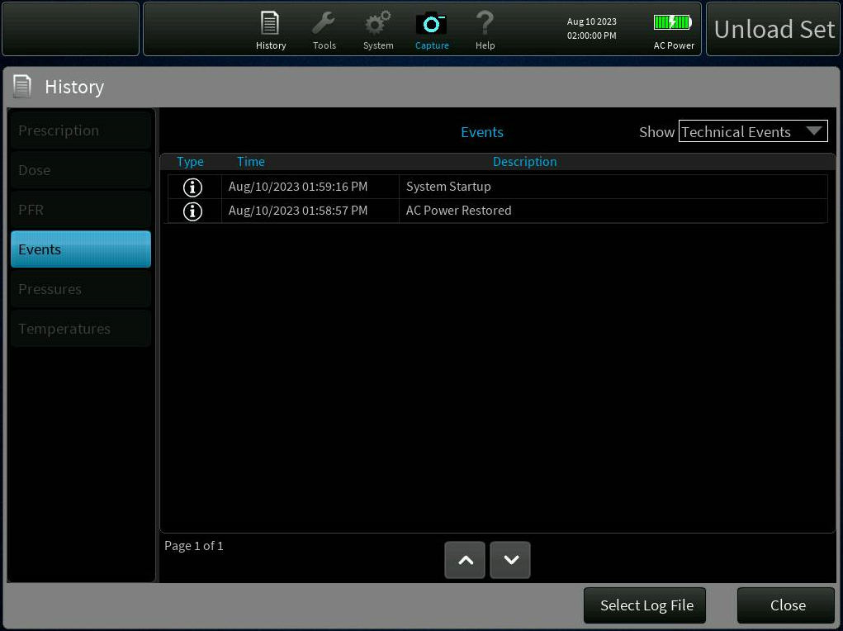

Figure - Select Log File Button on History Screen

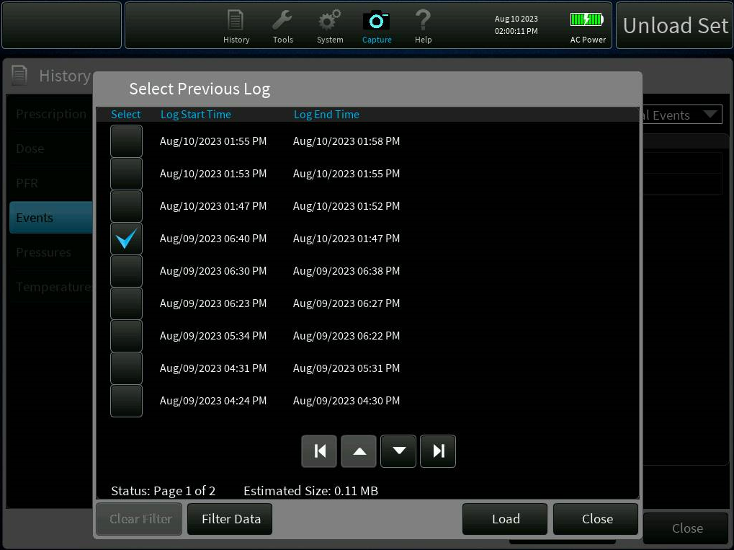

Figure - Previous Log Selection

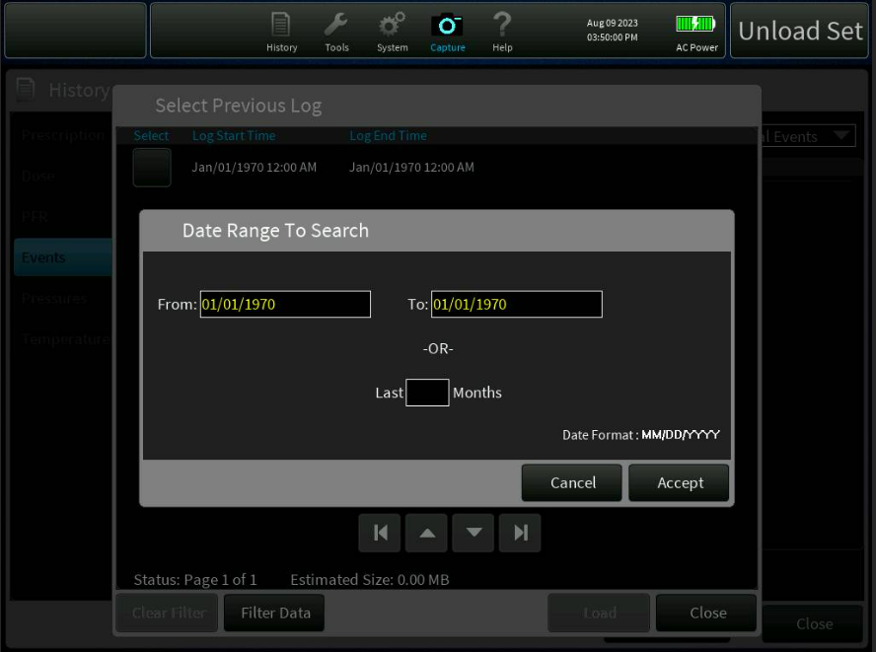

Figure - Filter by Date Screen

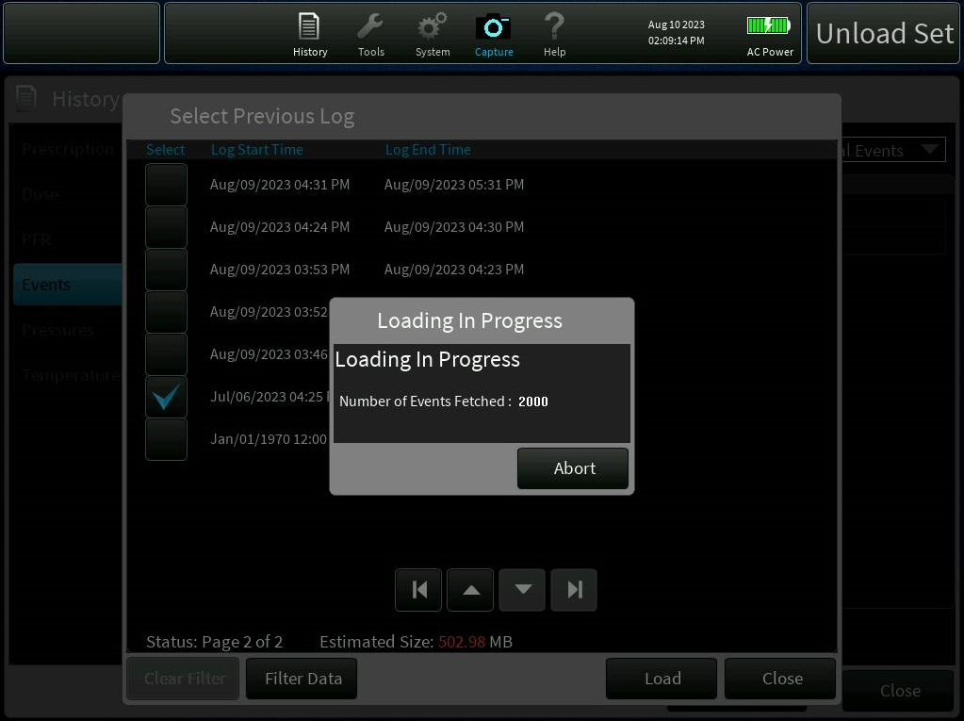

Figure - Load in Progress Dialog

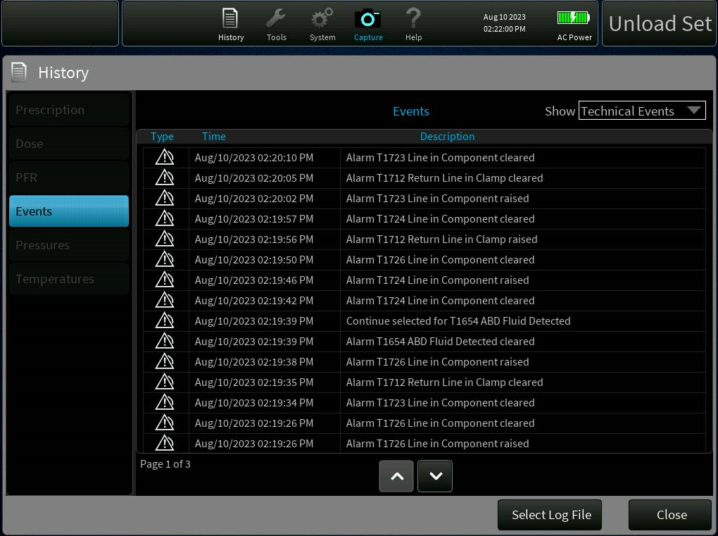

Figure - Loaded Events

**Implementation Description:**

* **AlarmIds.init.h -** *sPriorityData* structure has been added to generate the *mProcessingPriorityData* array from the DOORS script. IECAlarmPriorities.h header file is added for type of priority of Alarm that is Logged in mProcessingPriorityData array.
* **GenerateAlarmIds.dxl -** *Create_Alarms_PriorityData()* function is added to the DOORS script to generate the *mProcessingPriorityData* array in AlarmIds.cpp file.
* **TherapyLoggerDictionary.h -** *toDataStorePreviousPatientHistoryfilename* added for the DB file name from which the Events will be fetched. *toDataStoreAbortEventsFetch* is added to send the Abort signal to Abort the Fetching of events from the Log file. *fromDataStorePreviousHistoryFetchStatus* is added to send the Fetch status from the DataStore to GUI. *fromDataStoreAbortHistoryDataEventFetchAck* is added to send the Abort Acknowledgement from DataStore to GUI. *fromDataStoreNewRecordEventNotify* is added to send a new block of Records of size 25 after fetched from the LogFile.
* **SDVFS.c -** Updated the _g_SDVFS.mxPathname_ from 32 to 240 as the Log File names cannot be accommodated in 32-byte array.
* **SQLMgr.h -** Two Following Keys have been added to *enum eSqlMgrKeys* to attach the dictionaries. GET_PREVIOUS_PATIENT_HISTORY – To get the selected Log file name which Operator has selected on the GUI and start the Events Fetch. ABORT_HISTORY_DB_EVENT_FETCH – Abort the Events fetch operation by the Sub-task.  Following member variables have been added to SQLManager Class to fetch the Events history from the selected log file. *mPreviousLogDB* – to store the DB handle for the selected Log file. *mFetchHistoryDbEventsTask* – a sub-task to fetch the events from the log file. *mHistoryDbFetchSemaphore* – a semaphore onto which a sub-task will wait before fetching the events. *mMutexAbortEventFetch* – mutex to avoid race condition on aborting the events fetch operation. *mIsEventsFetchAborted* - Boolean variable to validate whether the events fetch operation is aborted or not. *mpPreviousPatientHistory* – dictionary variable to associated with the DB filename. *mpAbortEventsFetch* - dictionary variable to associated to Abort the Fetch Operation.**{**}
* **SQLMgr.cpp -** Two header files TherapyEventRecord.h (to prepare an event record from the data fetched from the Log file) and Looping.h (to add a separate task to fetch events from Log file) are added. Following Macros have been added: HISTORY_DB_PRIORITY - Priority of the sub-task which fetches the events from the log file, HISTORY_DB_TASK_STACK_SIZE - sub-task allocated stack memory, HISTORY_DB_EVENT_LIMIT - Maximum number of events fetched from a particular Log file, COLUMN_EVENT_TYPE - type of event fetched from the Log file, COLUMN_EVENT_TIME - time of the event at which it was generated, COLUMN_EVENT_USER_ID - User ID of an event, COLUMN_EVENT_DATA - Event Data fetched from the Log file, COLUMN_ACTION_USER_ID - User Action ID. Following functions are added to support the History Events Fetch Functionality on the Data Store side. *StartHistoryDbTask()* – Starts the sub-task to fetch the events from the Log file, *RunHistoryDbTask()* – function of the sub-task. It will start the while loop which fetched the Events from the Log file once the Semaphore is released, *AbortPreviousHistoryEventsFetch()* – To abort the Fetch operation, *ParseLogParameters()* – To parse the Event Data fetched from the Log file and set the Data in the Therapy Event Record, *CreatePreviousHistoryEventRecord()* – creates a therapy event record from the event Data fetched from the Logs file, *PreviousHistoryEventList()* – creates, compiles and executes the SQL query and creates an event record which is push to the Event List to be displayed on the GUI, *OpenSDpreviousHistoryDb()* – opens the selected Log DB, *LoadPreviousHistoryData()* – This Loads the selected DB file as soon as the operator clicks the Load button on the File Dialog, *InitializePreviousHistoryEventsFetch()* – This function releases the semaphore onto which the sub-task is waiting when a new request to fetch event from the GUI is requested. Following function are modified to support the Events fetch: *void SQLManager::Shutdown()* – Abort the event fetch when device is shutdown, *SQLManager::~SQLManager()* – Stop the sub-task.
* **HistoryDbMessageOverlay.h -** *HistoryDbMessageOverlay* class is added for Progress Dialog. It adds the functionality to close the Progress dialog, Abort and progression of the Events fetch.
* **HistoryDbMessageOverlay.cpp -** Implements the *HistoryDbMessageOverlay* class.
* **HistoryEventsPanel.h -** Following keys have been added to attach Toolbar dictionaries. HISTORY_DB_KEY – To receive the Events fetch status from the Datastore, HISTORY_DB_EVENT_KEY – To receive a signal when a new Therapy Event record is ready, PREVIOUS_HISTORY_ABORT_ACK – To receive the Abort acknowledgement of event fetch from the Datastore. Following Function are newly added: *AddEventToEventList()* – called when a new therapy event record is captured from the data store. It pushes the new event in the Event List, *AbortPreviousDbEventFetch()* – called when Abort Ack is received from the data store, *SendQueryHistoryDbStatus()* – called when the DB fetch status is received from the Data Store.
* **HistoryEventsPanel.cpp -** Below functions are modifed in the History Events Panel : *HistoryEventsPanel(const PegRect& where)* –  *toGuiPreviousHistoryFetchStatus*, *toGuiPreviousHistoryNewRecordEvent*, *toGuiAbortHistoryDataEventFetchAck* are attached to the respective keys.
* **HistoryScreen.h -** *LoadEvents *pInstanceLoadEvents* – Added *LoadEvents* instance to Enable/disable other panels on the history Screen.
* **HistoryScreen.cpp -** *HistoryScreen::HistoryScreen()* – Enable/disable the other panels (other than History Events panel) on the basis of *LoadEvents* instance status.
* **PreviousHistoryLoadEvents.h -** Defines a newly added Singleton “*LoadEvents*” class.
* **PreviousHistoryLoadEvents.cpp -** Implements *LoadEvents* class.
* **PreviousLogDbFilterOverlay.h -** Defines “*PreviousLogDbFilterOverlay*” class to filter Log files based on Date Range or Number of months.
* **PreviousLogDbFilterOverlay.cpp -** Implements “*PreviousLogDbFilterOverlay*” class.
* **PreviousLogDbScreen.h -** Defines “*PreviousLogDbScreen*” class to List out all the available Log files present on the device. This class restricts the operator to select only one log file to Load the events. Class also provided Filter Data on the List of Log files. Implements the functionality of *PreviousLogDbScreen* class.
* **PrisMaxGUI.gpj -** Added below .cpp files as module of PrisMaxGUI project: *HistoryDbMessageOverlay.cpp,* *PreviousHistoryLoadEvents.cpp,* *PreviousLogDbScreen.cpp* *PreviousLogDbFilterOverlay.cpp.*
* **ScreenDriver.h -** Added *DialogLoadPreviousHistoryDB = 750* as a screen ID for the Previous history Dialog.
* ***ScreenDriver.cpp*** - ScreenDriver constructor is modified such that HistoryDbScreen is created using factory method and inserted into sFactorys[] array. ScreenDriver Destructor is modified to delete the HistoryDbScreen object.
* **ToolbarScreen.h -** *LoadEvents *pInstanceLoadEvents –* Added a variable for *LoadEvents* class.
* **ToolbarScreen.cpp -** Below functions are modified: *ToolbarScreen() -* Initializes __ the __ *LoadEvents* __ instance, Attaches *toGuiTherapyRecoveryAttemptRestore* __ dictionary to “LOAD_HISTORY_DB_KEY” such that History icon is disabled when B2222 alarm is active after therapy recovery.  __ *ToolbarScreen::Update(int key)* *–* switch case “ToolbarView::ICON_BUTTON_0” is modified to enable history icon on the initial screen and set the *LoadEvents* instance member variables to hide/show “Select Log File” button on the History Screen.
* **AlarmIds.cpp -** mProcessingPriorityData is an Alarm Priority array generated from the DOORS script *“GenerateAlarmIds.dxl”.*
* **AlarmIds.h -** This headed file is generated from the DOORS script. *sPriorityData –* newly structure is added to this header files and *mProcessingPriorityData* is declared.
* **TherapyStateManager.cpp -** *EventHandler() –* Update the switch case *“TherapyEvents::THERAPY_RECOVERY_ATTEMPT_RESTORE”* such that when an event is received, *toGuiTherapyRecoveryAttemptRestore* is set to true to disable the history icon on the Toolbar.   
  *ProcessStateChangeFromGuiMode()* - Updated the switch case   
  "GuiMode::END" to set *toGuiTherapyRecoveryAttemptRestore* to *false* to enable the history icon on Toolbar.  
  *TherapyRecovTransitionToTreatment() - toGuiTherapyRecoveryAttemptRestore* is set to *false* to enable the history icon when continue is pressed on *B2222* alarm after therapy recovery and device enter into treatment.
* **Toolbar.h -** ** Added the below keys to attach the toolbar and Therapy Logger dictionary : KEY_PREVIOUS_PATIENT_HISTORY – attaches the fromGuiPreviousPatientHistoryfilename dictionary to receive log filename from GUI, KEY_PREVIOUS_DB_HISTORY – to receive the DB fetch status from the data store and sets in a ToolbarDictionary for the GUI to receive it, KEY_ABORT_ACK – receives acknowledgement signal from data store and sets in a ToolbarDictionary for the GUI to receive it, KEY_ABORT_EVENTS_FETCH – receive abort signal from GUI and sets in a TherapyLoggerDictionary for the DataStore to receive it, *KEY_PREVIOUS_HISTORY_EVENT – therapy event record from data store.*
* ***ToolbarDictionary.h --*** Following are the *ToolbarDictionaries* newly added : __ *fromGuiPreviousPatientHistoryfilename* Signal sent from GUI to DataStore to Query Previous Patient History, __ *toGuiPreviousHistoryFetchStatus* – Signal from Data Store to GUI to notify the status of Query Database, __ *fromGuiAbortEventsFetch* __ - Signal sent from GUI to DataStore to Abort the Fetching of Events from Previous History DB file, *toGuiAbortHistoryDataEventFetchAck* Acknowledgement to Abort Previous history Event Fetch, *toGuiPreviousHistoryNewRecordEvent* - Block of Therapy Event Records to send Event Data to GUI, *toGuiTherapyRecoveryAttemptRestore* - Set to disable the History option from toolbar to Load the Previous History Events.
* ***HistoryDbScreen.h*** - defines HistoryDbScreen class which derived from IScreen and provide means to open log files from Events panel. It attaches PreviousLogDbScreen View to handle its Message Events. Screen ID 750 is assigned to this screen.
* **HistoryDbScreen.cpp** - It defines the member variable and member functions of HistoryDbScreen class and also implements the virtual functions of IScreen class.
* **PreviousHistoryRecordList.h** - defines a new Macro PREVIOUS_HISTORY_RECORDS_BLOCK_SIZE of size 25. An Encodable array "PreviousHistoryRecordList" is added of size 25.

**Code Review summary:**

<https://bitbucket-prod.aws.baxter.com/projects/PMAX3/repos/prismaxcp/pull-requests/526/overview>  
<https://bitbucket-prod.aws.baxter.com/projects/PMAX3/repos/prismaxcp/pull-requests/494/overview>  
<https://bitbucket-prod.aws.baxter.com/projects/PMAX3/repos/prismaxcp/pull-requests/419/overview>  
<https://bitbucket-prod.aws.baxter.com/projects/PMAX3/repos/prismaxcp/pull-requests/359/overview>  
<https://bitbucket-prod.aws.baxter.com/projects/PMAX3/repos/prismaxguiassets/pull-requests/139/overview>  
<https://bitbucket-prod.aws.baxter.com/projects/PMAX3/repos/prismaxguiassets/pull-requests/165/overview>

**Updated Deliverables:**

These files were updated in BitBucket Commit ID - 87ad19ea7a1

AlarmIds.init.h  
GenerateAlarmIds.dxl  
TherapyLoggerDictionary.h  
SDVFS.c  
SQLMgr.h  
SQLMgr.cpp  
HistoryDbMessageOverlay.h  
HistoryDbMessageOverlay.cpp  
HistoryEventsPanel.h  
HistoryEventsPanel.cpp  
HistoryScreen.h  
HistoryScreen.cpp  
PreviousHistoryLoadEvents.h  
PreviousHistoryLoadEvents.cpp  
PreviousLogDbFilterOverlay.h  
PreviousLogDbFilterOverlay.cpp  
PreviousLogDbScreen.h  
PrisMaxGUI.gpj  
HistoryDbMessageOverlay.cpp,  
PreviousHistoryLoadEvents.cpp  
PreviousLogDbScreen.cpp  
PreviousLogDbFilterOverlay.cpp.  
ScreenDriver.h  
ScreenDriver.cpp  
ToolbarScreen.h  
ToolbarScreen.cpp  
AlarmIds.cpp  
AlarmIds.h  
TherapyStateManager.cpp  
Toolbar.h  
ToolbarDictionary.h  
HistoryDbScreen.h  
HistoryDbScreen.cpp

## 

## 3.1.2 Ensure that displayed PFR total are all rounded to the same precision (PFAL-2266**)**

**Design Update:**

No impact on the design.

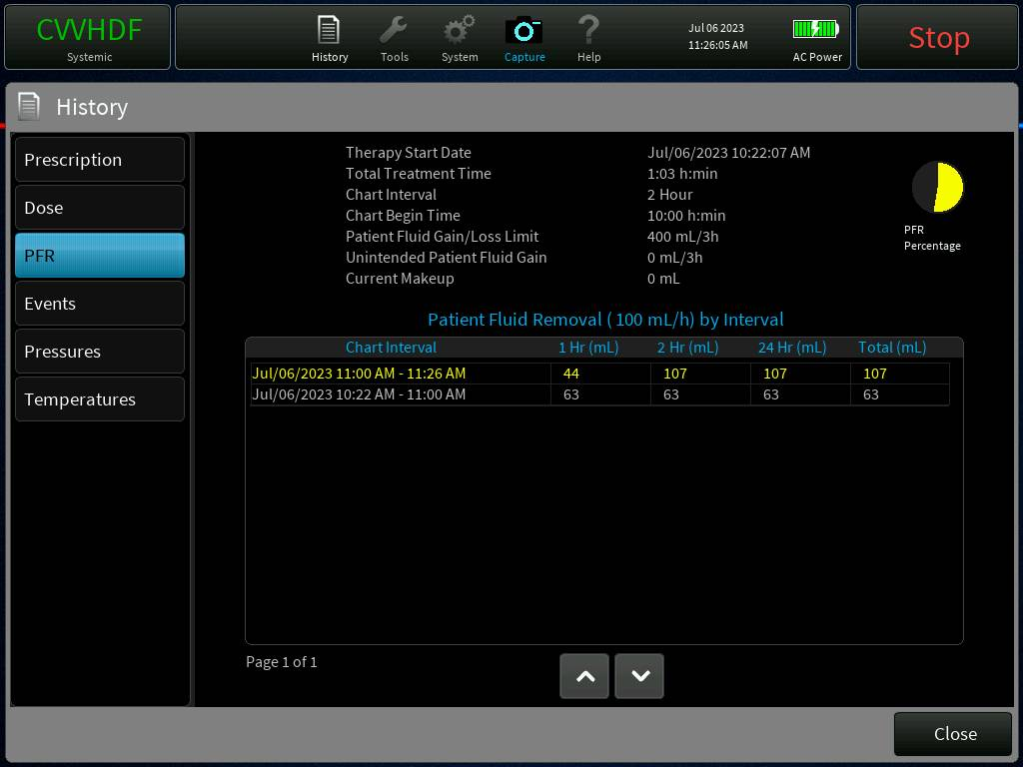**Display Updates:**

Figure - PFR History Screen

**Implementation Description:**

**JSONMessageHistoryPFR.cpp**\*\*\*\*\*\*\*\*\*\*\*\*\*\*\*\*\*

1) Added library <cmath>

2) Rounded off parameters mPfrChartData.mTrackedPFR[PfrChartData::PCD_PFR_PER_CHART].ml(), mPfrChartData.mTrackedPFR[PfrChartData::PCD_PFR_PER_DAY].ml() and mPfrChartData.mTrackedPFR[PfrChartData::PCD_PFR_TOTAL].ml() using round() function.

**JSONMessagePeriodicVolumes.cpp**\*\*\*\*\*\*\*\*\*\*

1) Added library <cmath>

2) Rounded off parameters mLogData.mVolumeArray[TherapyLoggerGraphData::UNINTENDED_PFR_VOL]), mLogData.mSample.mTotalVolumeRemoved, mLogData.mVolumeArray[TherapyLoggerGraphData::PFR_LAST_CHART_VOL]) and mLogData.mVolumeArray[TherapyLoggerGraphData::PFR_LAST_CHART_TOTAL_VOL]) using round() function.

**HistoryPFRPanel.cpp**\*\*\*\*\*\*\*\*

1) Rounded off parameters pfr.mTrackedPFR[PfrChartData::PCD_PFR_PER_HOUR].ml(), }}{{{}pfr.mTrackedPFR[PfrChartData::PCD_PFR_PER_CHART].ml(), round(pfr.mTrackedPFR[PfrChartData::PCD_PFR_PER_DAY].ml(){{ }}{{and}} pfr.mTrackedPFR[PfrChartData::PCD_PFR_TOTAL].ml() {{using round() function.}}{{ }}

**Code Review summary:**

<https://bitbucket-prod.aws.baxter.com/projects/PMAX3/repos/prismaxcp/pull-requests/406/overview>

**Updated Deliverables:**

The following files were updated as part of BitBucket commit ID 6d1d718cadc:

src/DataStore/JSON/JSONMessageHistoryPFR.cpp  
src/DataStore/JSON/JSONMessagePeriodicVolumes.cpp  
src/GUI/PrisMaxGUI/HistoryPFRPanel.cpp

## 3.1.3 Allow all users to update system time, and remove multiple time offsets (PFAL-2216)

**Design Update:**

Removed option to enter and saving datetime offset in software.  
Date Time update is written in RTC in both service and therapy mode using same methods.  
System automatically reboot machine after date and time is updated.  
Date/Time update option is available in only service mode and therapy mode initial state.

Refer attached sequence diagram.

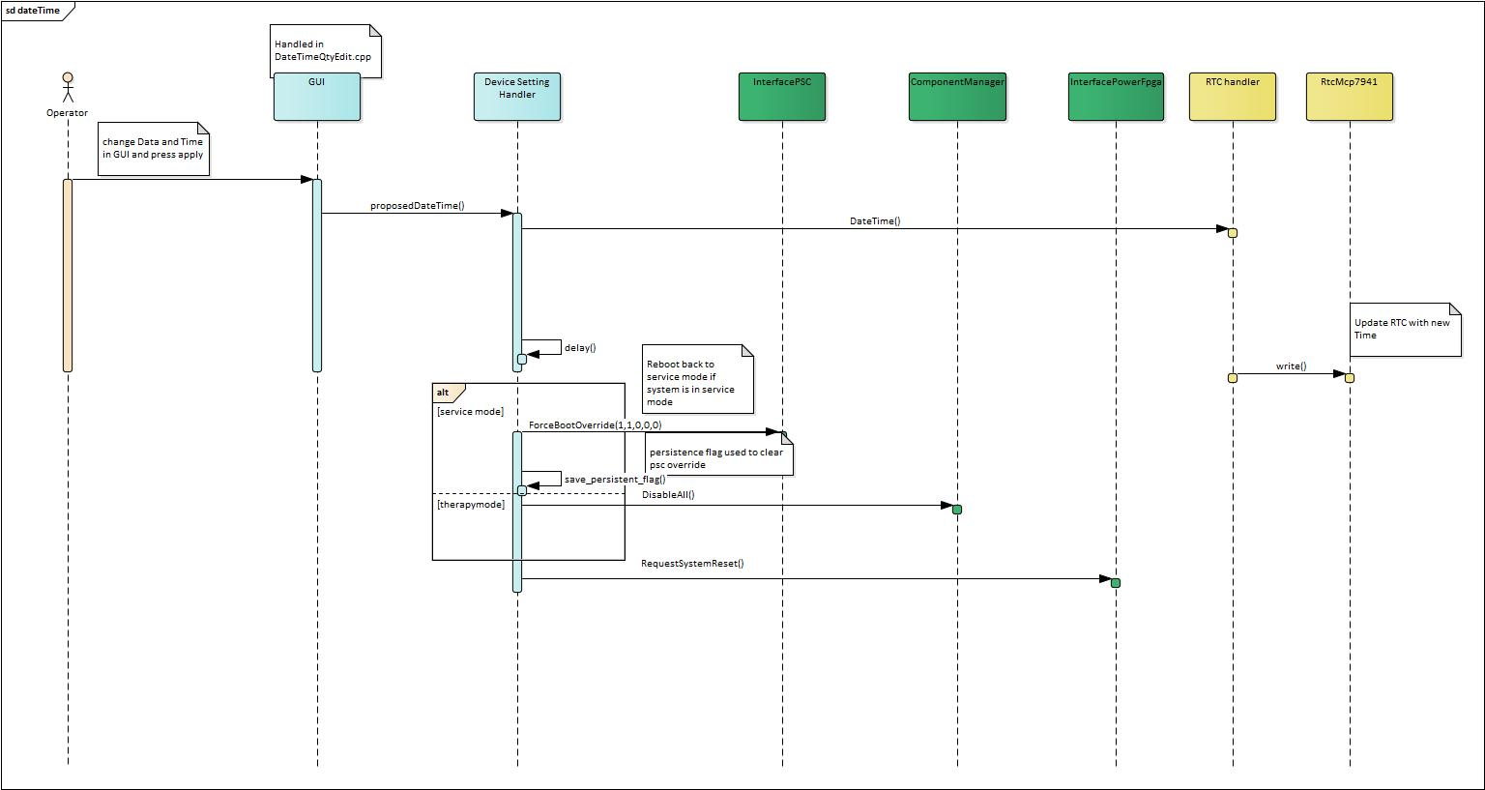

**Display Updates:**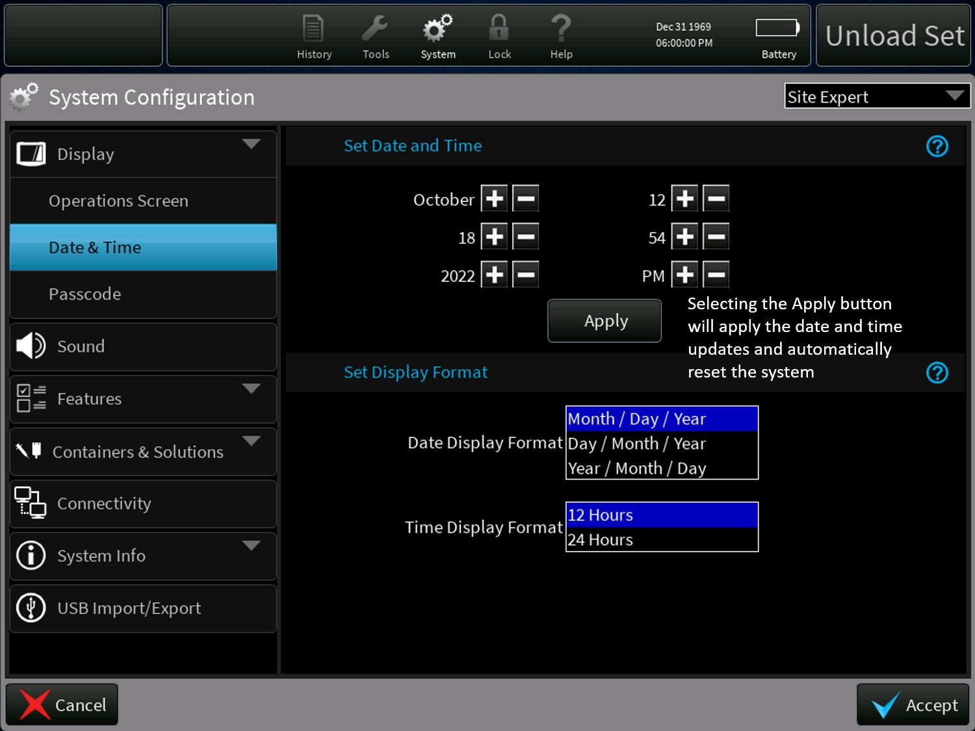

Figure - Update Date/Time Menu

**Implementation Description:**

**\*\*\*src/ToolBar/DeviceSettingsHandler.cpp \*\*\*\*\*\*\*\*\*\*\*\*\*\***  
1)DeviceSettingsHandler :: Update()  
1.1) Method is modified to remove setting offset time dictionary( gsIoMgrDictionary.mMainPcba.mToIoDateTimeOffset ) in therapy mode.  
1.2) Removed checking ROLES for updating RTC (using dictionary gsIoMgrDictionary.mMainPcba.mToIoRtcDateTime )  
This allows updating time in therapy mode and service mode.

2)DeviceSettingsHandler :: Service( )  
2.1 Updated method to restart system using PwrFpga.RequestSystemReset(). This is done only after sending RTC update message to RTC Handler.  
There are many seconds available before system shutdown.  
2.2. If system is in service mode system need to reboot back to service mode . This is handled by using PSC override option. PscCtrl.ForceBootOverride(PscBootOverride(true, true, false, false, false)) .  
2.3. In therapy mode components are disabled to avoid alarm sound during shutdown in therapy mode  
using gsComponentManager.DisableAll()

3)DeviceSettingsHandler::Init()  
clear PSC override if persistent flag is set to indicate rebooted due to date time update.

**\*\*src/ioMgr/RtcHandler.cpp \*\*\*\*\*\*\*\*\*\*\*\***  
1)Removed member variables used for offset dictionaries.  
2)RtcHandler::Update  
Method is updated to remove receiving offset datetime values.

3)RtcHandler::TimeProcessing()  
Updated method to remove setting offset dictionary

4)  
Removed methods SetOffset , GetOffset and CheckOffset since they are no longer needed.

**\*\*\*src/Therapy/Controllers/StartupController.cpp \*\*\*\*\*\*\*\*\*\*\*\*\*\*\*\*\*\*\*\*\*\*\*\*\*\*\*\*\*\*\*\*\*\***  
1) StartupController::RecoverResetStatus()  
Method is updated to set resetStatus to false, when reset is due to RST_REQ_CP (due to date time update)  
This prevents reset alarm when system is rebooted due to date time update in therapy mode.

**— src/ioMgr/ioMgrTasks.cc \*\*\*\*\*\*\*\*\*\*\*\*\*\*\*\*\*\*\*\*\*\*\*\*\*\*\*\*\*\*\*\*\*\*\***  
clean up by removing offset dictionaries.  
gsIoMgrDictionary.mMainPcba.mFromIoDateTimeOffset  
gsIoMgrDictionary.mMainPcba.mToIoDateTimeOffse

**— src/serviceMode/serviceTasksApps.cc \*\*\***  
Clean up by removing offset dictionaries.  
gsIoMgrDictionary.mMainPcba.mFromIoDateTimeOffset  
gsIoMgrDictionary.mMainPcba.mToIoDateTimeOffse

**— src/ToolBarGuiDictionary/ToolBarDictionary.cpp \*\*\***  
Remove dictionary for reading offset to GUI ( mToGuiDateTimeOffset )

**— src/AppIoMgrDictionary/PersistentStorage/IoManagerDictionaryPersStorWarmStart.cpp \*\***  
Added persistence flag to save reboot by datetime Update.

**— src/ioMgr/PersistentImage/PersistentImageTask.cpp \*\*\*\***  
Update WARM_START_BOX_TO_IMAGE[ ] to include new flag for persistent (toIoResetByCP_datetime)  
Updated WARM_START_IMAGE_TO_BOX[] to include newflag for persistent (fromIoResetByCP_datetime)

**— src/GUI/PrisMaxGUI/DateTimeQtyEdit.cpp \*\*\***  
Added text to indicate pressing APPLY button for date time update will cause system reboot.

**— src/GUI/PrisMaxGUI/SysConfigNavigator.cpp \*\*\*\*\***  
1)Updated sOperatorSystemNodeInfos[] to include DATETIME tab in operator mode.  
2)SysConfigNavigator::buildTree()  
Updated to remove datetime tab when NEWPATIENT/SAME PATIENT is pressed.  
**\*\*\*src/AppIoMgrDictionary/PersistentStorage/IoManagerDictionaryPersStorWarmStart.cpp, IoManagerDictionaryPersStorWarmStart.h and PersStorGroupSetup.cpp**  
Updated for added new persist dictionaries for storing DateTime change event, Changed On and Changed to(fromIoDateTimeResetPerformed, fromIoProposedDateTime and fromIoDateTimeChangedOn)  
   
**\*\*\* src/AppIoMgrDictionary/IoManagerDictionary.cc, IoManagerDictionary.h and IoManagerDictionarySetup.cpp**  
    Updated for adding new dictionary for sharing resettting date time change status in ioMgr fron Therapy(mResetSystemDateTimeResetStatus)  
   
**__ src/EncodableTypes/DateTimeQty.cpp, DateTimeQty.h**  
    Updated for adding new function TimeStamp() for returning Date Time as double value in YYYYMMDDhhmmss format.  
   
**__ src/GUI/PrisMaxGUI/AlarmDisplayDataConst.inc**  
Updated for adding new message event (E2380) for DateTime reset status  
   
**__ src/GUI/PrisMaxGUI/DateTimeQtyEdit.h, DateTimeQtyEdit.cpp**  
Updated for drawing box's for date & Time in UI  
 

**__ src/ioMgr/PersistentImage/PersistentImageTask.cpp**  
Updated for storing and reading DateTime changes from persist  
   
**__ src/ioMgr/RtcHandler.h, RtcHandler.cpp**  
Updated for stroing DateTime changes into persist on DateTime reste and clearning in persist after generating message event  
   
**__ src/Shared/EventIds.h, EventIds.cpp**  
Updated for adding Date Time change event (MSG_DATE_TIME_CHANGED = 153)  
   
**__ src/Therapy/Controllers/TherapyDataLogger.cpp,TherapyDataLogger.h**  
Updated for adding new function for generating DateTime change message.

**Code Review summary:**

<https://bitbucket-prod.aws.baxter.com/projects/PMAX3/repos/prismaxcp/pull-requests/358/overview>

**Updated Deliverables:**

The following files were updated in BitBucket commit ID 48e9889bcce

src/AppIoMgrDictionary/PersistentStorage/IoManagerDictionaryPersStorWarmStart.cpp  
src/AppIoMgrDictionary/PersistentStorage/IoManagerDictionaryPersStorWarmStart.h  
src/AppIoMgrDictionary/PersistentStorage/PersStorGroupSetup.cpp  
src/AppIoMgrDictionary/MainPcbaParams.cpp  
src/AppIoMgrDictionary/MainPcbaParams.h  
src/GUI/PrisMaxGUI/Assets/PrismaxStrings.h  
src/GUI/PrisMaxGUI/DateTimeQtyEdit.cpp  
src/GUI/PrisMaxGUI/DateTimeQtyEdit.h  
src/GUI/PrisMaxGUI/SysConfigNavigator.cpp  
src/GUI/PrisMaxGUI/SysConfigScreen_Creators.cpp  
src/ioMgr/PersistentImage/PersistentImageTask.cpp  
src/ioMgr/ioMgrTasks.c  
src/ioMgr/RtcHandler.cpp  
src/ioMgr/RtcHandler.h  
src/serviceMode/serviceTasksApps.cc  
src/Therapy/Controllers/StartupController.cpp  
src/Therapy/Controllers/TherapyDataLogger.cpp  
src/Therapy/Controllers/TreatmentSessionController.cpp  
src/Therapy/StateManagers/TherapyStateManager.cpp  
src/Therapy/therapyTasks.cc  
src/ToolBar/DeviceSettingsHandler.cpp  
src/ToolBar/DeviceSettingsHandler.h  
src/ToolBar/ToolBar.cpp  
src/ToolBarGuiDictionary/ToolBarDictionary.cpp  
src/ToolBarGuiDictionary/ToolBarDictionary.h  
src/ToolBarGuiDictionary/ToolBarDictionarySetup.cpp  
src/AppIoMgrDictionary/IoManagerDictionary.cc  
src/AppIoMgrDictionary/IoManagerDictionary.h  
src/AppIoMgrDictionary/IoManagerDictionarySetup.cpp  
src/EncodableTypes/DateTimeQty.cpp  
src/EncodableTypes/DateTimeQty.h  
src/GUI/PrisMaxGUI/AlarmDisplayDataConst.inc  
src/Shared/EventIds.h  
src/Shared/EventIds.cpp  
  
  
UnitTest/Stubs/src/Toolbar/DeviceSettingsHandler_Stub.cpp  
UnitTest/Stubs/src/Toolbar/ToolBar_Stub.cpp  
UnitTest/Therapy/Controllers/StartupController/StartupController_UT.cpp

## 3.1.4 Support updating product codes for filter sets in the field (PFAL-2218)

**Design Update:**

Currently, the set of product codes for each filter set type is hardcoded in the software, which means that a new software release is required each time the set changes.

The system should be updated to allow uploading a file in service mode that contains all of the defined product codes for each filter set, and then using that file to determine what filter set corresponds to a given product code.

**Display Updates:**

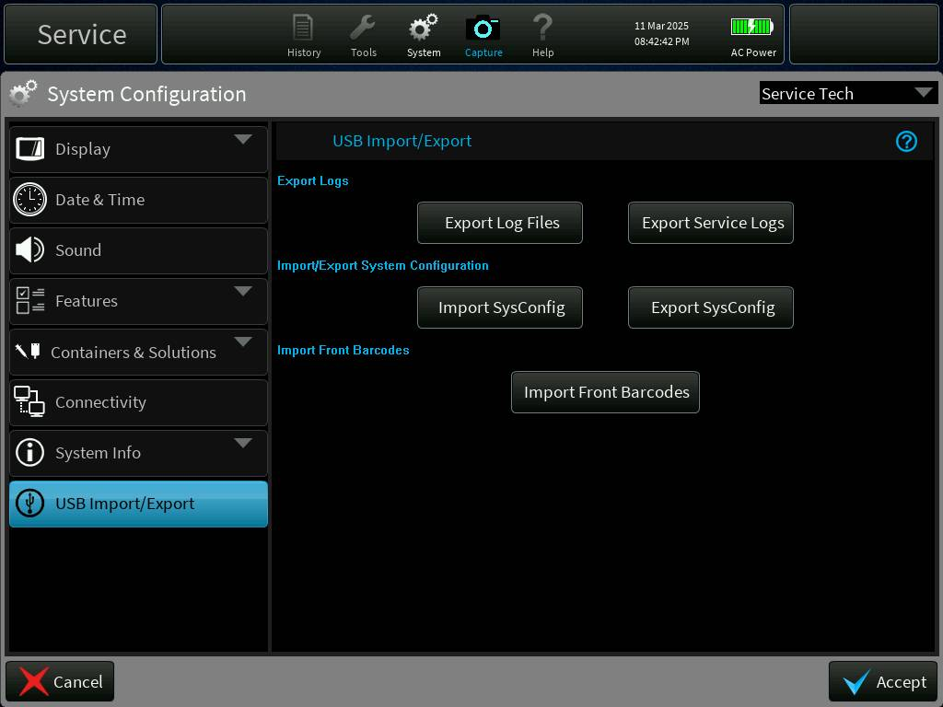

Figure - Barcode Import Screen

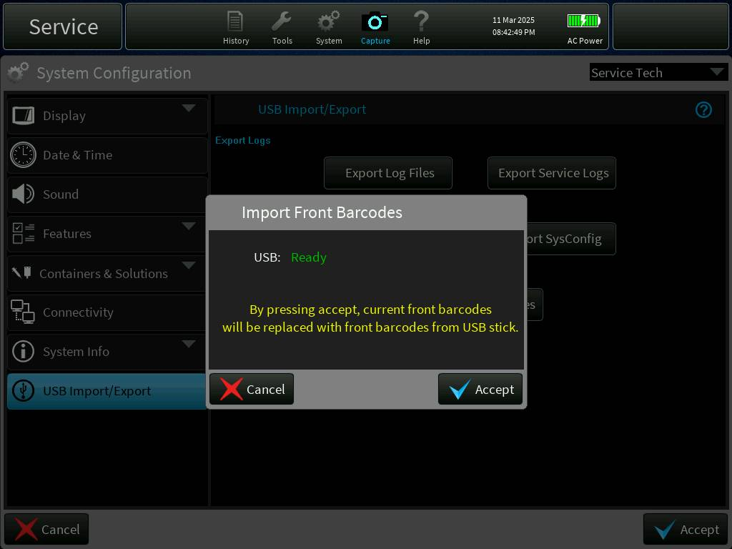

Figure - USB Ready for Import

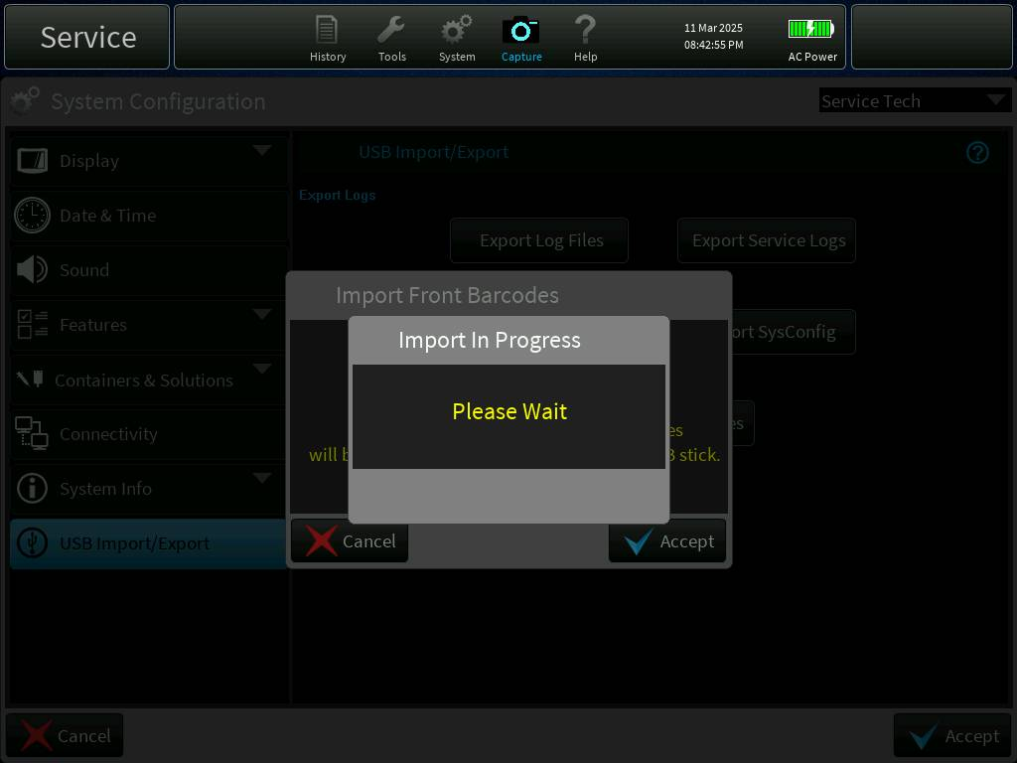

Figure - Import in Progress

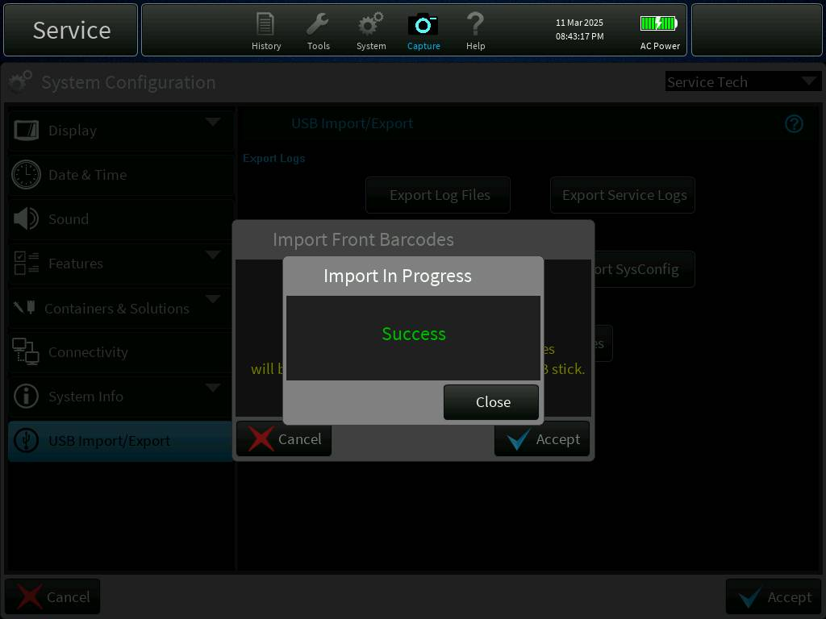

Figure - Import Success Screen

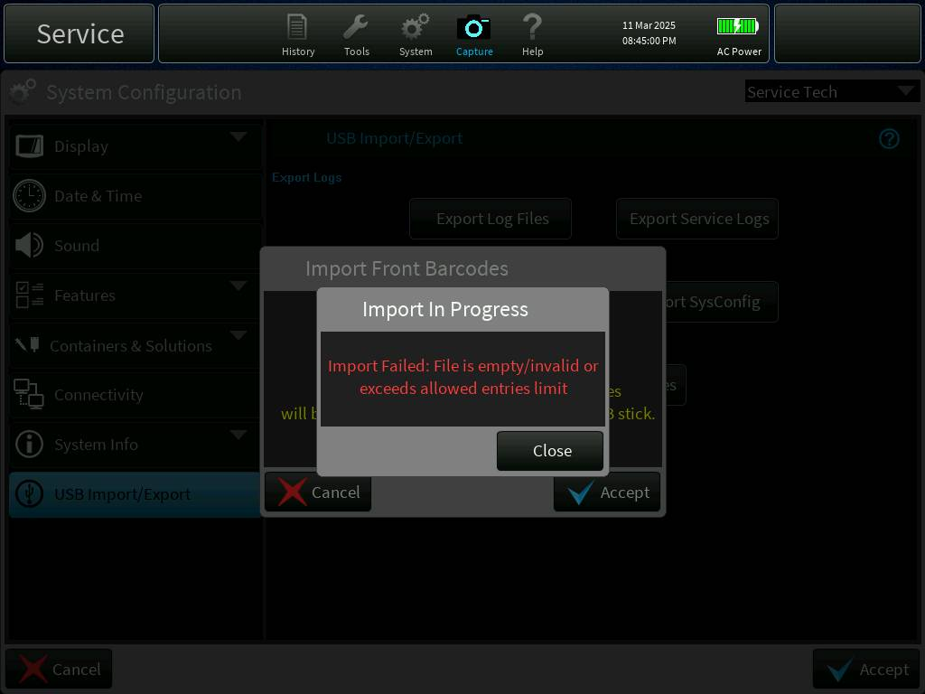

Figure - Import Failure Screen

**Implementation Description:**

**src/AppDataStoreDictionary/TherapyLoggerDictionary.cc**  
Added dictionaries for sending barcode table and signaling.

********************************************************************************************

**src/DataStore/SQL/Handlers/SQLScripts.cpp**  
1)Added sqlFilterSetProductCodeCreate string containing sql script for creating default front barcode.  
2)Added method GetCreateFilterSetProductCodesFromDefaultsSql() to return sqlFilterSetProductCodeCreate .  
3)Updated void SQLManager::CreateMainDB() to include command to create front barcode table.

********************************************************************************************

**src/DataStore/SQL/Handlers/SysConfigSQL.cpp**  
1)Added method FilterSetProductCodeCallback().  
This method is a callback from ReadFilterSetProductCodes command .  
filterSetProductCodeDB (contains list of front barcodes ) are updated in this method and it is send to therapy vas and service vas using dictionary TherapyLoggerDictionary::fromDataStoreFilterSetProductCodeDB .  
Dictionary TherapyLoggerDictionary::statusFilterSetProductCodes is also set to indicate successful read of the table from the db.

2)Added new method ReadFilterSetProductCodes()  
This used to send the sql commands to ""SELECT * FROM PRODUCTCODES " from the table .  
callback attached is FilterSetProductCodeCallback .

********************************************************************************************

**src/DataStore/SQL/Utils/FilterSetProductCodeImportUtils.cpp**  
New file added for helper methods .  
1)struct productCodesTableContent - structure to contain each front barcode information .  
2)  
SQLManager::ParseProductCodes(const char* fileName, const char* pBuff, int pBuffLen, int bytesRead)  
This method is used to parse file selected during front barcode import.  
a)Read file and Perform crc check  
b)Apply Decryption

c)Check import file is empty or exceeded product codes limit(250)  
d)Take backup of existing table into static productCodesTableContent array.  
e)Check if the files contain valid sql commands (INSERT OR REPLACE INTO PRODUCTCODES VALUES)  
f)Skip if SQL query is not valid and stop import if any product code version is invalid

g)Update Import status and display Success/Failure import dialog

**src/DataStore/SQL/SQLMgr.cpp**

This file was modified for creating PRODUCTCODES table if not exist(with default values) and reading existing products codes in PRODUCTCODES table after BootUp and added some dictionary references for read and writing front barcodes from DB.

1) Added "CheckCreateFilterSetProductCodes()" function

     This function will look for PRODUCTCODES table on bootup and created if not exist.

2) Added "ImportFilterSetProductCodes()" function

     This function added for selecting correct .ess file from USB and importing into DB.

********************************************************************************************

**src/Definitions/FileDefs.h**

Modified for adding ".ess" file extension for product code file import.

********************************************************************************************

**src/Definitions/FilterSetProductCodeImportStatus.h**

Added this file for front barcodes import status enums.

********************************************************************************************

**src/EncodableTypes/Barcode.h**

**src/EncodableTypes/Barcode.cpp**

Modified scanned/selected set barcode validation logic, scanned/selected barcode during validation first checking either it is Circuit barcodes or not, if it is not circuit barcodes, it will be validated in EANBarcodes (font barcodes) , if it is not valid proper error dailog will be displayed.

********************************************************************************************

**src/EncodableTypes/EANBarcode.h**

**src/EncodableTypes/EANBarcode.cpp**

Modified above two files for front barcode validation received from scanning/selected set. earlier barcode validation logic is common for scanned/selected set from dialog, now it is seperated by adding "isManualOverrise" flag, this flag will be sent from Barcode class based on user selected set from dialog or scanned barcode from set.

********************************************************************************************

**src/EncodableTypes/FilterSetProductCode.h**

**src/EncodableTypes/FilterSetProductCode.cpp**

Added these files for storing barcode information like Productcode , filtersetId and Circuit type.

********************************************************************************************

**src/EncodableTypes/FilterSetProductCodeDB.h**

**src/EncodableTypes/FilterSetProductCodeDB.cpp**

Added these files for string list of front product codes imported into DB and other information like product code position, length and product code version...

********************************************************************************************

**src/EncodableTypes/FilterSetProductCodeList.h**

Added this file for creating EncodableArray of type "FilterSetProductCode" with max capacity "250" as "FilterSetProductCodeList" and this type is used in dictionaries for storing list of product code read from DB.

********************************************************************************************

**src/EncodableTypes/FilterSetProductCodesData.h**

**src/EncodableTypes/FilterSetProductCodesData.cpp**

Added for storing product codes of filter sets and validating scanned product code from list of available product codes.

1) Added Method "UpdateFilterSetProductCodes()"

   Added for updating list of front product codes after bootup or successful import.

2) Added Method "IsProductCodeValid()"

   Added for validating scanned product code is valid or not (it should be present in product codes list)

3) Added Method "GetFilterId()"

   Added for getting filter set id after finding product code in product codes.

4) Added Method "GetProductCodeLength()"

   Added for getting product code length.

5) Added Method "GetProductCodePosition()"

   Added for getting product code position.

6) Added Method"GetProductCodeVersion()"

   Added for getting product code version.

********************************************************************************************

**src/EncodableTypes/ShortText.h**

Added new EncodableArray type for storing "14" characters string (capacity), actually this is introduced for storing imported/read product codes from DB, this is a varitaion for "Text" type, Text can store max "127" characters string but if we use this type for storing 250 product codes of length less than "14" characters, it is limiting dictionary capacity for storing 250 barcodes.

********************************************************************************************

**src/GUI/PrisMaxGUI/DialogImportProductCodesScreen.h**

**src/GUI/PrisMaxGUI/DialogImportProductCodesScreen.cpp**

Added new screen for displaying dialogs during importing front barcodes from USB, there are different variations in dialog like import inProgress, Success/Failure, lookup for .ess file in USB and valid .ess file status.

1) Added Method "Configure()"

   Added for displaying variant import status dialog based on variation received during import for product codes from USB.

2) Added Method "Message()"

   Added for receiving action events from GUI and performing action accordingly.

3) Added Method "ExternalControl()"

   Added for creating external control like displaying USB Ready state dialog.

4) Added Method "Update())

   Added for receieving barcodes import status during import and completion and it will display proper dialog as per the import status received.

5) Added Method "UpdateAcceptAndUsbReady()"

   Added for displaying USB available and ready messaged based on USB connected for disconnected from device.

6) Added Method "DisplayWorkingMessage()"

   Added for creating dialog for displaying front barcodes import status, and it is common dialog for all barcodes import status during import and completion.

7) Added Method "CloseWorkingMessage()"

   Added for closing front barcodes import dialog.

********************************************************************************************

**src/GUI/PrisMaxGUI/ScreenDriver.h**

**src/GUI/PrisMaxGUI/ScreenDriver.cpp**

Updated for adding new Screen for importing front barcodes from USB.

********************************************************************************************

**src/GUI/PrisMaxGUI/SysConfigNavigator.h**

**src/GUI/PrisMaxGUI/SysConfigNavigator.cpp**

**src/GUI/PrisMaxGUI/SysConfigScreen.h**

**src/GUI/PrisMaxGUI/SysConfigScreen.cpp**

**src/GUI/PrisMaxGUI/SysConfigScreen_Creators.cpp**

Modified above files for adding Import option for importing front barcodes from USB , similar to  sysconfiguration import

********************************************************************************************

**src/serviceMode/serviceTasksApps.cc**

**src/Therapy/StateManagers/TherapyStateManager.cpp**

Modified above two files for adding sys configuration check after bootup based on PRODUCTCODES table and read status.

********************************************************************************************

**src/ToolBar/ToolBar.h**

**src/ToolBar/ToolBar.cpp**

Updated method "Update()" for sending fron barcodes import status to GUI based on event received from Datastore during & after completion of event.

********************************************************************************************

**src/ToolBarGuiDictionary/ToolBarDictionary.h**

**src/ToolBarGuiDictionary/ToolBarDictionary.cpp**

**src/ToolBarGuiDictionary/ToolBarDictionary.h**

Added dictionaries for receiving front barcodes import status from Datastore during import and after completion of import.

********************************************************************************************

**src/cp.int**

Increased StackLength (from 0x80000 to 0x87000, Approx:30KB) of "DataStoreLoggerCommTaskStart" task during importing front barcodes from USB.

Increased StackLength of Datastore Initial Taskfrom 0x25000 to 0x27000, Approx: 8KB for storing 250 barcodes information read from DB (PRODUCTCODES)

**Code Review summary:**

<https://bitbucket-prod.aws.baxter.com/projects/PMAX3/repos/prismaxcp/pull-requests/355/overview>  
<https://bitbucket-prod.aws.baxter.com/projects/PMAX3/repos/prismaxcp/pull-requests/413/overview>  
<https://bitbucket-prod.aws.baxter.com/projects/PMAX3/repos/prismaxcp/pull-requests/453/overview>  
<https://bitbucket-prod.aws.baxter.com/projects/PMAX3/repos/prismaxcp/pull-requests/458/overview>  
<https://bitbucket-prod.aws.baxter.com/projects/PMAX3/repos/prismaxcp/pull-requests/500/overview>  
<https://bitbucket-prod.aws.baxter.com/projects/PMAX3/repos/prismaxcp/pull-requests/513/overview>  
<https://bitbucket-prod.aws.baxter.com/projects/PMAX3/repos/prismaxguiassets/pull-requests/123/overview>

**Updated Deliverables:**

The following files were updated in BitBucket commit ID: [412a22360a9](https://bitbucket-prod.aws.baxter.com/projects/PMAX3/repos/prismaxcp/pull-requests/513/commits/412a22360a97ede60853a196ad37edfe62bc9841)

/src/AppDataStoreDictionary/TherapyLoggerDictionary.cc  
/src/AppDataStoreDictionary/TherapyLoggerDictionary.h  
/src/AppDataStoreDictionary/TherapyLoggerDictionarySetup.cpp  
/src/DataStore/SQL/Handlers/SQLScripts.cpp  
/src/DataStore/SQL/Handlers/SysConfigSQL.cpp  
/src/DataStore/SQL/SQL.gpj  
/src/DataStore/SQL/SQLMgr.cpp  
/src/DataStore/SQL/SQLMgr.h  
/src/DataStore/SQL/Utils/FilterSetProductCodeImportUtils.cpp  
/src/DataStore/SQL/Utils/Utils.gpj  
/src/Definitions/FileDefs.h  
/src/Definitions/FilterSetId.h  
/src/Definitions/FilterSetProductCodeImportStatus.h  
/src/EncodableTypes/Barcode.cpp  
/src/EncodableTypes/Barcode.h  
/src/EncodableTypes/CMakeLists.txt  
/src/EncodableTypes/CpEncodableTypes.gpj  
/src/EncodableTypes/EANBarcode.cpp  
/src/EncodableTypes/EANBarcode.h  
/src/EncodableTypes/FilterSetProductCode.cpp  
/src/EncodableTypes/FilterSetProductCode.h  
/src/EncodableTypes/FilterSetProductCodeDB.cpp  
/src/EncodableTypes/FilterSetProductCodeDB.h  
/src/EncodableTypes/FilterSetProductCodeList.h  
/src/EncodableTypes/FilterSetProductCodesData.cpp  
/src/EncodableTypes/FilterSetProductCodesData.h  
/src/EncodableTypes/ShortText.h  
/src/GUI/PrisMaxGUI/Assets/PrismaxStrings.h  
/src/GUI/PrisMaxGUI/DialogImportProductCodesScreen.cpp  
/src/GUI/PrisMaxGUI/DialogImportProductCodesScreen.h  
/src/GUI/PrisMaxGUI/DialogSelectSetBarcode.cpp  
/src/GUI/PrisMaxGUI/GuiMsgIds.h  
/src/GUI/PrisMaxGUI/PrisMaxGUI.gpj  
/src/GUI/PrisMaxGUI/ScreenDriver.cpp  
/src/GUI/PrisMaxGUI/ScreenDriver.h  
/src/GUI/PrisMaxGUI/SysConfigNavigator.cpp  
/src/GUI/PrisMaxGUI/SysConfigNavigator.h  
/src/GUI/PrisMaxGUI/SysConfigScreen.cpp  
/src/GUI/PrisMaxGUI/SysConfigScreen.h  
/src/GUI/PrisMaxGUI/SysConfigScreen_Creators.cpp  
/src/Therapy/StateManagers/TherapyStateManager.cpp  
/src/ToolBar/ToolBar.cpp  
/src/ToolBar/ToolBar.h  
/src/ToolBarGuiDictionary/ToolBarDictionary.cpp  
/src/ToolBarGuiDictionary/ToolBarDictionary.h  
/src/ToolBarGuiDictionary/ToolBarDictionarySetup.cpp  
/src/cp.int  
/src/serviceMode/serviceTasksApps.cc  
/UnitTest/DataStore/SQL/SQLMgr/CMakeLists.txt  
/UnitTest/DataStore/SQL/SQLMgr/SQLMgr_UT.cpp  
/UnitTest/DataStore/SQL/SQLMgr/SQLMgr_UT_Macros.h  
/UnitTest/EncodableTypes/CMakeLists.txt  
/UnitTest/EncodableTypes/EANBarcode/CMakeLists.txt  
/UnitTest/EncodableTypes/EANBarcode/EANBarcode_UT.cpp  
/UnitTest/EncodableTypes/FilterSetProductCodesData/CMakeLists.txt  
/UnitTest/EncodableTypes/FilterSetProductCodesData/FilterSetProductCodesData_UT.cpp  
/UnitTest/Stubs/src/DataStore/SQL/Handlers/SQLScripts_Stub.cpp  
/UnitTest/Stubs/src/DataStore/SQL/Handlers/SysConfigSQL_Stub.cpp  
/UnitTest/Therapy/Controllers/BarcodeController/BarcodeController_UT.cpp

## 

## 3.1.5 Support reloading of filter set when “CRRT/TPE Wrong Set” alarm is raised (PFAL-2227)

**Design Update:**

When TPE/CRRT set recognition fails for the first time in setup, then a new Set Loading Failure (T2379) is raised.

This alarm provides action to load and unload the set. “Unload” button will unload the set and keeps the alarm active whereas load button will load the set again and alarm is cleared. Set Recognition test will start after Loading is completed.

T2379 alarm will be raised only once and if the set recognition fails again then wrong set alarms (T0608 and T1783) will be raised subsequently.

 When Wrong set alarms (T0608 or T1783) is raised, modified the system to allow the operator to unload/load the filter set to ensure that tubing segments are properly loaded, so that test can be re-run.

Added two new actions "Load Set" and "Unload Set" on T0608 and T1783 alarm to load and unload the filter set. Retest button is added to run the Set Recognition Test from T0608 and T1783 alarm.

**Display Updates:**

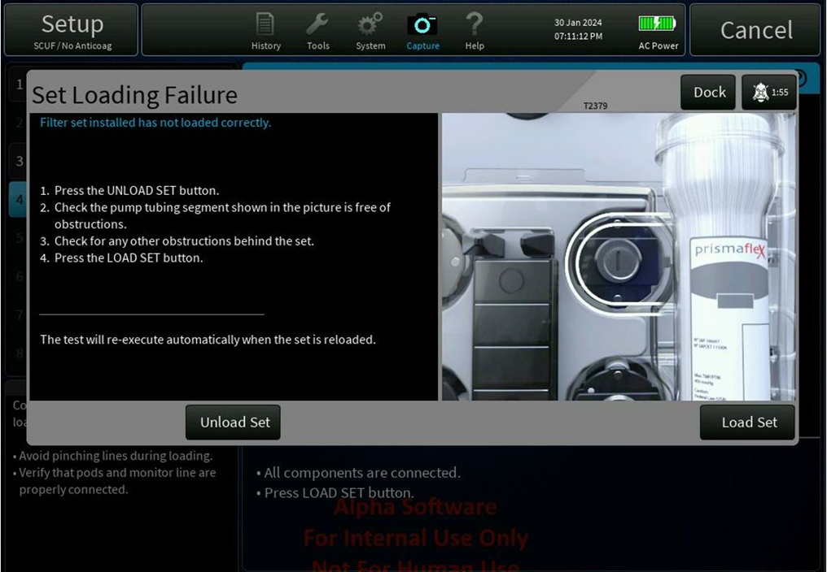

Figure - Set Loading Failure Alarm

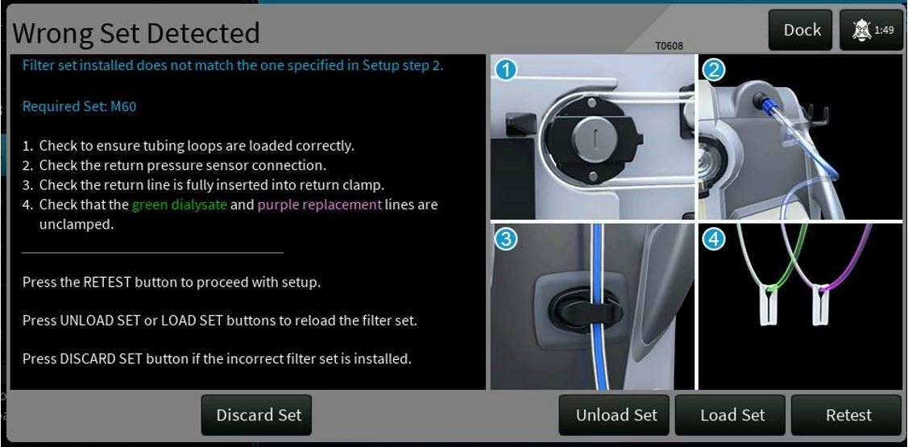

Figure - Wrong Set Detected Alarm

**Implementation Description:**

**DictionarySetupGroup.cpp**

**DictionarySetupGroup.h**

**TherapyDictionarySetup.cpp**

-Added one new dictionary *"toGuisetRecognitionTestIsFailed"* which will update the set recognition failure status from therapy to GUI for back button enable/disable in case of set recognition failure.

----------------------------------------------------------------------------------------------------------------------------------------

**PrisMaxBitmaps.h**

-Added one new bitmap *"BID_AttachSet_Kronos_CRRT_TPE"* for Alarm *T1783 & T0608*

-Added one new bitmap *"BID_alarm_Set_Loading_Failure_white"* for Alarm *T2379*

----------------------------------------------------------------------------------------------------------------------------------------

**PrismaxStrings.h**

-Added new two alarm actions SID for "Load Set" and "Unload Set".

-Added new SIDs for Alarm *T2379* for "Load Set" and "Unload Set".

----------------------------------------------------------------------------------------------------------------------------------------

**AlarmDisplayDataConst.inc**

-Alarm *T1783* & *T0608* alarms actions were CONTINUE and DISCARD_SET. now that is replaced with 4 alarm actions which are LOAD, UNLOAD, RETRY and DICARD_SET. related changes are mentioned below.

* New alarm Alarm *T2379* (Set Loading Failure) added with two actions LOAD and UNLOAD,

-Added display characteristics for the Alarm *T2379*, *T1783* & *T0608* for the newly added actions LOAD and UNLOAD.

-  Added two new names for the new added alarm actions LOAD and UNLOAD in to array which lists the external control names for *T2379, T1783 & T0608* alarm actions.

-Added newly added actions external control names to array which lists the SIDS for each alarm.

--------------------------------------------------------------------------------------------------------------------------------------

**AlarmGraphics.cpp**

-New bitmap is added to the existing alarm *T2379, T1783 & T0608*, so new *ImageStack()* and *Timeline()* methods are added.

----------------------------------------------------------------------------------------------------------------------------------------

**AlarmGraphicsSetup.inc**

-New two methods are added since new bitmap for Alarms T1783 & T0608.

* Two new methods are added since new bitmap for Alarm T2379.

-------------------------------------------------------------------------------------------------------------------------------------

**SetupAssemblyWizard.cpp**

-One new key is added for dictionary *"toGuisetRecognitionTestIsFailed"* which carry the status of set recognition failed. Based on this status the BACK button in component screen has to Enable/Disable.

-Added changes for dictionary attach and detach.

-In case *"STEP_COMPONENTS"* of *configureButtons()* method, the changes are added for BACK button enable/disable as per dictionary value *true/false*.

-In method *DictionaryUpdate()*, case *KEY_SET_REG_FAIL*: , added changes to get the status of set recognition pass/fail through dictionary *"toGuisetRecognitionTestIsFailed"*. based on the status it is calling method *configureButtons()* to reconfigure the buttons.

----------------------------------------------------------------------------------------------------------------------------------------

**AlarmActionIds.cpp**

-Added strings *"A0034::ALARM_ACTION_WRONG_SET_UNLOAD"* and *"A0035::ALARM_ACTION_WRONG_SET_LOAD"* for newly added alarm actions in to  *"AlarmActionIdStrings"* which provide a string listing DOORS ID and name for each alarm action.

-Added new two actions ID's to newly added alarms actions to *"AlarmActionToUserIdMap"*

-Added two new alarm action user id in to *"UserToAlarmActionIdMap"*.

* *"AlarmActionToUserIdMap"* and *"UserToAlarmActionIdMap"* updated for Alarm T2379 using DOORS.

--------------------------------------------------------------------------------------------------------------------------------

**AlarmActionIds.h**

-Added two new alarm action for "load Set" and "Unload Set" into *AlarmActionIds enum*.

-Changed "*MAX_ALARM_ACTION_USER_ID*" from 33 to 37 since three new alarm actions are introduced.

-----------------------------------------------------------------------------------------------------------------------------

**PrimeAlarmHandling.cpp**

-Added changes in the "*UserNotifier()*" method, the changes are below,

the changes are related to alarm actions *ALARM_ACTION_WRONG_SET_LOAD* and *ALARM_ACTION_WRONG_SET_UNLOAD*.

when the user presses *LOAD_SET* from alarm window, publishing *START_MAIN_CIRCUIT_LOAD* event and disabling *ALARM_ACTION_WRONG_SET_LOAD* alarm action and enabling *ALARM_ACTION_WRONG_SET_UNLOAD*.

when the user presses *UNLOAD_SET* from alarm window, publishing *START_MAIN_CIRCUIT_UNLOAD* event and enabling *ALARM_ACTION_WRONG_SET_LOAD* alarm action and disabling *ALARM_ACTION_WRONG_SET_UNLOAD*.

-Added one new method *"HandleWrongsetAlarmButtons()"* which is to handle the alarm actions in case of *SAFE_STATE* and therapy events *START_MAIN_CIRCUIT_UNLOAD*, *START_MAIN_CIRCUIT_LOAD*, *SET_LOADED* and *SET_UNLOADED*.

-Added one new method *"HandleLoadSetFailureAlarmButtons()"* which is to handle *T2379* alarm actions in case of *SAFE_STATE* and therapy *SET_LOADED* and *SET_UNLOADED*.

-When *T2379* Alarm is processed, *LOAD* action is disabled before starting Set Recognition Test.

In *SAFE_STATE_CHANGE*, *LOAD* and *UNLOAD* alarm actions has to disable in T2379, T1783 and T0608, will get enable once recover from *SAFE_STATE_CHANGE*.

In *START_MAIN_CIRCUIT_UNLOAD* and *START_MAIN_CIRCUIT_LOAD* the alarm actions ALARM_ACTION_RETRY and *ALARM_ACTION_DISCONNECT* should be disabled, it will get enable once its *LOADED*/*UNLOADED* properly.

In *SET_LOADED* event, all the four actions has to get enabled (*START_MAIN_CIRCUIT_UNLOAD, START_MAIN_CIRCUIT_LOAD, ALARM_ACTION_DISCONNECT and ALARM_ACTION_RETRY*).

In *SET_UNLOADED* event all three action will get enable except RETRY.

For *SET_LOADING_FAILURE* alarm *SetRecognitionTest()* is enabled for *ALARM_ACTION_WRONG_SET_LOAD* to perform the set Recognition Test after Filter Set is Loaded.

-------------------------------------------------------------------------------------------------------------------------------------

**PrimeAlarmHandling.h**

-The above mentioned new methods *"HandleWrongsetAlarmButtons()"* and *"HandleLoadSetFailureAlarmButtons()"* is declared here.

------------------------------------------------------------------------------------------------------------------------------------

**AlarmsConst.inc**

-For alarm *T1783* & *T0608* the alarm actions were *ALARM_ACTION_CONTINUE* and *ALARM_ACTION_DISCONNECT*. Now it changed to four alarm actions that are *ALARM_ACTION_WRONG_SET_UNLOAD*, *ALARM_ACTION_WRONG_SET_LOAD*, *ALARM_ACTION_DISCONNECT* and *ALARM_ACTION_RETRY*.

-For alarm *T2379* two alarm actions are added *ALARM_ACTION_WRONG_SET_UNLOAD* and *ALARM_ACTION_WRONG_SET_LOAD*.

-The default enabled status for newly added alarm actions are added in to "*mActionEnabledDefault*".

------------------------------------------------------------------------------------------------------------------------------------

**LoaderController.cpp**

For Alarm *T2379, T1783 and T0608*, the alarm actions *LOAD* and *UNLOAD* presses simultaneously which is not there now in any of *LOAD* *UNLOAD* combinations.

So when the *LOAD* and *UNLOAD* actions presses simultaneously *SET UNLOAD* stops immediately. When set *LOAD* pressed at the time of *LOAD* happens (*LOADER_MOTOR_EXTENDING*). The "targetPosition" was actualy changing between these two actions that should not happen in this simultaneous *LOAD* and *UNLOAD* case.

To overcome this issue we introduced a new bool variable *"PumpMotorRunonTimeOverride"* in the *struct "LoaderMoveStatus"*. This new variable will protect the *UNLOAD* action and makes the set unload stopped during *LOAD* action happens.

-Added scoped mutex to methods *PeriodicProcessing(), MoveLoader()* and events *START_MAIN_CIRCUIT_LOAD* and *START_MAIN_CIRCUIT_UNLOAD*.

----------------------------------------------------------------------------------------------------------------------------------

**LoaderController.h**

-The above mentioned *"PumpMotorRunonTimeOverride"* and *ScopedMutex* are declared in .h

---------------------------------------------------------------------------------------------------------------------------------

**PrimingManager.cpp**

-Subscribed two new events *RECOGNITION_TEST_COMPLETE* and *RECOGNITION_TEST_STARTING* for setting the dictionaries which GUI is looking for and and to perform Set Recognition Test for *T2379* Alarm.

-Attached one dictionary "*fromGuiMode*" for making the *BACK* button enable in case of *END GUI* mode.

-In *TherapyEvents::RECOGNITION_TEST_COMPLETE*, there are 2 dictionary setting. one is for enabling the *BACK* button in component screen and another one is for clearing the "set recognition in progress" screen.

-In *TherapyEvents::RECOGNITION_TEST_STARTING*, the changes are if the set recognition is already in failed state or Set Recognition Test is to be performed again, set the dictionary "*setRecognitionInProgress*" to true and "*setRecognitionExecuted*" to false which will help to again popup the "*set recognition in progress*" dialog and perform Set Recognition Test since we cleared the dialog when set recognition failed.

-In CASE, *PrimingModelController::STEP_RECOGNITION_TEST*, If set recognition passed, setting the dictionary to enable *BACK* button in component screen.

----------------------------------------------------------------------------------------------------------------------------------

**PrimingManager.h**

-Added key *"GUI_COMMAND"* in enum eKeys for dictionary *"fromGuiMode"*.

---------------------------------------------------------------------------------------------------------------------------------------

**PrimingModelController.cpp**

-Subscribing four events *START_MAIN_CIRCUIT_UNLOAD*, *START_MAIN_CIRCUIT_LOAD*, *SET_LOADED* and *SET_UNLOADED*.

-In *TherapyEvents::SET_UNLOADED/LOADED, START_MAIN_CIRCUIT_UNLOAD/UNLOAD, SAFE_STATE_CHANGE*, *"HandleWrongsetAlarmButtons()"* method is called which will handle the alarm action buttons enable/disable based on conditions. *START_MAIN_CIRCUIT_UNLOAD*

-In *TherapyEvents::SET_UNLOADED/LOADED, START_MAIN_CIRCUIT_UNLOAD/UNLOAD, SAFE_STATE_CHANGE,*   
*HandleLoadSetFailureAlarmButtons()* method is called which will handle the *T2379* alarm action buttons enable/disable based on conditions.

-For Alarm *T2379*, two new variables are added "*mRaiseLoadFailureSetAlarm*" and "*mRecognitionTestRequired*". If "*mRaiseLoadFailureSetAlarm*" is set to true, then *SET_LOADING_FAILURE* alarm is raised else *Wrong_SET* alarm is raised.

If "*mRecognitionTestRequired*" is set to true, then Set Recognition Test is performed after filter set is loaded.

Two new methods *"SetRecognitionTest()" and "GetRecognitionTest()"* are added to set and get the value of *"mRecognitionTestRequired"* using PrimingModelController instance *"gsPrimingModelController"*.

-New PrimeAlarmHandling variable *"loadSetFailureAlarm"* is added for Load Failure alarm which is intialized in the constructor.

**Code Review summary:**

PrisMaxCP - <https://bitbucket-prod.aws.baxter.com/projects/PMAX3/repos/prismaxcp/pull-requests/553/overview>  
PrisMaxGUIAssets - <https://bitbucket-prod.aws.baxter.com/projects/PMAX3/repos/prismaxguiassets/pull-requests/202/overview>

**Updated Deliverables:**

The following files were updated in BitBucket commit ID(PrisMaxCP - 8bd3fc7d6d8), (PrisMaxGUIAssets - 6974d975084)

1. src/AppGuiDictionary/DictionarySetupGroup.cpp  
   2) src/AppGuiDictionary/DictionarySetupGroup.h  
   3) src/AppGuiDictionary/TherapyDictionarySetup.cpp  
   4) src/GUI/PrisMaxGUI/Assets/PrisMaxBitmaps.h  
   5) src/GUI/PrisMaxGUI/Assets/PrismaxStrings.h  
   6) src/GUI/PrisMaxGUI/AlarmDisplayDataConst.inc  
   7) src/GUI/PrisMaxGUI/AlarmGraphics.cpp  
   8) src/GUI/PrisMaxGUI/AlarmGraphicsSetup.inc  
   9) src/GUI/PrisMaxGUI/SetupAssemblyWizard.cpp  
   10) src/Shared/AlarmActionIds.cpp  
   11) src/Shared/AlarmActionIds.h  
   12) src/Therapy/AlarmDetection/PrimeAlarmHandling.cpp  
   13) src/Therapy/AlarmDetection/PrimeAlarmHandling.h  
   14) src/Therapy/AlarmProcessing/AlarmsConst.inc  
   15) src/Therapy/Controllers/LoaderController.cpp  
   16) src/Therapy/Controllers/LoaderController.h  
   17) src/Therapy/Controllers/PrimingManager.cpp  
   18) src/Therapy/Controllers/PrimingManager.h  
   19 src/Therapy/Controllers/PrimingModelController.cpp  
   20) UnitTest/Stubs/src/Components/InterfaceLoader_Stub.cpp  
   21) UnitTest/Therapy/Controllers/LoaderController/LoaderController_UT.cpp  
   22) UnitTest/Therapy/Controllers/PrimingManager/PrimingManager_UT.cpp  
   23)UnitTest/Therapy/Controllers/PrimingModelController/PrimingModelController_UT.cpp

The updated list of files In PrisMaxGUIAssets are below,  
  
1) Strings/English.xml  
2) Bitmaps/src/PrisMaxBitmaps.h  
3) Strings/PrismaxStrings.h

## 3.1.6 Text/Image updates for Therapy Recovery and Manual Blood Return (PFAL-2287)

**Design Update:**

1)  
Added new scrollable dialog for displaying Manual Blood return instructions with images.  
Added a new Button ("Hand Crank") in B2222 alarm Screen.  
On pressing this button B2222 Alarm will dock for 10 minutes and it will also open a dialog with Manual Blood Return instructions. This dialog is a scrollable dialog.  
Reusable scrollable class is created for future extension and reuse.

"Continue" button on B2222 alarm will be disabled once user press "Hand Crank."

2)  
Changed title of all Call Service alarms to "System Failure" and updated Image (power button) instead tool image.  
Updated instructions in Call service alarm based on system failure during treatment or outside treatment.  
Updated history message events reflect system failure instead of call service.

**Display Updates:**

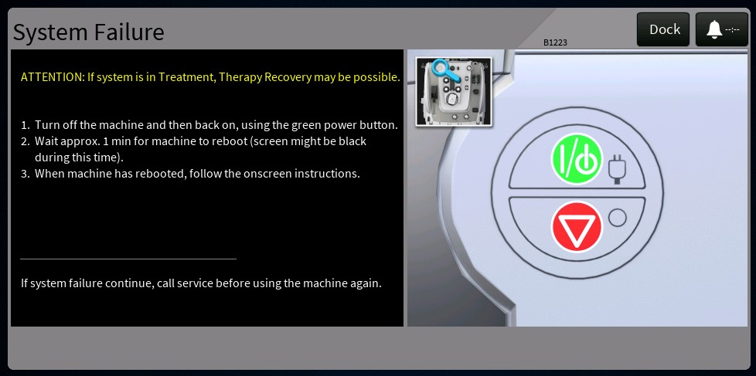

Figure - System Failure (In Treatment)

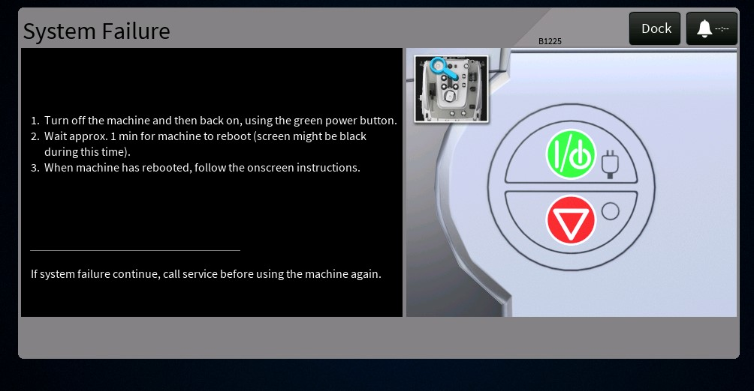

Figure - System Failure Alarm (Not in Treatment)

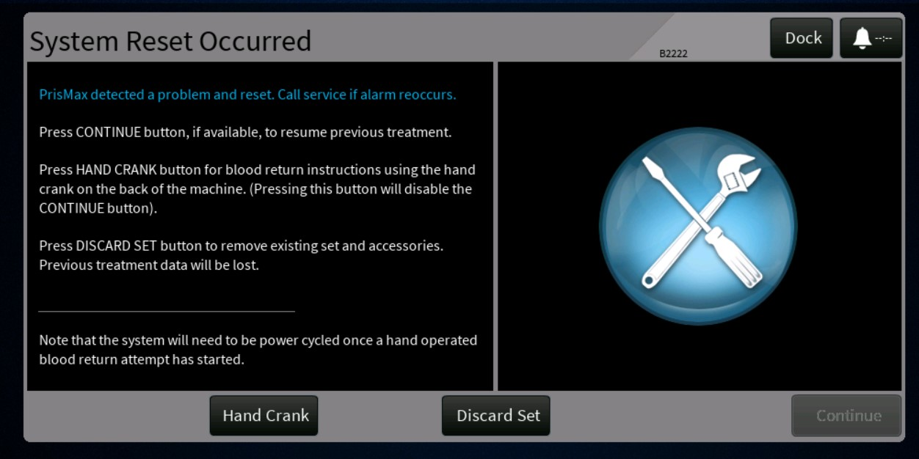

Figure - System Reset Alarm (B2222)

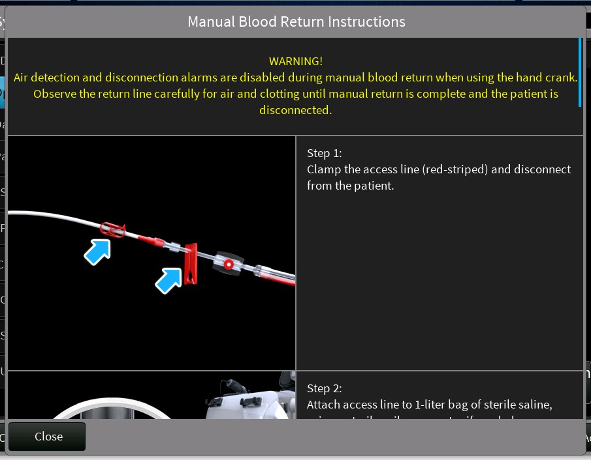

Figure - Manual Return Part 1

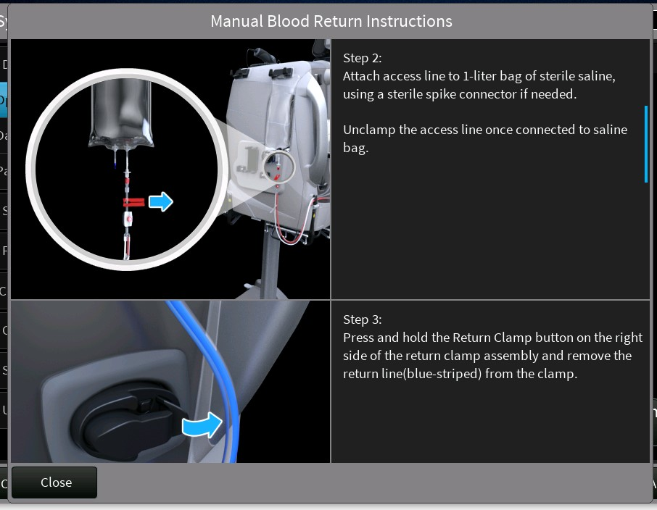

Figure - Manual Return Part 2

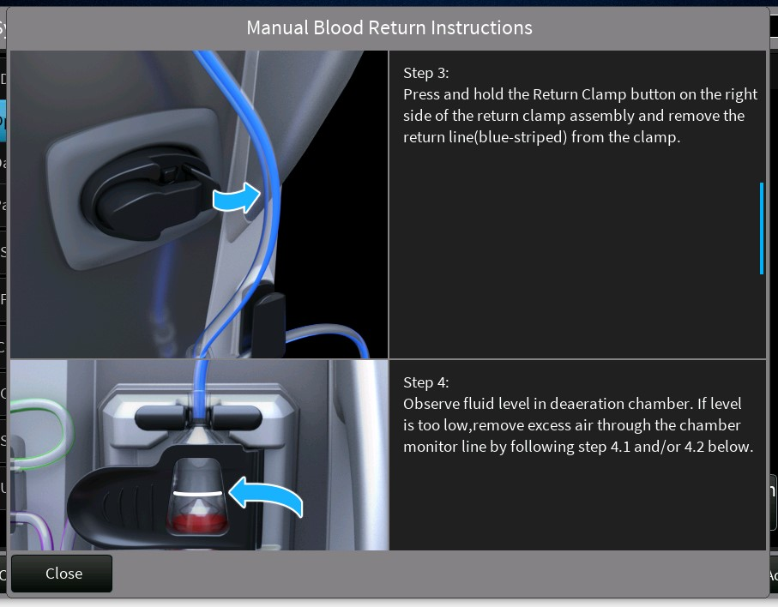

Figure - Manual Return Part 3

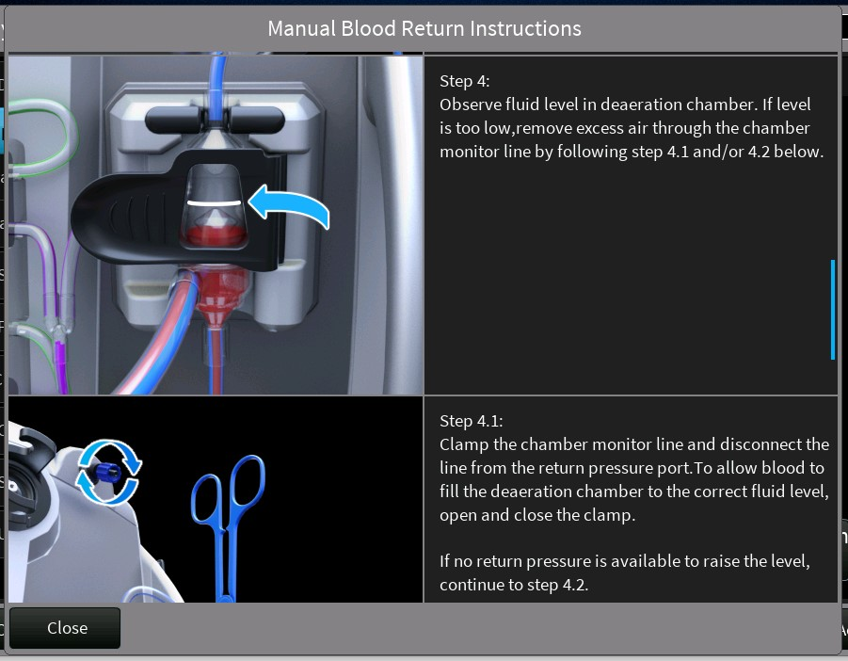

Figure - Manual Return Part 4

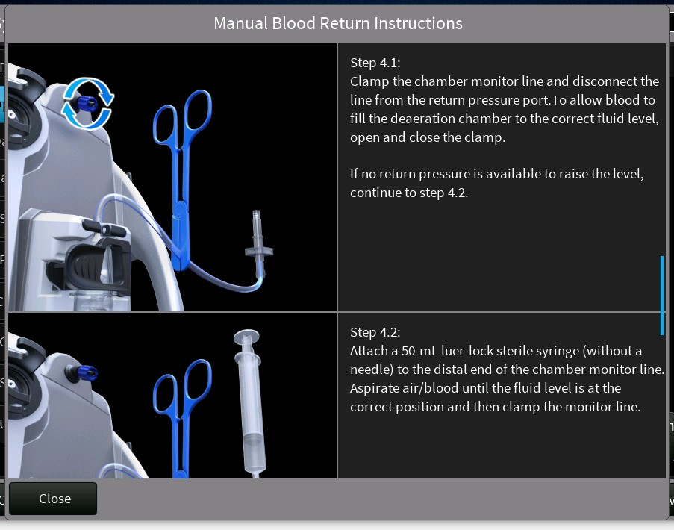

Figure - Manual Return Part 5

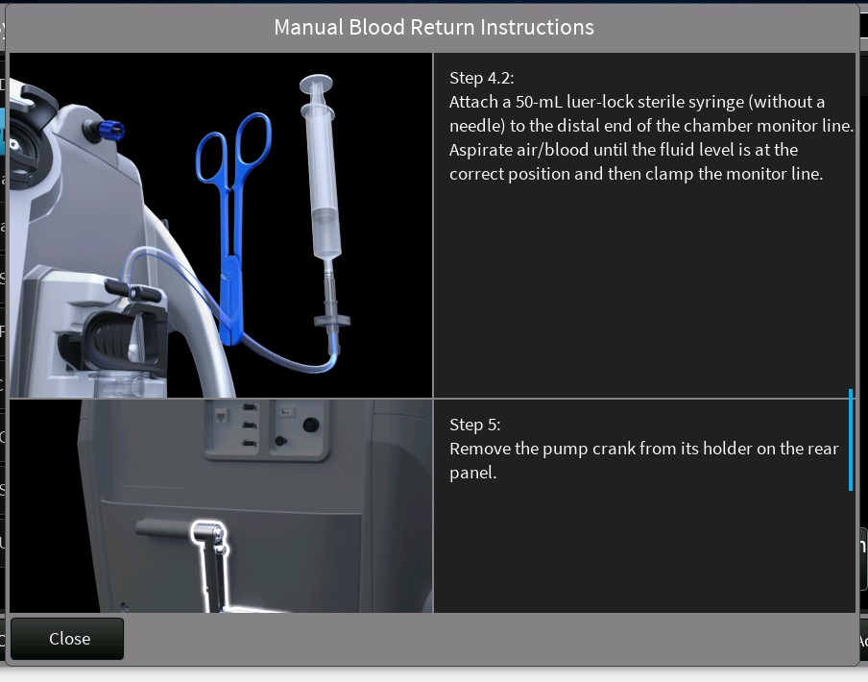

Figure - Manual Return Part 6

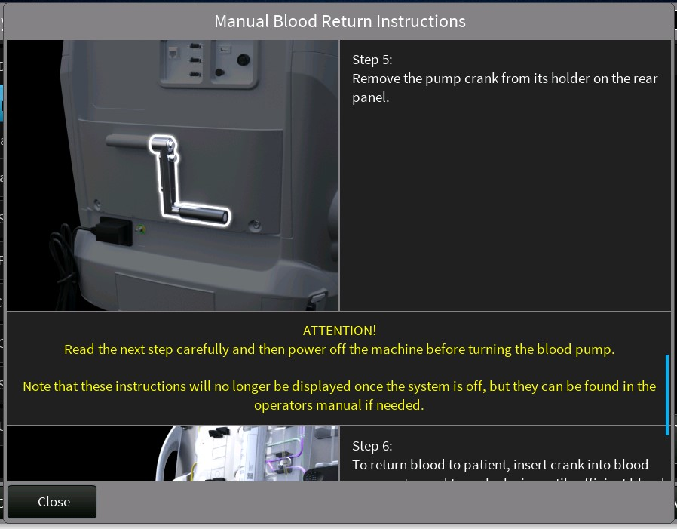

Figure - Manual Return Part 7

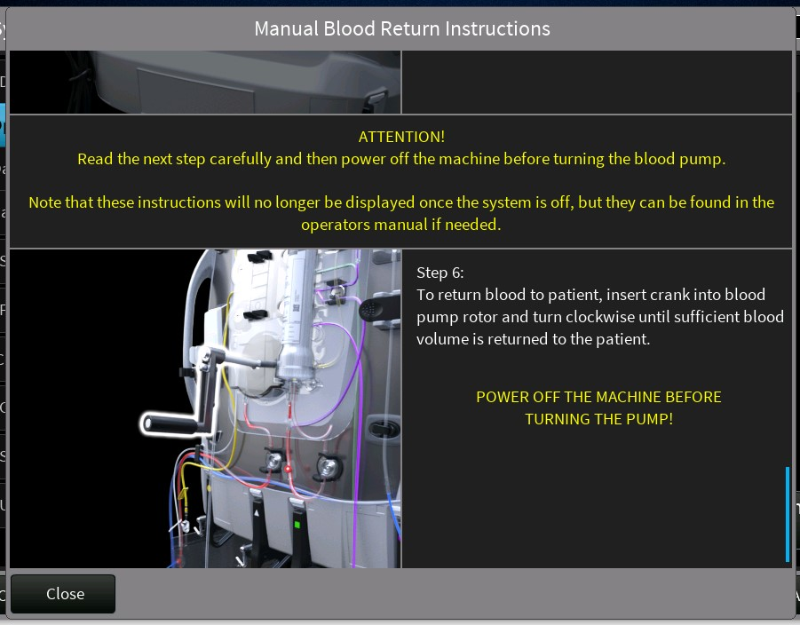

Figure - Manual Return Part 8

**Implementation Description:**

src/Shared/AlarmIds.cpp  
src/Shared/AlarmIds.h  
src/Shared/AlarmActionIds.cpp  
src/Shared/AlarmActionIds.h  
src/Shared/AlarmDialogRequests.h  
src/Therapy/AlarmProcessing/AlarmsConst.inc  
src/GUI/PrisMaxGUI/AlarmDisplayDataConst.inc  
Generated above files in DOORs for adding "Hand Crank" action button for B2222 Alarm.  
**********************************************************************************

src/GUI/PrisMaxGUI/AlarmGraphics.cpp  
src/GUI/PrisMaxGUI/AlarmGraphicsMalfunctions.inc  
Modified above files adding and updating PrisMax power button image in system failure alarms.  
**********************************************************************************  
src/GUI/PrisMaxGUI/AlarmManagerGUI.cpp  
Modified AlarmManagerGUI for opening Manual Blood Return Instructions screen when "Hand Crank" alarm action selected(on B2222).  
**********************************************************************************  
src/GUI/PrisMaxGUI/Assets/PrisMaxBitmaps.h  
src/GUI/PrisMaxGUI/Assets/PrismaxStrings.h  
Modified above files for adding new SID's and Bitmaps for displaying instructions and images in Manual Blood return instructions screen.  
**********************************************************************************

src/GUI/PrisMaxGUI/DefaultMarkupSupport.cpp  
Modified DefaultMarkupSupport file for displaying different message variants in system failure alarm for in/outside treatment.  
**********************************************************************************  
src/GUI/PrisMaxGUI/ManualBloodReturnInstructionsScreen.cpp  
src/GUI/PrisMaxGUI/ManualBloodReturnInstructionsScreen.h  
Added ManualBloodReturnInstructionsScreen class for Manual Blood return instructions dialog screen.  
**********************************************************************************

src/GUI/PrisMaxGUI/RowLayout.cpp  
src/GUI/PrisMaxGUI/RowLayout.h  
Added RowLayout class for displaying added UI Items in a row, Manual blood return dialog instructions are displaying using this class.  
**********************************************************************************

src/GUI/PrisMaxGUI/ScrollableItem.cpp  
src/GUI/PrisMaxGUI/ScrollableItem.h  
Added Scrollable Item class for creating a scrollable dialog, Manual blood return instructions are displaying using this class.  
**********************************************************************************

src/Therapy/AlarmProcessing/UserInterfaceManager.cpp  
Modified UserInterfaceManager class for docking B2222 alarm when "Hand Crank" action selected.  
**********************************************************************************

src/Therapy/AlarmHandling/AlarmHandler.cpp  
Modified AlarmHandler for sending Alarm action notification for Opening Manual Blood Return screen and disabling continue button when "Hand Crank" action selected.  
**********************************************************************************

**Code Review summary:**

<https://bitbucket-prod.aws.baxter.com/projects/PMAX3/repos/prismaxcp/pull-requests/559/overview>  
<https://bitbucket-prod.aws.baxter.com/projects/PMAX3/repos/prismaxguiassets/pull-requests/197/overview>

**Updated Deliverables:**

**The following files were updated in BitBucket commit ID** [**ab5fc1c79fb**](https://bitbucket-prod.aws.baxter.com/projects/PMAX3/repos/prismaxcp/pull-requests/559/commits/ab5fc1c79fb4b626d1cd921345e8072d02bfccb8)

src/GUI/PrisMaxGUI/AlarmDisplayDataConst.inc  
src/GUI/PrisMaxGUI/AlarmGraphics.cpp  
src/GUI/PrisMaxGUI/AlarmGraphicsMalfunctions.inc  
src/GUI/PrisMaxGUI/AlarmManagerGUI.cpp  
src/GUI/PrisMaxGUI/Assets/PrisMaxBitmaps.h  
src/GUI/PrisMaxGUI/Assets/PrismaxStrings.h  
src/GUI/PrisMaxGUI/CMakeLists.txt  
src/GUI/PrisMaxGUI/DefaultMarkupSupport.cpp  
src/GUI/PrisMaxGUI/ManualBloodReturnInstructionsScreen.cpp  
src/GUI/PrisMaxGUI/ManualBloodReturnInstructionsScreen.h  
src/GUI/PrisMaxGUI/PrisMaxGUI.gpj  
src/GUI/PrisMaxGUI/RowLayout.cpp  
src/GUI/PrisMaxGUI/RowLayout.h  
src/GUI/PrisMaxGUI/ScreenDriver.cpp  
src/GUI/PrisMaxGUI/ScreenDriver.h  
src/GUI/PrisMaxGUI/ScrollableItem.cpp  
src/GUI/PrisMaxGUI/ScrollableItem.h  
src/Shared/AlarmActionIds.cpp  
src/Shared/AlarmActionIds.h  
src/Shared/AlarmDialogRequests.h  
src/Shared/AlarmIds.cpp  
src/Shared/AlarmIds.h  
src/Therapy/AlarmHandling/AlarmHandler.cpp  
src/Therapy/AlarmProcessing/AlarmsConst.inc  
src/Therapy/AlarmProcessing/UserInterfaceManager.cpp  
src/Therapy/Controllers/StartupController.cpp

## 

## 3.1.7 TPE priming updates to ensure air bubbles are removed from return line (PFAL-2281)

**Design Update:**

1. For all TPE primes, the ABD will be enabled after the Effluent Pump stops (on the final priming bag).
2. For TPE primes ensure that at least twice the volume of the return line (the section measured after the ABD) is flushed through the system after the ABD is enabled. This is necessary to ensure the return line is free of air before connecting it to a patient.
3. For all therapy types eliminate the observed half second lag of the Blood Pump. This was observed when reference to the response of the Effluent Pump.
4. Prevent the Effluent Pump from starting before the Blood Pump. This only impacts TPE due to the way the set tubing is routed. Running the Effluent Pump without the Blood Pump for TPE can cause a vacuum condition within the filter.
5. For CRRT therapies that only require one bag for priming, the liquid level adjustment in the deaeration chamber must be delayed until after the Thermax Bag Test completes. *Note: this was discovered as part of the investigation and is not applicable to TPE, since all TPE primes require either 2 or 3 bags.*
6. The Priming Algorithm will monitor when an automatic liquid level adjustment occurs. In this way, the Algorithm decides when to enable the ABD based upon whether an open-loop level or automatic level adjustment occurs.

**Display Updates:**

No impact to the UI.

**Implementation Description:**

1. For all TPE primes, the ABD is enabled 3 seconds after the Effluent Pump stops, near the end of priming.  The 3 seconds allow time for the volume of fluid upstream of the ABD to be flushed clear prior to enabling air detection. There is also a condition to ensure that a minimum amount of fluid is left in the final priming bag. Although with proper parameters this should never happen.
2. For TPE2000, "PrQb3" was reduced from 250 to 244 mL/min with each corresponding cycle time being extended to maintain the same consumption of priming solution for each cycle. This was done to allow additional time for the Blood Pump to run without the Effluent Pump. Note that the flow rate change to TPE2000 will result in a ratio of blood/effluent flow through the filter which will more closely resemble that of TPE1000. TPE1000 flow rates will remain unchanged.
3. For CRRT, TPE and HP, an increased delay before commanding the Blood Pump clockwise, after commanding it in the counterclockwise direction. The existing delay was increased from 0.5 to 1.0 second which now syncs up to what higher-level software is expecting. Note: this occurs between priming bag changes and impacts all primes that require more than one priming bag.
4. For all TPE primes, the Effluent Pump is delayed so it lags the Blood Pump 0.5 seconds after a bag change.
5. For CRRT and TPE therapies that only use one bag for priming, an enumeration to track the status of the Thermax Bag Test was created. This is used internal to the Priming Model to signal when a level adjustment can be requested.
6. For CRRT and HP, higher-level software will pass "LLadjActive" from the ARPS model as an input into the Priming Model. Higher-level software will now wait to enable the ABD until commanded by the Priming Control Algorithm. The Priming Control Algorithm will begin monitoring the newly added input at the point when "PrimeStatus.EnableARPSairRemoval" is set true. If the input UseLiqLevSensor is false, the Priming Control Algorithm will stop monitoring and proceed to send the legacy open-loop commands. Otherwise, the Priming Control Algorithm will wait to enable the ABD until after a successful level adjustment is detected or a minimum amount of fluid is left in the final priming bag (whichever occurs first). This extra logic is only utilized in the event LLadjActive does not complete within the expected time.

**Code Review summary:**

<https://bitbucket-prod.aws.baxter.com/projects/PMAX3/repos/prismaxcp/pull-requests/598/overview>

**Updated Deliverables:**

The following files were updated in [604a9205ffd](https://bitbucket-prod.aws.baxter.com/projects/PMAX3/repos/prismaxcp/pull-requests/598/commits/604a9205ffdff6392bf9b1093e1b1da0d42c57e8)

PrimeControllerTop.slx  
PrimeControllerTopIntf.xls  
LIB_PrimeControllerStateFlow.slx  
KrD_PrimingParams.m  
EN_ARPS_AIR_REMOVAL.m (added)  
THERMAX_TEST_STATUS.m (added)  
  
PrimeControllerTop.cpp  
PrimeControllerTop.h  
PrimeControllerTop_data.cpp

## 3.1.8 HPX labeling updates (PFAL-2275)

**Design Update:**

**Only show the glucose related advisory for the Adsorba cartridge**

Add a new markup text tags ADSORBA that can be used by DefaultMarkupSupport.cpp to show only the glucose related advisory text when an ADSORBA filer is used and HPX to show the cartridge name on the review prescription screen.

Modify DefaultMarkupSupport to use therapy data from the dictionary to determine if a user selects any Adsorba (for ASDORBA tag) or HPX custom cartridge (HPX tag).

Update the following SIDs to use the new ADSORBA tag for showing the relevant glucose items.

SID_ADVISORY_PRIME

SID_ADVISORY_PRIME_COMPLETE

SID_ADVISORY_PRIME_HP

SID_ADVISORY_PRIME_PREPARE

Update the following SID to display the cartridge name when an HPX set is in use.

SID_PRESCRIPTION_DIALOG_MARKUP

Also add the display of cartridge name to the review prescription dialog.

**Display Updates:**

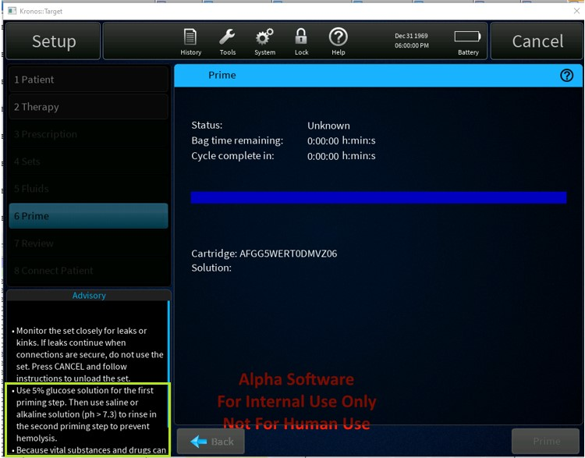

Figure - Dialog Displayed for Adsorba Cartridges

**Implementation Description:**

Added 2 conditional cases to Default Markup Support.  
ADSORBA - checks for an Adsorba 150 or 300 set selected in the Setup - Therapy step  
HPX - checks for HPX selected in Setup - Therapy step

Labeling updates:  
SID_PRESCRIPTION_DIALOG_MARKUP - added HPX conditional that includes the cartridge text  
SID_ADVISORY_PRIME_PREPARE - added ADSORBA to first conditional for glucose warning.  
SID_ADVISORY_PRIME_HP - added ADSORBA conditional around first bullet point about glucose warning.  
SID_ADVISORY_PRIME - replaced glucose conditional with ADSORBA conditional. Added new conditional for second bullet point.  
SID_ADVISORY_PRIME_COMPLETE - replaced glucose conditional with ADSORBA conditional. Added new conditional for second bullet point.

**Code Review summary:**

PrisMaxCP

<https://bitbucket-prod.aws.baxter.com/projects/PMAX3/repos/prismaxcp/pull-requests/564/overview>

PrisMaxGUIAssets

https://bitbucket-prod.aws.baxter.com/projects/PMAX3/repos/prismaxguiassets/pull-requests/205/overview

https://bitbucket-prod.aws.baxter.com/projects/PMAX3/repos/prismaxguiassets/pull-requests/261/overview

**Updated Deliverables:**

The following files were updated in BitBucket commit ID

PrisMaxCP - 6156ca69cd94808e69b7b4157071078db88511d0

PrisMaxGUIAssets - [1ec273a5c22](https://bitbucket-prod.aws.baxter.com/projects/PMAX3/repos/prismaxguiassets/commits/1ec273a5c2288f9d72b6c2285ee27d034b4b0be3)

CP: DefaultMarkupSupport.cpp (modified)  
Binaries: Default.psf

## 3.1.9 Bag mixing image update before priming (PFAL-2274)

**Design Update:**

Only minor code changes (Replaced priming images with new images)

Display Updates:

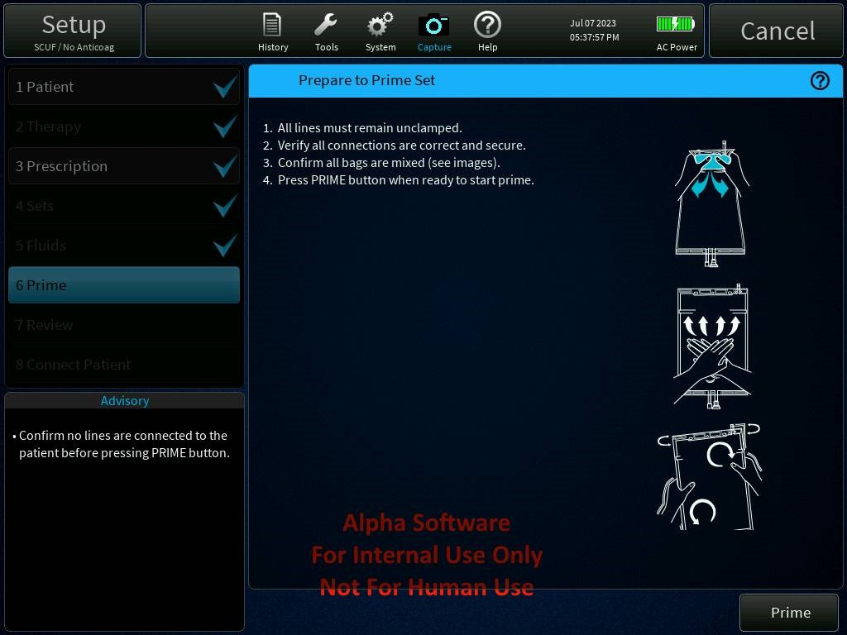

Figure - Updated Bag Mixing Graphic

**Implementation Description:**

* Replaced Prime_Bag_Break.png in PrisMaxGUIAssets.
* Created a new PrisMaxBitMaps.bin with latest image provided.

**Code Review summary:**

PrisMaxGUIAssets : <https://bitbucket-prod.aws.baxter.com/projects/PMAX3/repos/prismaxguiassets/pull-requests/115/overview>

**Updated Deliverables:**

1.Prime_Bag_Break.png  
Replaced existing image with new image.  
  
Commit ID to master  
----------------------------  
PrisMaxGUIAssets : ebdf6138e9e

## 3.1.10 Miscellaneous GUI labeling updates (PFAL-2273)

**Design Update:**

Only minor code changes (updated alarm images).

**Display Updates:**

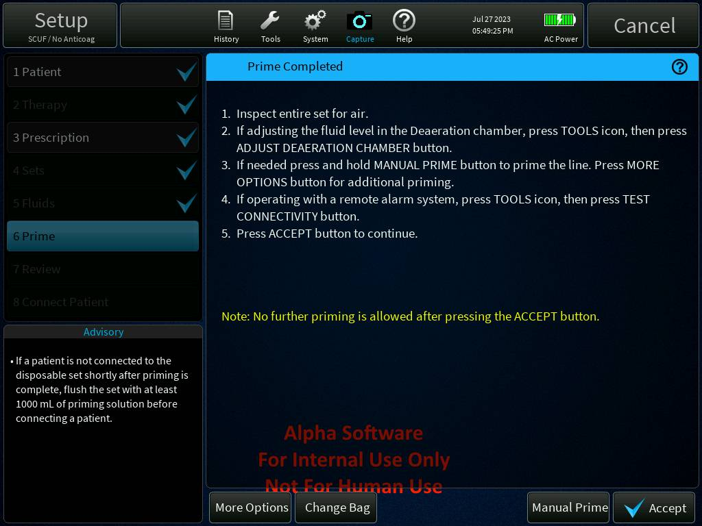

Figure - Updated Prime Complete Steps

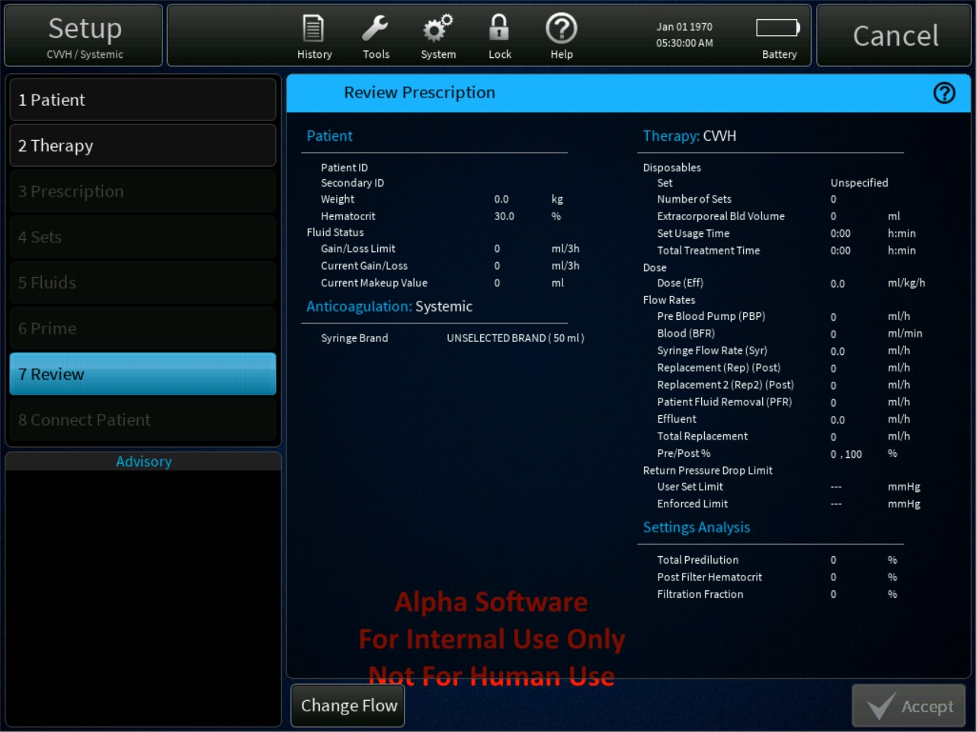

Figure - Review Prescription Fix

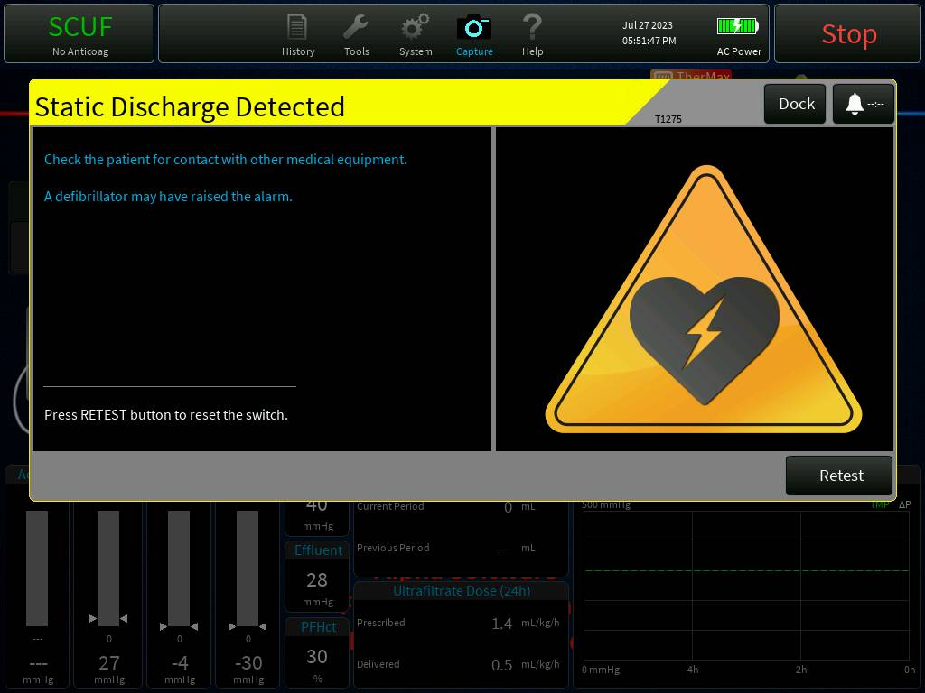

Figure - Static Discharge Detect Alarm previously High Voltage Detected

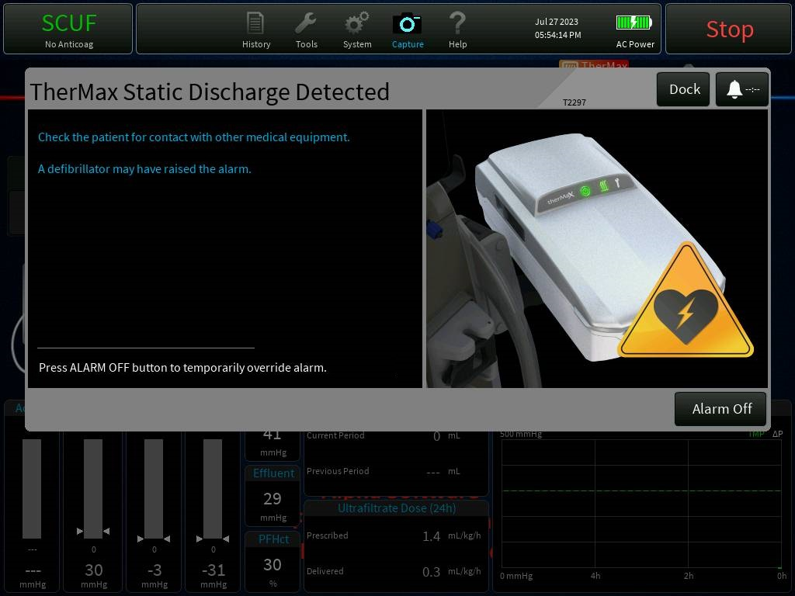

Figure - TherMax Discharge Detected previously TherMax at Mains Voltage

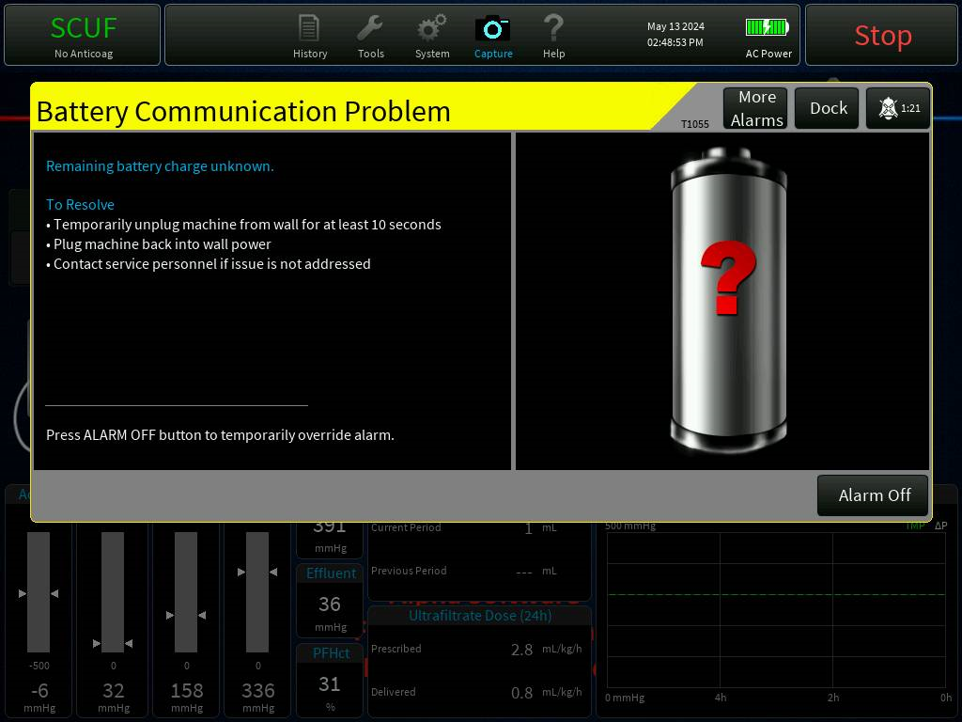

Figure - Battery Communication Problem previous High Battery Temp

**Implementation Description:**

1. Updated the string SID_PRESCRIPTION_DIALOG_MARKUP to remove extra parentheses at the end of "Post" in the Review Prescription screen in CVVH treatment.
2. Updated alarm text (SID_ALARM_T1055_BODY) and title (SID_ALARM_T1055_TITLE) for Battery Temp High alarm (T1055)
3. Updated the image displayed for T1055 alarm.
4. Updated alarm text (SID_ALARM_T1275_BODY) and title (SID_ALARM_T1275_TITLE) for discharger alarm (T1275).
5. Updated the image to display caution triangle with defib symbol in the middle for T1275.
6. Updated alarm text (SID_ALARM_T2297_BODY) and title (SID_ALARM_T2297_TITLE) for TherMax discharger alarm (T2297).
7. Updated the image to have caution triangle with defib symbol for T2297
8. Changed the order of steps on 'Prime Completed' screen.

**Code Review summary:**

PrisMaxCP  
<https://bitbucket-prod.aws.baxter.com/projects/PMAX3/repos/prismaxcp/pull-requests/467/overview>  
PrisMaxGUIAssets  
<https://bitbucket-prod.aws.baxter.com/projects/PMAX3/repos/prismaxguiassets/pull-requests/117/overview>

**Updated Deliverables:**

1. PrisMaxBitmaps.h  
   Added BIDs for the new images.  
2. AlarmDisplayDataConst.inc/AlarmConst.inc  
   Updated alarm action (from Override to Alarm Off) for T2297 alarm.  
3. AlarmGraphics.cpp  
   Updated image for T1275 alarm  
4. AlarmGraphicsMalfunctions.cpp  
   Updated the image for T2297 alarm  
5. AlarmGraphicsPower.inc  
   Updated the image for T1055 alarm.  
  
Commit ID to master  
-----------------------  
PrisMaxCP - df542ef96f5  
PrisMaxGUIAssets - ab18793072a

## 3.1.11 German translations for “hours” vs. “time of day” (PFAL-2263)

**Design Update:**

No Design changes, only Minor code changes.

**Display Updates:**

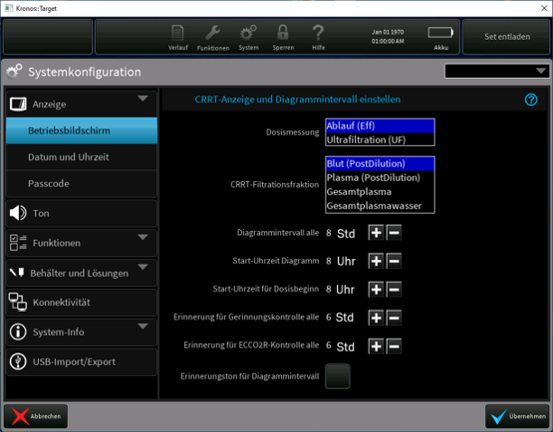

Figure - Example German Translation

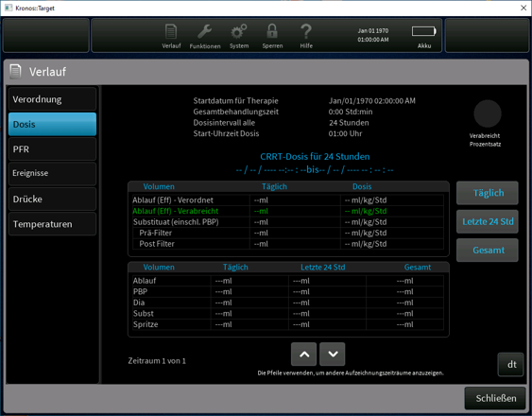

Figure - German on Dose Screen

**Implementation Description:**

src/GUI/PrisMaxGUI/OpsPlot.cpp

************************************

Modified this file for increasing safety string label width for accommodating 34 characters from 31 characters to display time units.

src/GUI/PrisMaxGUI/SysConfigScreen_Creators.cpp

*****************************************************

Added new SID for displaying duration units for German language and then updated SID in the logic.

**Code Review summary:**<https://bitbucket-prod.aws.baxter.com/projects/PMAX3/repos/prismaxcp/pull-requests/354/overview>  
<https://bitbucket-prod.aws.baxter.com/projects/PMAX3/repos/prismaxcp/pull-requests/389/overview>  
<https://bitbucket-prod.aws.baxter.com/projects/PMAX3/repos/prismaxcp/pull-requests/405/overview>  
<https://bitbucket-prod.aws.baxter.com/projects/PMAX3/repos/prismaxcp/pull-requests/443/overview>  
<https://bitbucket-prod.aws.baxter.com/projects/PMAX3/repos/prismaxcp/pull-requests/434/overview>  
<https://bitbucket-prod.aws.baxter.com/projects/PMAX3/repos/prismaxguiassets/pull-requests/52/overview>  
<https://bitbucket-prod.aws.baxter.com/projects/PMAX3/repos/prismaxguiassets/pull-requests/85/overview>  
<https://bitbucket-prod.aws.baxter.com/projects/PMAX3/repos/prismaxguiassets/pull-requests/104/overview>  
<https://bitbucket-prod.aws.baxter.com/projects/PMAX3/repos/prismaxguiassets/pull-requests/111/overview>  
<https://bitbucket-prod.aws.baxter.com/projects/PMAX3/repos/prismaxguiassets/pull-requests/111/overview>  
<https://bitbucket-prod.aws.baxter.com/projects/PMAX3/repos/prismaxguiassets/pull-requests/126/overview>  
<https://bitbucket-prod.aws.baxter.com/projects/PMAX3/repos/prismaxguiassets/pull-requests/129/overview>

**Updated Deliverables:**  
src/GUI/PrisMaxGUI/OpsPlot.cpp  
src/GUI/PrisMaxGUI/SysConfigScreen_Creators.cpp  
src/GUI/PrisMaxGUI/Assets/PrismaxStrings.h

## 3.1.12 Update software to prevent T2300 TherMax bag inflation failures during priming (PFAL-2299)

**Design Update:**

The proposed update will allow more time for the "ThermaxBagInflate" Test to complete.

**Display Updates:**

No update to UI.

**Implementation Description:**

The proposed update involves updating the timeout so that it checks fluid pumped since the beginning of when the "ThermaxBagInflate" Test starts rather than using the total amount of fluid pumped from the start of priming. Based on experimentation and execution of test scripts, it was determined that 150 mL gave over 2x margin and still allowed enough time to perform the subsequent "ThermaxBagCheck" Test. Enumerations were also added to monitor Thermax Bag tests so that the ARPS pump will not attempt to perform a level adjustment of the chamber until after the TherMax tests complete.

Portion of the model updated:

PrimeControllerTop/PrimeController/PrimeControllerStateFlow/Active/PrimeAndRePrime/Thermax Tests

**Code Review summary:**

PrisMaxGUIAssets

PFAL-2299

https://bitbucket-prod.aws.baxter.com/projects/PMAX3/repos/prismaxguiassets/pull-requests/277/overview

**Updated Deliverables:**

PrimeControllerTop.slx

PrimeControllerTopIntf.xls

LIB_PrimeControllerStateFlow.slx

KrD_PrimingParams.m

EN_ARPS_AIR_REMOVAL.m (added)

THERMAX_TEST_STATUS.m (added)

PrimeControllerTop.cpp

PrimeControllerTop.h

PrimeControllerTop_data.cp

English.xml

PrisMaxGUIAssets commit ID’s- [a0d0921ddaa](https://bitbucket-prod.aws.baxter.com/projects/PMAX3/repos/prismaxguiassets/commits/a0d0921ddaa45e2bf2587404b5660e15f82974bc)

## 3.1.13 Improve reliability of the software in handling simultaneous bag changes (PFAL-2219)

**Design Update:**  
Update the bag change start, complete and cancel event handling code in BagController to protect against using a Scale enum value of MAXSCALE.

Note: there is some code contained within the newly added protection that may not be executed if/when the Scale enum value returned from BagController::FillBagChangeStatusArray(). However, this will not cause any undesirable effects:

* The protected code when handling the BAG_CHANGE_START event is associated with handling a bag change that results without opening a scale (i.e. remove bag from a closed scale). There is already another [PFAL-2303](https://jira-bp.aws.baxter.com/browse/PFAL-2303) associated with this logic, so any further changes will be addressed as part of this [PFAL-2303](https://jira-bp.aws.baxter.com/browse/PFAL-2303).
* The protected code when handling the BAG_CHANGE_CANCEL or BAG_CHANGE_COMPLETE events will never have a situation where this code should have been executed but isn't because these scenarios are not possible.

For supporting evidence, see the attached sequence diagrams:

* "Change Bag Start Sequence.uxf/png" - documents scenario that causes a BIOT
* "Change Bag Complete Sequence.uxf/png", "Change Bag Complete Sequence2.uxf/png" and "  
  Change Bag Complete Sequence3.uxf/png" - document scenarios that can never occur.
* 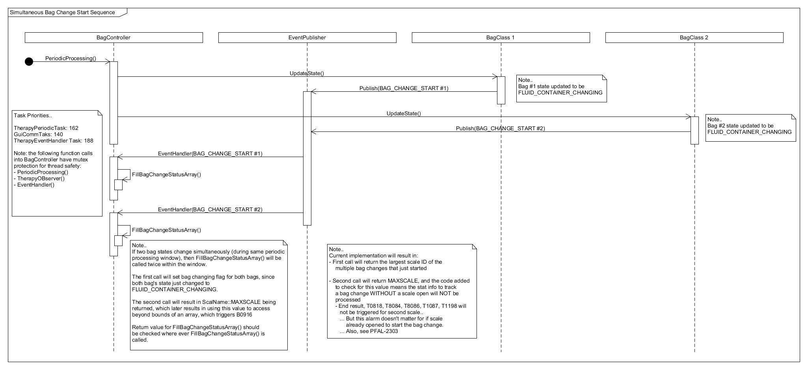

Figure - Change Bag Start

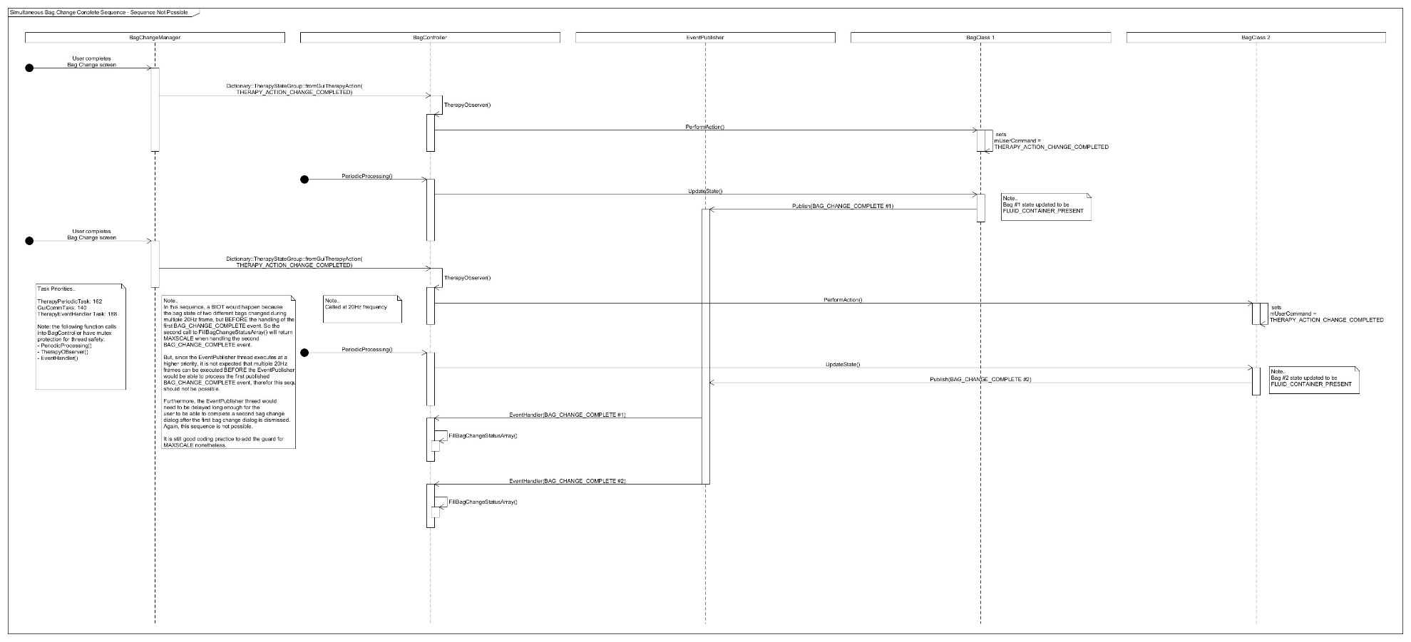

Figure - Bag Change Complete 3

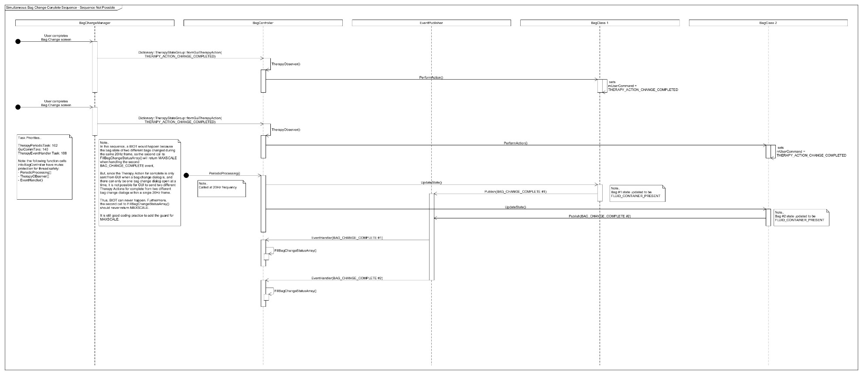

Figure - Bag Change Complete

**Display Updates:**

No impact to the UI

**Implementation Description:**  
Event handling in the BagController class was updated as follows:

**BAG_CHANGE_START event**  
ScaleOpen and LocallyFilteredWeight methods are now protected against being  
called from a NULL pointer on the BagClass array.

**BAG_CHANGE_COMPLETE event**  
Bag change complete states captured, and then two of these events occurring before a periodic processing call

Two of these events occurring sequentially before a therapy periodic processing frame  
is not possible. However, protection was still added around the usage of the MAXSCALE enum to be safe.

**BAG_CHANGE_CANCEL event**  
Not possible for two of these events to occur before a therapy periodic processing call.  
Protection against usage of MAXSCALE enum still added to be safe.

**Code Review summary:**

<https://bitbucket-prod.aws.baxter.com/projects/PMAX3/repos/prismaxcp/pull-requests/543/overview>

**Updated Deliverables:**

The following source code files were modified:  
- src/Therapy/Controllers/BagController.cpp  
- UnitTest/Therapy/Controllers/BagController/BagController_UT.cpp  
  
 Commit ID - a59dd030310  
 Commit Date - 15 Nov 2023

## 3.1.14 HP-X Auto leveling Priming update (PFAL-2288)

**Design Update:**  
The proposed change to the SW will only initialize the internal clamp closed state variables in the ARPSModelController in the constructor rather than also on the transition to the initial state. This will prevent the ARPSModelController from setting those internal clamp closed state values to something other than the real clamp value. After powering PrisMax on, the internal clamp closed state variables will follow the true clamp value based on the CLAMP_CLOSED and CLAMP_OPENED events generated by the ReturnClampController.

See attached class diagram:

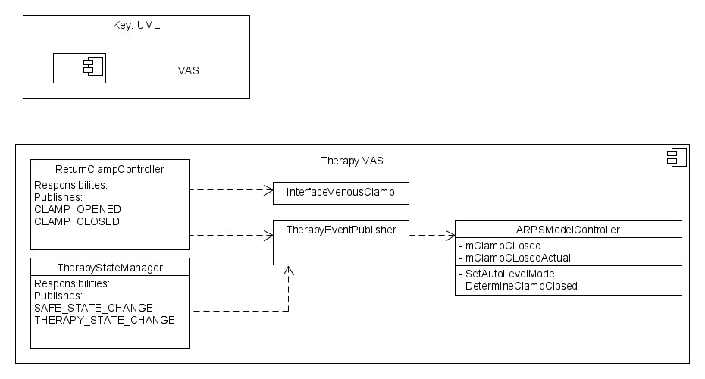

**Display Updates:**

No impact to the UI

**Implementation Description:**

In ARPSModelController, remove the setting of mClampClosed and mClampClosedActual Booleans in the Initialize method. In the ARPSModelController constructor, set both of those variables to true (clamp is always closed on initial PrisMax power up).

**Code Review summary:**

<https://bitbucket-prod.aws.baxter.com/projects/PMAX3/repos/prismaxcp/pull-requests/549/overview>

**Updated Deliverables:**  
The following files were updated in BitBucket commit ID 97f2788634ae0fd44c7ff7f2b4f283f2cfdcc6f0

BagController.cpp (modified)  
BagController_UT.cpp (modified)

## 3.1.15 Improve HP-X Priming sequence when no PBP bag is used (PFAL-2288)

**Design Update:**  
The proposed change to the Priming Control Algorithm will prime the PBP line using the first solution for all HP therapies when PBP is not selected. In other words, the Priming Control Algorithm will always prime the PBP line (all the way to the PBP bag connector) using the first solution, when a PBP flow rate is 0 and a bag is not present.

**Display Updates:**

No impact to the UI

**Implementation Description:**

The proposed update to the Priming Control Algorithm involves priming the PBP line from the first solution only when no PBP is selected. When no PBP is selected this is considered a "short" prime. The timing for when the PBP line is primed for short primes has been updated so it now happens when the section of the access line upstream of the PBP junction is filled. This is implemented using a 2x volume to ensure no air is present before commanding the PBP pump to run.

Parts of the model updated:

PrimeControllerTop/PrimeController/PrimeControllerStateFlow/Active/HPxTimeCalcs

PrimeControllerTop/PrimeController/PrimeControllerStateFlow/Active/PrimeAndRePrime/PreBlood/PreBlood_HP

**Code Review summary:**

<https://bitbucket-prod.aws.baxter.com/projects/PMAX3/repos/prismaxcp/pull-requests/549/overview>

**Updated Deliverables:**

The following files were updated in BitBucket commit ID 97f2788634ae0fd44c7ff7f2b4f283f2cfdcc6f0

PrimeControllerTop.slx  
PrimeControllerTopIntf.xls  
LIB_PrimeControllerStateFlow.slx  
KrD_PrimingParams.m  
EN_ARPS_AIR_REMOVAL.m (added)  
THERMAX_TEST_STATUS.m (added)

PrimeControllerTop.cpp  
PrimeControllerTop.h  
PrimeControllerTop_data.cpp

## 3.1.16 Update Data Sampling Rate to Match EMR Transmission Rate (PFAL-2267)

**Design Update:**  
Updated TherapyDataLoggerTask_start() so that therapy data used for EMR output is refreshed every 5 seconds.  
Updated the frequency at which the methods will be called to get the latest data on weight, pressure, dose, PFR etc.  
Updated the number of EMR samples saved per hour as 720.

**Display Updates:**

No updates to the UI.

**Implementation Description:**  
1. Added a flag mWriteToDatabase to control writing to logdb.  
2. Added a new method UpdateWriteFlag() to set the new flag.  
3. The following dictionaries   
 TherapyLoggerDictionary::toDataStoreScaleWeights  
 TherapyLoggerDictionary::toDataStorePressures  
 TherapyLoggerDictionary::toDataStorePeriodic  
will get updated only if the flag mWriteToDatabase is set.

4. The following methods   
 gsTherapyDataLogger.ProcessWeightData();  
 gsTherapyDataLogger.ProcessPressureData();  
 gsTherapyDataLogger.ProcessPeriodicLogData();  
 gsTherapyDataLogger.ProcessDosePfrData();  
 gsTherapyDataLogger.UpdateEMRDataBase();   
will be called every 5 seconds to refresh the data.  This will not update log db since mWriteToDatabase is set

**Code Review summary:**

<https://bitbucket-prod.aws.baxter.com/projects/PMAX3/repos/prismaxcp/pull-requests/566/overview>

**Updated Deliverables:**

1. src/Therapy/Controllers/TherapyDataLogger.cpp  
2. src/Therapy/Controllers/TherapyDataLogger.h  
3. src/Therapy/TherapyDataLoggerTask.cc

## 3.1.17 Sustained High Return Pressure Causes a BIOT (PFAL-2341)

**Design Update:**

The check on Return pressure should be removed from the function PodRepositionSequenceController::SystemSafe(). The sequence diagram of the current behavior is attached in Orig_SystemSafeSeq.uxf and Orig_SystemSafeSeq.PNG. This shows how the BIOT occurs when the ENGLOG error occurs. The sequence diagram with the pressure check removed is below:

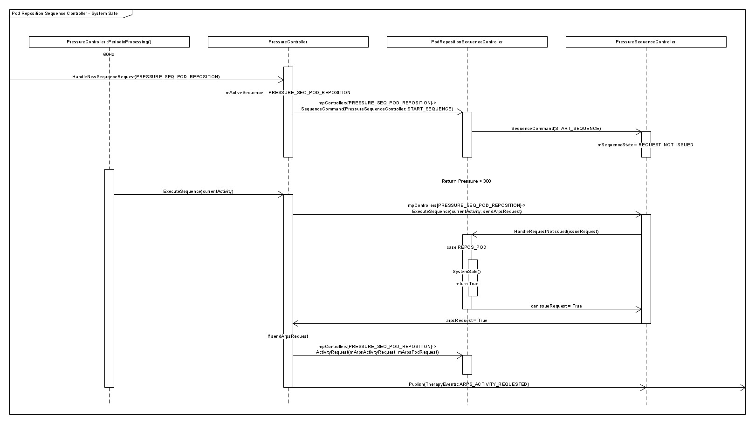

**Display Updates:**

No updates to the UI

**Implementation Description:**

The maximum pressure for a return pressure too high alarms was increased from 300.00 mmHg to 350.00 mmHg.

PodRepositionSequenceController::SystemSafe() no longer checks the return pressure when determining if the system is safe for a pod repositioning on the return.

**Code Review summary:**

<https://bitbucket-prod.aws.baxter.com/projects/PMAX3/repos/prismaxcp/pull-requests/558/commits>

**Updated Deliverables:**

AlarmsAndOperatingPointTop.cpp/h  
PodRepositionSequenceController.cpp  
PodRepositionSequenceController_Stub.cpp  
PodRepositionSequenceController_UT.cpp  
  
Commit ID: 48bcc181384de1902918942dd2d341872bcaedfe  
Commit Date: 21 Dec 2023

## 3.1.18 English XML Updates (PFAL-2297)

**Design Update:**   
XML changes (Update xml file to correct xml related issues)

**Display Updates:**

**N/A**

**Implementation Description:**

Update strings in xml

**Code Review summary:**

PrisMaxGUIAssets

PFAL-2331

https://bitbucket-prod.aws.baxter.com/projects/PMAX3/repos/prismaxguiassets/pull-requests/244/overview  
https://bitbucket-prod.aws.baxter.com/projects/PMAX3/repos/prismaxguiassets/pull-requests/264/overview

[PFAL-2322](https://jira-bp.aws.baxter.com/browse/PFAL-2322)  
<https://bitbucket-prod.aws.baxter.com/projects/PMAX3/repos/prismaxguiassets/pull-requests/229/overview>  
  
[PFAL-2324](https://jira-bp.aws.baxter.com/browse/PFAL-2324)  
<https://bitbucket-prod.aws.baxter.com/projects/PMAX3/repos/prismaxguiassets/pull-requests/230/overview>  
  
[PFAL-2394](https://jira-bp.aws.baxter.com/browse/PFAL-2394)  
<https://bitbucket-prod.aws.baxter.com/projects/PMAX3/repos/prismaxguiassets/pull-requests/231/overview>

**Updated Deliverables:**  
English.xml

PFAL-2331  
PrisMaxGUIAssets - [d41193b2b0e](https://bitbucket-prod.aws.baxter.com/projects/PMAX3/repos/prismaxguiassets/commits/d41193b2b0ef71d9029865bfdf4a5dc18fe67554)

[PFAL-2322](https://jira-bp.aws.baxter.com/browse/PFAL-2322)  
PrisMaxGUIAssets - bd7936be812  
  
[PFAL-2324](https://jira-bp.aws.baxter.com/browse/PFAL-2324)  
PrisMaxGUIAssets - fc91a11b9bc  
  
[PFAL-2394](https://jira-bp.aws.baxter.com/browse/PFAL-2394)  
PrisMaxGUIAssets - 9c933c116b0

## 3.1.19 PrisMax Delivered Dose is displayed incorrectly (PFAL-2510)

**Design Update:**  
Updating history sample data, pressure data, scales weight data, dose data, EMR data and periodic data updating for every 10-sec

Pressure data updated in log.db every 10-Sec

Updating dose in History screen after 30-Sec when treatment started, and dose rollover occurred.

Updating mTopOfChartRecord when dose rollover occured.

**Display Updates:**

No updates to the UI.

**Implementation Description:**  
Modified "TherapyDataLoggerTask_start()" in "TherapyDataLoggerTask.cc" for updating data in below functions for every 10-sec.

* ProcessHistorySampleData()
* ProcessPressureData();
* ProcessPeriodicLogData()
* ProcessWeightData();
* UpdateEMRDataBase()
* ProcessDosePfrData();

Modified "TherapyDataLoggerTask_start()" in "TherapyDataLoggerTask.cc" for updating weight data for every 30-sec and periodic data in 60-sec in logdb by signaling below dictionaries.

* + TherapyLoggerDictionary::toDataStoreScaleWeights.Set(SignalType());
  + TherapyLoggerDictionary::toDataStorePeriodic.Set(SignalType());

Added "isValidDoseTime()" function in EMRDataBase for calculating dose time to update dose.

Added "UpdateTopOfChartRecordToLatestRecord()" function in EMRDataBase for updating "mTopOfChartRecord" when dose period rollover occured.

Modified "UpdateDoseInfo()" function in TherapyDataLogger.cpp for updating daily dose when dose time is valid.

* mAvgDoseEffDaily
* mAvgDoseRepPreDaily
* mAvgDoseRepTotDaily
* mAvgDoseRepPostDaily
* mAvgDoseUfrDaily

Updated "CheckForDosePeriodRollover()" function in TherapyDataLogger.cpp for updating "mTopOfChartRecord" in EMRDataBase.cpp when dose period rollover occurred.

Updated "EMR_SAMPLES_PER_HOUR" to 360 in TherapyDataLogger.h

**Code Review summary:**

[**https://bitbucket.internal.vantive.com/projects/PMAX3/repos/prismaxcp/pull-requests/1**](https://bitbucket.internal.vantive.com/projects/PMAX3/repos/prismaxcp/pull-requests/1)

**Commit ID: a0af355ef5e**

**Commit date: 20 Dec 2024**

For more details refer to Attachment_PFAL-2510.docx

# **4 Change Verification (CV)**

Refer to the PFALs (captured in Attachment_PFAL_JIRA and Attachment_PFAL-2510.docx) for a description of any updated tests, regression analysis, and test executions results for individual PFAL verification.

Document SVTP8010 [R9] specify the test procedures that will be executed as formal verification of the 3.4 software release and will include all formal tests defined in the PFALs. Document VVP8049 will specify the test procedures that will be executed as formal verification for the SW 3.5 software release.

## 4.1 Verification Testing

Refer to the individual PFALs (captured in Attachment_PFAL_JIRA and relevant attachment in Attachment_PFAL-2510.docx) for determination and description of the tests used to verify that the changes were implemented correctly.

## 4.1.1 System Requirement Verification

There are no system verification protocols that are identified for changes apart from that in PFAL-2510. All the impacted system requirement verification can be satisfied by tracing the system requirements to the lower level requirement and associated verification results.

For PFAL-2510, refer to relevant attachment in Attachment_PFAL-2510.docx

## 4.2 Regression Testing

Refer to the individual PFALs (captured in Attachment_PFAL_JIRA and relevant attachment in Attachment_PFAL-2510.docx) for the regression analysis and description of the tests used to verify that the no unintended changes were implemented.

## 4.2.1 Regression Testing

There are no system verification protocols identified for Regression, except for PFAL-2510. Refer to relevant attachment listed in Attachment_PFAL-2510.docx or list of System verification test protocols

## 4.3 Verification Results

Refer to the individual PFALs (captured in Attachment_PFAL_JIRA) for a description of the test execution and results for both verification and regression testing. For PFAL-2510, refer to VVR8049, for description of test execution and results for verification and regression testing.

DOCUMENT END